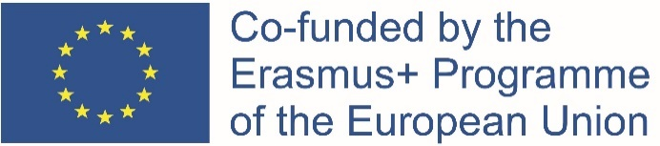 | 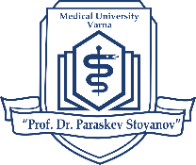  MEDICAL UNIVERSITY – VARNA  “Prof. Dr. Paraskev Stoyanov”  55, Marin Drinov Str., 9002 Varna, Bulgaria  Tel.: +359 52/ 65 00 57, Fax: +359 52/ 65 00 19  e-mail: uni@mu-varna.bg, www.mu-varna.bg

Medical University – Varna
offers the following available places for Erasmus internships
during 2022/2023 academic year:
Erasmus pre-graduate state internship during the 6th year of academic studies
State | City | University | Available places | Traineeship duration  (min-max  in months) | Language of instruction
Poland | Katowice | Medical University of Silesia | 2 | 3 - 6 | English
Portugal | Lisbon | Universidade De Lisboa | 2 | 3-6 | Portugal
Romania | Constanta | Ovidius University of Constanta | 2 | 3-6 | English/ French
 | Oradea | Universitatea din Oradea | 2 | 3-6 | English
 | Iasi | Grigore T. Popa University of Medicine and Pharmacy | 2 | 2 - 3 | English
Turkey | Izmir | Ege University | 1 | 3 - 9 | Turkish /English
Erasmus summer internship after the 3rd or 4th year of academic studies
Lithuania | Kaunas | Lithuanian University оf Health Sciences | 2 | 2 | English
Poland | Katowice | Medical University of Silesia | 2 | 2 | English
 | Wroclaw | Wroclaw Medical University | 1 | 2 | English
 | Gdansk | Medical University of Gdansk | 2 | 2 | English
Romania | Constanta | Ovidius University of Constanta | 2 | 2 | English/ French
 | Oradea | Universitatea din Oradea | 2 | 2 | English
 | Iasi | Grigore T. Popa University of Medicine and Pharmacy | 2 | 2 | English
Hungary | Seged | University of Szeged | 2 | 2 | English
France | Lyon | University Claude Bernard - Lyon | 2 | 2 | French

The applicants should have an average grade (GPA) as of the time of application minimum 4.50.

The applicants must have taken all their exams till the time of application.

APPLICATION DOCUMENTS:
- Application form (available on www.mu-varna.bg)
- Declaration form concerning personal data protection (available on www.mu-varna.bg)
- Certificate for average grade (GPA) as of the time of application minimum 4.50 (issued by the Students' Office)
- Letter of recommendation signed by a professor in MU-Varna
- Certificate for language proficiency (for mobility language other than English)

Application deadline – 05.10.2022
Application documents have to be submitted in the International Relations Department (room 209) from 1:00 to 4:00 PM and online: erasmus@mu-varna.bg

