Title of the paper
(bulgarian language, capital letters, times new roman, 14 pt, BOLD, Centered)

Academic title, degree, authors name and surname, place of work (Times New Roman, 12 pt, centered text)

Abstract: (In English, font Times New Roman, 12 pt, Italic, Justify, not more than 200 words or 1500 signs). The development of internet technologies and the improvement of e-learning platforms has placed the instructor in an entirely new role. Electronic learning is designed for self-study, consistent with students’ characteristics and allowing them to manage their own learning process. This way, the teacher can leave the field of the “knowing it all” and transfer into becoming a tutor who can support the learning path of students using internet communication technologies. Such a shift unveils the controversial status of the teaching institution in a world of digits, which is additionally complicated by the advent of Y and Z generations in higher education known as “digital natives” who can perfectly handle the use all electronic devices and their countless applications as compared to the inability of many of their professors. Despite the skepticism in the academic world towards the use of electronic platforms instructors have not lost their importance but on the contrary, their responsibility has even increased in their new role of being competent guides to students in the sea of information and resources available in cyberspace.

Key words: competency; formal and informal learning; e-learning; tutor; effectiveness; self-study (Times New Roman, 12 pt, Italic, Justify)

Times New Roman, 12 pt, Bold, Left Alignment, Indentation: First Line 1 cm
The paper should be formatted with the following characteristics: size of page 21 см × 29,7 см (А4), Top: 2,5 см, Bottom: 2,5 см, Left: 3 см, Right: 2,5 см; Font Times New Roman, 12 pt, Justify, Spacing – 1 (Single) and indent from the first paragraph 1 см (First line). Maximum number of pages should be 6 (six), including the title, abstract, tables, figures and bibliography. Pages should not be numbered.

Papers should be sent to the following address: Ezik_konf17@mu-varna.bg.

The Organising Committee will publish the papers that correspond to the conference subject areas and have been approved by the reviewers. In order to meet the requirements for formatting we recommend you directly format your paper using the template which has been formatted according to them.
Citations in the text should be done as follows: a figure in square brackets [1] that corresponds to the list of bibliography items at the end of the paper. Bibliography formatting should be written according to the given example.

Tables and figures
The tables and figures should be separated from the main body of the text by a single space. The tables and figures should be numbered and captions should be provided, while the images should be centered.

Figure captions should be written below them:

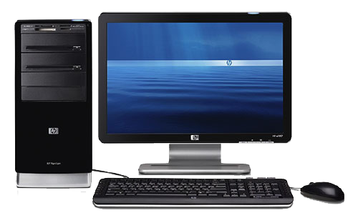

Fig. 1. Caption.

Table captions should be written above. The text should be 10 pt, Times New Roman.

Тable 1. Title

References and resources: Font: Times New Roman, Size: 10, Alignment: Justified;

References:

- Андрейчин, Л. и кол. Български тълковен речник.София 1976, с. 611
- Мерджанов, И. E-Campus. Съвременни форми на електронно обучение в академична среда. Варна, 2013. с. 26
- Пейчева-Форсайт, Р. Адаптивна, базирана на доверието електронна система за оценяване на ученето //Електронното обучение във висшите училища. СУ "Св. Климент Охридски". София, 2016, с. 229
- http://wirtschaftslexikon.gabler.de/Definition/individualisierung.html (22.09.2016)
- http://www.segabg.com/article.php?id=815051 (24.09.2016).

Contact details:

Address:
Тelephone number:
Е-mail:

