From: Sofia Latifian
Sent: Friday, August 02, 2013 1:47 AM
To: students_office@mu-varna.bg
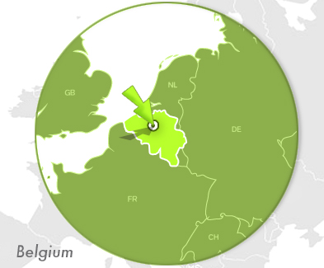
„ My name is Sofia Latifian.
I am a Medical Doctor since 2007. Nowadays I am working in the University Hospital in Brussels, Belgium. I am doing a specialization in Medical Oncology. I am proud to have done my medical education at Medical University-Varna. That is an institution with an impressing history and a promising future. The professors are very motivated and in the same time very understandable towards the difficulties of the future doctors. The team of Medical University Varna is very motivated which is giving us the opportunity to learn according to the last guidelines and on modern technics.
The students are not only building the bases of the medical knowledge but developing a scientific way of thinking; the ability to save life and cure the patients. They have also the possibility to be creative and choose their supplementary activities. The theory is very well associated with the clinical practice in Modern University Hospitals.
All of this prepared me to be able to work and be competitive in the European health system. But for me Medical University-Varna is not only a place to study. It is where I met one of my best friends and great examples for being a good doctor and a good person. A part of the studies Varna is a great place for relaxing and having fun.
If I need to go back in time I will choose again studying medicine at Medical University Varna! “

