 | MEDICAL UNIVERSITY – VARNA  “Prof. Dr. Paraskev Stoyanov”  55, Marin Drinov Str., 9002 Varna, Bulgaria  Tel.: +359 52/ 65 00 57, Fax: +359 52/ 65 00 19  e-mail: uni@mu-varna.bg, www.mu-varna.bg | 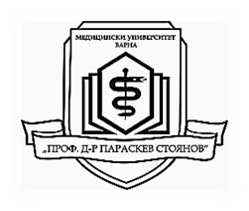

AVAILABLE PLACES FOR ERASMUS INTERNSHIP
DURING 2019/2020 ACADEMIC YEAR

Erasmus pre-graduate state internship during the 6th year of academic studies
State | City | University | Available places | Traineeship duration  (min-max in months) | Language of instruction
Germany | Rostock | Universität Rostock | 2 | 3 - 6 | German
Italy | Bari | University of Bari Aldo Moro | 2 | 3 - 6 | English
Poland | Katowice | Medical University of Silesia | 2 | 3 - 6 | English
Slovenia | Maribor | University of Maribor | 2 | 3 - 6 | English
Turkey | Edirne | Trakya University | 3 | 3 - 6 | Turkish or English
 | Izmir | Ege University | 1 | 3 - 6 | Turkish or English
Hungary | Budapest | Semmelweis University | 2 | 3 – 6  (Surg, Int Med, О&G) | English
Erasmus summer internship after the 3rd or 4th year of academic studies
Germany | Rostock | Universität Rostock | 1 | 2 | German
Romania | Constanta | Ovidius University of Constanta | 1 | 2 | English/ French
Turkey | Edirne | Trakya University | 1 | 2 | Turkish or English

