Medical university -Varna
„Prof. Dr. Paraskev Stoyanov”

Faculty „Medecine“
Second Department of Internal Diseases

Aleksander Aleksandrov Petrov, MD

Level of awareness of patients with chronic kidney disease regarding kidney transplantation and importance of awareness in the choice of renal replacement therapy

ABSTRACT
of a thesis for the educational and scientific degree
„Doctor“

Supervisor:
Prof. Dr. Svetla Vasileva Staykova, MD, PhD, DSc

Varna, 2021
The dissertation contains 142 standard pages and is illustrated with 2 tables, 85 figures and 1 appendix. The literature includes 233 literary sources, of which 11 in Cyrillic and 222 in Latin.

The dissertation was discussed and approved for public defense by the Department Council of the Second Department of Internal Medicine at the Medical University "Prof. Dr. Paraskev Stoyanov ”- Varna.

External members:
1. Prof. Dr. Emil Paskalev, MD, Ph.D., DSc
2. Prof. Dr. Raina Robeva, Ph.D.
3. Assoc. Prof. Dr. Alexander Osichenko, MD, Ph.D.

Spare external member:
1. Assoc. Prof. Velislava Dimitrova, MD, Ph.D.

Internal members:
1. Prof. Dr. Valentina Madzhova, MD, Ph.D.
2. Prof. Dr. Dimitrichka Bliznakova, MD, Ph.D.

Spare internal member:
1. Assoc. Prof. Dr. Rositsa Zorcheva, MD, Ph.D.

The public defense of the dissertation will take place on 17.12.2021 at 11.00 in the Faculty of Dental Medicine - Varna at an open meeting of the Scientific Jury.
The materials on the defense are available in the Scientific Department of MU - Varna and are published on the website of the Medical University - Varna.
Note: In the abstract the numbers of the tables and figures do not correspond to the numbers in the dissertation.
CONTENTS

LIST OF ABBREVIATIONS

BHLS | Вrief health literacy screen
DMCAT | Decision Making Capacity Assessment Tool
GFR | Glomerular filtration rate
KDIGO | Kidney Disease Improving Global Outcomes
NVS | Newest vital sign
REALM | Rapid Estimate of Adult Literacy in Medicine
R3K-T | Rotterdam Renal Replacement Knowledge-Test
TOFHLA | Test of Functional Health Literacy in Adults
USRDS | United States Renal Data System

INTRODUCTION

Pollution of the environment, industry, constant contact with drugs, food additives and genetically modified products, as well as systemic exposure to stress, lead to an increase in the diseases of "modern man". The kidneys are one of the main organs that are affected by these processes, increasing the risk of developing chronic disease.
According to the international classification of KDIGO (Kidney Disease Improving Global Outcomes), chronic kidney disease (CKD) is defined as "disorders of kidney structure or function, available for more than 3 months, which affect health." Chronic kidney disease is one of the major and socially significant health problems affecting society globally. According to the World Health Organization (WHO), the incidence of CKD worldwide is estimated at about 13.4% (11.7-15.1%) and the number of patients who have reached end-stage renal disease (ESKD) is between 4.902 and 7.083 million. As of 2010, there were 928,000 registered deaths as a result of CKD and 14,754,000 with permanent health disorders, which puts kidney disease in 6th place in the statistics on the etiology of mortality in the global aspect. These figures are incomplete, as a large proportion of patients living in middle- or low-income countries remain outside the statistical analysis due to the lack of centralized registers and rapid access to health care. This gives grounds to speak of "the tip of the CKD iceberg", as the true number of those affected remains unclear.
Bulgaria is no exception to these statistics. Here, the incidence of CKD is 12.8%, which makes every 8th person or about 700-750 thousand people, 90% of them with advanced kidney disease, and about 3800 are patients on hemodialysis. In 2007, the Bulgarian Nephrological Society conducted a screening campaign in several districts of the country, and the results showed that 26% of the Bulgarian population had criteria for CKD. More impressively, 12% of respondents did not suspect that they had one. According to the summarized data of the National Statistical Institute (NSI) and the National Center for Public Health and Analysis at the Ministry of Health for 2018, urogenital diseases accounted for 1.4% of mortality in the country, and this percentage increased in 2019 at 1.7%. The reasons for this probably lie in the increasing frequency of risk factors among the population. Again, according to the statistics of the National Statistical Institute, the number of hemodialysis patients (acute and chronic) in 2010 in Bulgaria was 6598 people and 459,744 hemodialysis procedures were reported. In 2019, the number of patients undergoing hemodialysis treatment was 9863, respectively 586 333 procedures. With an average price of a hemodialysis procedure of BGN 144 (price until 2019), this means that the annual amount paid by the state amounts to over BGN 84 million. In addition, mortality from acute cardiovascular disease is more than 50 percent higher in patients with CKD than in the population without kidney disease. Mortality from common heart attacks is 11 times more common in patients with end-stage renal disease than in the healthy population.
Kidney patients who have reached the terminal stage of their disease have three options to continue living: hemodialysis (HD), peritoneal dialysis (PD) and kidney transplantation (KT). Proven to be the best method of kidney replacement therapy is the kidney transplantation, both in terms of maintaining a healthy metabolism and the quality of life of the patient. KT allows the patient to gain the self-confidence of a healthy person and has been shown to reduce the risk of developing depressive syndrome in patients with CKD. However, there are many "myths" about this treatment, and it is their debunking that holds the key to successful transplantation. Good health culture and awareness is achieved through training of patients with CKD and especially the potential recipients. Studies in this direction show that the health literacy of the population is extremely low. There is low awareness among the patients in the pre-dialysis and dialysis stages, especially when it comes to kidney transplantation. It turns out that there is a large percentage of candidate recipients who only after kidney transplantation for the first time face some aspects of the post-transplant period, such as continuous immunosuppressive therapy and possible disease complications. This is subsequently a prerequisite for poor cooperation and, in general, for a poor prognosis for the graft and the person.
Determining the current awareness regarding kidney transplantation is important on the overall prognosis of the disease and is a way to detect "pitfalls" in communication with the patient and possible kidney transplantation, which directly reflects on the quality of life of recipients in the future.

AIM, TASKS AND HYPOTHESIS

Aim

The aim of the dissertation is to study the level of awareness of patients with chronic kidney disease regarding kidney transplantation and the importance of awareness in the choice of renal replacement therapy.

Tasks

- Assessment of the level of awareness regarding chronic kidney disease (CKD)
- Determining the level of awareness regarding kidney transplantation
- Determining people's awareness of hemodialysis as a method of replacement therapy
- Measuring the level of awareness of peritoneal dialysis as a method of replacement therapy
- Development of a plan for a Guide for patients with chronic kidney disease and treatment methods based on which the patient to make an informed choice

Hypothesis

We assume that the Bulgarian patient is not sufficiently informed about his/hers disease and needs accurate, synthesized information to help him/her make an informed choice regarding his/her treatment.
MATERIALS AND METHODS

Object and scope of the study

The objects of the survey are 126 respondents, divided into four groups:
- Healthy controls - persons who do not have information about kidney disease - 37 units
- Persons in pre-dialysis stage (G1-G4) - 20 units
- Persons undergoing replacement therapy of renal function (hemodialysis and peritoneal dialysis) - 47 units
- Persons with a kidney transplant - 22 units

The respondents answer a specially created questionnaire, consisting of five panels:
- Part One - Demographics - Gender, Age, Education, Employment and Religion
- Part Two - General questions concerning the level of awareness regarding chronic kidney disease (CKD) - 12 closed questions
- Part Three - Questions concerning the level of awareness regarding kidney transplantation - 22 closed questions
- Part Four - Questions concerning people's awareness of hemodialysis as a method of substitution treatment - 6 closed questions
- Part Five - Questions concerning peritoneal dialysis as a method of replacement treatment - 4 closed questions
- Part Six - Issues related to quality of life - 4 closed questions

The survey of the selected population’s awareness was carried out with the permission of ethics committee on research of MU-Varna with Protocol / Decision 106 / 30.09.2021, as each participant filled in a declaration of informed consent.

Criteria for inclusion in the study:
- Age over 18 years
- Clinically healthy - for the control group
- People diagnosed with chronic kidney disease
- Persons undergoing renal replacement therapy
- People with a kidney transplant
- Persons who have signed an informed consent

Exclusion criteria:
- Age under 18
- Persons who have not signed an informed consent
- People with another chronic disease or other transplanted organ

Research methodology

Documentary method - analysis of published studies and data on chronic kidney disease, kidney transplantation and patient awareness, as well as the following regulations:
- Health Act
- Law on transplantation of organs, tissues and cells in Bulgaria
- Medical standard "Nephrology"

Historical method - reference to Bulgarian and foreign language literature sources, scientific articles, information sites, medical literature, dissertations and monographs, which affect the level of awareness regarding chronic kidney disease and kidney transplantation among the population. The reason for using the historical approach is to justify the importance of the study.

Sociological methods - all selected persons fill in a specially created questionnaire.

Statistical methods - for analysis and interpretation of experimental data in order to reveal the nature of the observed phenomena and their interdependencies, which are the subject of this thesis:
- Dispersion analysis (ANOVA, MANOVA) - the frequency distribution of the considered features is presented in tabular form;
- Variation analysis - to assess the quantitative characteristics of the condition of the studied trait. For this purpose, what is typical for the given population is established and the influence of the naturally acting factors is described. Of particular importance is the characterization of the scattering, the variation of the signs in order to take into account the influence of the random factors;
- Correlation analysis - applied to reveal the causal relationships between individual studied traits;
- Regression analysis - statistical analysis of the obtained results in order to establish the type and parameters of one or several factors, as the results are presented in the form of experimental data;
- Comparative analysis (hypothesis evaluation);
- Assessment of the reliability of the questionnaire used (Cronbach’α);
Data were statistically processed using SPSS v.20, using descriptive indicators for quantitative and qualitative variables and presented in tabular and graphical form.
RESULTS

The obtained results are systematized in tables and illustrated with figures for illustration.
The opinion is of 126 respondents, who passed through the Clinic of Nephrology at the University Hospital "St. Marina EAD - Varna. The distribution of patients is presented in table. 1

Tabl. 1. Demographic of the respondents
Indicator |  | Number (%)
Study group | Healthy controls | 37/29.4 %
 | Patients undergoing hemodialysis | 47/37,3 %
 | Patients with CKD in the predialysis stage (G1-G4) | 20/15,9%
 | Transplant patients | 22/17.5 %
Gender | men | 54/42.9 %
 | women | 72/57.1 %
Age (yaers) | mean±SD (range) | 54.4 ± 12.5 (17 – 81)
Education | Primary education | 5/4.0 %
 | Basic education | 16/12.7 %
 | Secondary education | 64/50.8 %
 | Higher education | 41/32.5 %
Employment | Yes | 43/34.4 %
 | No | 31/24.8 %
 | I am retired | 51/40.8 %
Religion | Christianity | 104/82.5 %
 | Islam | 10/7.9 %
 | Another | 1/0.8 %
 | I do not profess religion | 11/8.7 %

There was a significant difference in terms of age in the study groups (p = 0.029), with the oldest patients in the predialysis stage (59.65 years) and the youngest healthy controls (50.4 years) (Fig. 1).

Fig. 1. Average age of patients according to the study group

Although the mean age of men was slightly lower than that of women, no significant difference was found (53.5 years for men and 55.1 years for women, respectively).

Assessment of the level of awareness regarding chronic kidney disease (CKD)
A significant proportion of respondents indicated that a person has two kidneys 97.6%, with one patient stating that it is not true that a person has two kidneys and two cannot answer the question.
According to approximately 1/3 (65.9%) of the respondents, it is not true that if the kidneys do not hurt, then a person is healthy (Fig. 2).
There was no significant difference in the opinion of the subjects about kidney pain according to gender and age.
A significant difference was found in terms of the educational level of the surveyed persons (p = 0.049), as according to the majority of persons with primary and primary education if the kidneys do not hurt, then they are healthy, while the majority of persons with secondary and higher education disagree with this statement (Fig. 3).

Fig. 2. Distribution according to the subjects' awareness of kidney pain

Table. 2. Distribution according to the subjects' awareness of kidney pain and educational level
 |  |  | If the kidneys do not hurt, then they are healthy
 |  |  | That's right | FALSE | I do not know
Education | Primary | Count | 3 | 1 | 1
 |  | % within Education | 60,0% | 20,0% | 20,0%
 | Basic | Count | 8 | 6 | 1
 |  | % within Education | 53,3% | 40,0% | 6,7%
 | Secondary | Count | 17 | 44 | 2
 |  | % within Education | 27,0% | 69,8% | 3,2%
 | Higher | Count | 9 | 30 | 1
 |  | % within Education | 22,5% | 75,0% | 2,5%
Total |  | Count | 37 | 81 | 5
 |  | % within Education | 30,1% | 65,9% | 4,1%

A significant difference was found in the opinion of the subjects in the four groups about kidney pain (p = 0.026) (Fig. 3). Weak dependence was also found between the studied indicators (ρ = 0.248; p = 0.006).

 |  |  | If the kidneys do not hurt, then they are healthy
 |  |  | That's right | FALSE | I do not know
Study group | Healthy controls | Count | 16 | 18 | 2
 |  | % within Study group | 44,4% | 50,0% | 5,6%
 | Patients undergoing hemodialysis | Count | 13 | 33 | 1
 |  | % within Study group | 27,7% | 70,2% | 2,1%
 | Transplant patients | Count | 1 | 20 | 1
 |  | % within Study group | 4,5% | 90,9% | 4,5%
 | Patients with CKD in the predialysis stage (G1-G4) | Count | 7 | 10 | 1
 |  | % within Study group | 38,9% | 55,6% | 5,6%
Total |  | Count | 37 | 81 | 5
 |  | % within Study group | 30,1% | 65,9% | 4,1%

Fig. 4. Distribution according to the subjects' awareness of kidney pain and the study group

The majority of respondents are aware that people with diabetes have an increased risk of developing chronic kidney disease (81.5%). No difference was found according to gender, age and study group. A difference was found in terms of the education of the respondents (p = 0.027). People with a higher level of education are significantly more informed on this issue than those who are less educated (Fig. 5).

 |  |  | People with diabetes have an increased risk of developing chronic kidney disease
 |  |  | That's right | FALSE | I do not know
Education | Primary | Count | 4 | 0 | 1
 |  | % within Education | 80,0% | 0,0% | 20,0%
 | Basic | Count | 11 | 1 | 3
 |  | % within Education | 73,3% | 6,7% | 20,0%
 | Secondary | Count | 48 | 0 | 16
 |  | % within Education | 75,0% | 0,0% | 25,0%
 | Higher | Count | 38 | 0 | 2
 |  | % within Education | 95,0% | 0,0% | 5,0%
Total |  | Count | 101 | 1 | 22
 |  | % within Education | 81,5% | 0,8% | 17,7%
Fig. 5. Distribution according to awareness of the relationship between diabetes mellitus and chronic kidney disease and the educational level of the subjects

Just over 2/3 (68.3%) of the respondents indicate smoking as a risk factor for the development of chronic kidney disease (Fig. 6). There is no difference in the opinion of the surveyed persons according to gender, age and educational level.
A large proportion of respondents (76.2%) identified weight loss in obese patients as a favorable factor for limiting CKD (Fig. 7). There is no difference in the opinion of the surveyed persons according to gender, age and educational level.

Fig. 6. Identification of smoking as a risk factor

Fig. 7. Determining weight loss as a favorable factor preventing CKD in obese patients

According to 83.7% of the respondents, it is not true that kidney diseases mainly affect the elderly (Fig. 8). There was no difference in the opinion of the respondents according to the studied group and gender, but such was found in terms of educational degree (p = 0.044) (Fig. 9).
Фиг. 8. Opinion on the effect of frequent use of painkillers on the kidneys according to the studied groups of patients

 |  |  | Kidney disease affects the elderly. When we are young there is no danger of diseases of our kidneys
 |  |  | That's right | FALSE | I do not know
Education | Primary | Count | 2 | 2 | 1
 |  | % within Education | 40,0% | 40,0% | 20,0%
 | Basic | Count | 3 | 11 | 1
 |  | % within Education | 20,0% | 73,3% | 6,7%
 | Secondary | Count | 9 | 52 | 2
 |  | % within Education | 14,3% | 82,5% | 3,2%
 | Higher | Count | 1 | 38 | 1
 |  | % within Education | 2,5% | 95,0% | 2,5%
Total |  | Count | 15 | 103 | 5
 |  | % within Education | 12,2% | 83,7% | 4,1%
Fig. 9. Opinion on the effect of frequent use of painkillers on the kidneys according to the studied groups of patients. Distribution according to educational degree

More than ¾ (76.2%) of the surveyed persons indicate that CKD can be hereditary. There is no difference in the opinion of the surveyed persons according to gender, age and educational level.
According to a significant part of the respondents (79.8%), the frequent use of painkillers can seriously damage the kidneys, and a significant difference was found according to the studied group of patients (p <0.05). Patients with kidney transplantation have the greatest support for this statement (Fig. 10).

 |  |  | Frequent use of painkillers can seriously damage the kidneys
 |  |  | That's right | FALSE | I do not know
Study group | Healthy controls | Count | 31 | 0 | 6
 |  | % within Study group | 83,8% | 0,0% | 16,2%
 | Patients undergoing hemodialysis | Count | 33 | 2 | 12
 |  | % within Study group | 70,2% | 4,3% | 25,5%
 | Transplant patients | Count | 21 | 0 | 1
 |  | % within Study group | 95,5% | 0,0% | 4,5%
 | Patients with CKD in the predialysis stage | Count | 14 | 0 | 4
 |  | % within Study group | 77,8% | 0,0% | 22,2%
Total |  | Count | 99 | 2 | 23
 |  | % within Study group | 79,8% | 1,6% | 18,5%
Fig. 10. Opinion on the effect of frequent use of drugs on the kidneys according to the studied groups of patients

Interestingly, only 68.8% of respondents confirmed that the kidneys maintained a normal hemoglobin level, with a significant difference in the opinion of patients according to the studied groups (p = 0.045) (Fig. 11). Transplant patients are most informed about kidney function, while in the group of patients who do not know this information, healthy controls have the largest relative share.

 |  |  | The kidneys maintain normal hemoglobin levels
 |  |  | That's right | FALSE | I do not know
Study group | Healthy controls | Count | 22 | 1 | 14
 |  | % within Study group | 59,5% | 2,7% | 37,8%
 | Patients undergoing hemodialysis | Count | 34 | 3 | 10
 |  | % within Study group | 72,3% | 6,4% | 21,3%
 | Transplant patients | Count | 18 | 2 | 1
 |  | % within Study group | 85,7% | 9,5% | 4,8%
 | Patients with CKD in the predialysis stage | Count | 12 | 1 | 7
 |  | % within Study group | 60,0% | 5,0% | 35,0%
Total |  | Count | 86 | 7 | 32
 |  | % within група | 68,8% | 5,6% | 25,6%
Fig. 11. Opinion of the subjects on renal function in terms of maintaining hemoglobin levels

Less than half of the respondents (44.4%) indicate that it is not normal to have "foam" in the excreted urine (Fig. 12). There was a significant difference in the opinion of the respondents in the different study groups (p = 0.001) and the educational degree (p <0.001). The most informed are the patients with transplantation (Fig. 13) and those with higher education (Fig. 14).

Fig. 12. Opinion on the presence of "foam" in the urine

 |  |  | It is normal to have "foam" in the urine
 |  |  | That's right | FALSE | I do not know
Study group | Healthy controls | Count | 8 | 15 | 14
 |  | % within Study group | 21,6% | 40,5% | 37,8%
 | Patients undergoing hemodialysis | Count | 12 | 17 | 17
 |  | % within Study group | 26,1% | 37,0% | 37,0%
 | Transplant patients | Count | 3 | 18 | 0
 |  | % within Study group | 14,3% | 85,7% | 0,0%
 | Patients with CKD in the predialysis stage | Count | 3 | 5 | 12
 |  | % within Study group | 15,0% | 25,0% | 60,0%
Total |  | Count | 26 | 55 | 43
 |  | % within Study group | 21,0% | 44,4% | 34,7%
FIG. 13. By grouping with regard to proteinuria as a "norm"

 |  |  | It is normal to have "foam" in the urine
 |  |  | That's right | FALSE | I do not know
Education | Primary | Count | 1 | 1 | 3
 |  | % within Education | 20,0% | 20,0% | 60,0%
 | Basic | Count | 8 | 0 | 7
 |  | % within Education | 53,3% | 0,0% | 46,7%
 | Secondary | Count | 15 | 24 | 24
 |  | % within Education | 23,8% | 38,1% | 38,1%
 | Higher | Count | 2 | 30 | 9
 |  | % within Education | 4,9% | 73,2% | 22,0%
Total |  | Count | 26 | 55 | 43
 |  | % within Education | 21,0% | 44,4% | 34,7%
Fig. 14. Opinion on the presence of "foam" in the urine according to education

The majority of respondents (96.8%) are of the opinion that patients with kidney disease should avoid salty foods and only half (50.4%) are informed that osteoporosis can be caused by chronic kidney disease (Fig. 15). There was a significant difference in opinion about the impact of chronic kidney disease on osteoporosis according to the study group (p <0.001). Kidney transplant patients are most aware of the impact of chronic kidney disease on the development of osteoporosis (68.18%), while 72.97% of the healthy control group do not know whether chronic kidney disease is a risk factor for the development of osteoporosis (Fig. 16).

Fig. 15. Opinion on the impact of chronic kidney disease on osteoporosis

 |  |  | Osteoporosis can be caused by chronic kidney disease
 |  |  | That's right | FALSE | I do not know
Study group | Healthy controls | Count | 7 | 3 | 27
 |  | % within Study group | 18,9% | 8,1% | 73,0%
 | Patients undergoing hemodialysis | Count | 31 | 1 | 14
 |  | % within Study group | 67,4% | 2,2% | 30,4%
 | Transplant patients | Count | 15 | 1 | 6
 |  | % within Study group | 68,2% | 4,5% | 27,3%
 | Patients with CKD in the predialysis stage | Count | 10 | 1 | 9
 |  | % within Study group | 50,0% | 5,0% | 45,0%
Total |  | Count | 63 | 6 | 56
 |  | % within Study group | 50,4% | 4,8% | 44,8%
Fig. 16. Opinion on the impact of chronic kidney disease on osteoporosis according to the study group

4.2. Assessment of the level of awareness regarding kidney transplantation
Respondents' opinion on the preservation of renal function in the donation of 1 kidney is mixed (Fig. 17).

Fig. 17. Opinion on the preservation of renal function after donation of one kidney

There was a significant difference in the opinion of the respondents in the four study groups (p = 0.004), with transplant patients being most familiar with the preservation of renal function after kidney donation and transplantation (Fig. 18).
Another significant difference was found in terms of educational degree (p = 0.013). People with higher education are most aware that donating a kidney does not lead to loss of kidney function (Fig. 19).

 |  |  | After donating 1 kidney, the donor loses 1/2 of his kidney function for the rest of his life
 |  |  | That's right | FALSE | I do not know
Study group | Healthy controls | Count | 16 | 8 | 13
 |  | % within Study group | 43,2% | 21,6% | 35,1%
 | Patients undergoing hemodialysis | Count | 18 | 14 | 13
 |  | % within Study group | 40,0% | 31,1% | 28,9%
 | Transplant patients | Count | 2 | 15 | 5
 |  | % within Study group | 9,1% | 68,2% | 22,7%
 | Patients with CKD in the predialysis stage | Count | 5 | 5 | 10
 |  | % within Study group | 25,0% | 25,0% | 50,0%
Total |  | Count | 41 | 42 | 41
 |  | % within Study group | 33,1% | 33,9% | 33,1%
Fig. 18. Opinions by groups

 |  |  | After donating 1 kidney, the donor loses 1/2 of his kidney function for the rest of his life
 |  |  | That's right | FALSE | I do not know
Employment | Primary | Count | 2 | 1 | 2
 |  | % within Employment | 40,0% | 20,0% | 40,0%
 | Basic | Count | 7 | 0 | 8
 |  | % within Employment | 46,7% | 0,0% | 53,3%
 | Secondary | Count | 21 | 19 | 23
 |  | % within Employment | 33,3% | 30,2% | 36,5%
 | Higher | Count | 11 | 22 | 8
 |  | % within Employment | 26,8% | 53,7% | 19,5%
Total |  | Count | 41 | 42 | 41
 |  | % within Employment | 33,1% | 33,9% | 33,1%
Fig. 19. Opinions according to the educational degree

According to 55.7% of the respondents, the statement that by law kidney transplantation in Bulgaria is allowed in a relationship between a donor and a recipient up to the first lateral line (first cousin) or between spouses with at least 3 years of legal relationship (Fig. 20).

Fig. 20.

It is interesting that among the patients with transplantation there are those who are not familiar with the legislative system of Bulgaria regarding organ transplantation (Fig. 21).
Only 29.8% of the subjects knew that cross-donation did not mean that the donor and the recipient exchanged one kidney each (Fig. 22). Patients with a kidney transplant know the correct meaning of cross-donation (p <0.001), which is logical given the fact that these patients are familiar with the procedure given their treatment (Fig. 23).

 |  |  | By law, kidney transplantation in Bulgaria is allowed in case of kinship between donor and recipient (recipient) up to the first lateral line (first cousin) or between spouses with at least 3 years of legal relationship.
 |  |  | That's right | FALSE | I do not know
Study group | Healthy controls | Count | 19 | 1 | 15
 |  | % within Study group | 54,3% | 2,9% | 42,9%
 | Patients undergoing hemodialysis | Count | 23 | 5 | 17
 |  | % within Study group | 51,1% | 11,1% | 37,8%
 | Transplant patients | Count | 17 | 1 | 4
 |  | % within Study group | 77,3% | 4,5% | 18,2%
 | Patients with CKD in the predialysis stage | Count | 9 | 1 | 10
 |  | % within Study group | 45,0% | 5,0% | 50,0%
Total |  | Count | 68 | 8 | 46
 |  | % within Study group | 55,7% | 6,6% | 37,7%
Fig. 21. Distribution by groups

Fig. 22. Respondents' opinion on cross-donation

Fig. 23. Respondents' opinion on cross-donation according to the surveyed groups

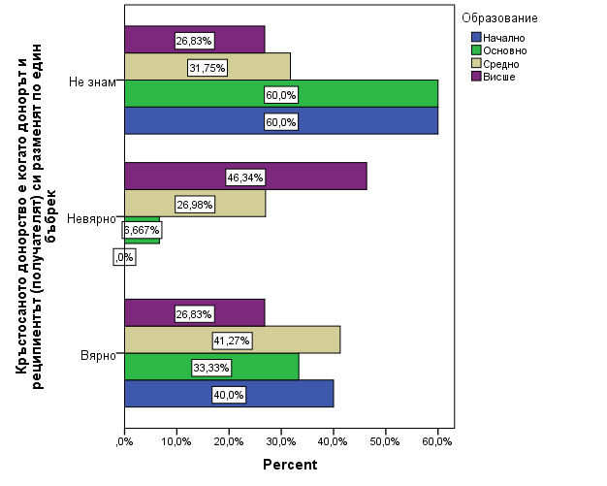
Fig. 24. Respondents' opinion on cross-donation according to educational degree

A significant difference in the opinion about cross-donation is also established with regard to the educational degree (p = 0.028), as the persons with higher education are most familiar with the essence of cross-donation (Fig. 24).
Only 19.5% are aware that cross-donation is legal in Bulgaria (Fig. 25).

Fig. 25. Opinion on the lawful conduct of cross-donation

There was a significant difference in the opinion of the respondents in the three study groups (p = 0.003), which shows that even transplant patients are not well informed about the legal conduct of cross-donation (Fig. 26).
Just over half of the respondents (58.2%) are aware that dialysis patients have a difference in renal function compared to those with a kidney transplant (Fig. 27).

Fig. 26. “In Bulgaria, it is already legal to conduct cross-donation” according to the studied groups

Fig. 27.

There was a significant difference in the opinion of the respondents regarding the renal function of dialysis patients and of patients with kidney transplantation regarding the study group (p = 0.01) (Fig. 28).

Fig. 28. Opinions by groups

A significant difference is also established with regard to the opinion of the surveyed persons according to the educational degree (p=0.006). People with higher education are more informed about the difference in renal function in dialysis patients and in those with kidney transplantation (Fig. 29).
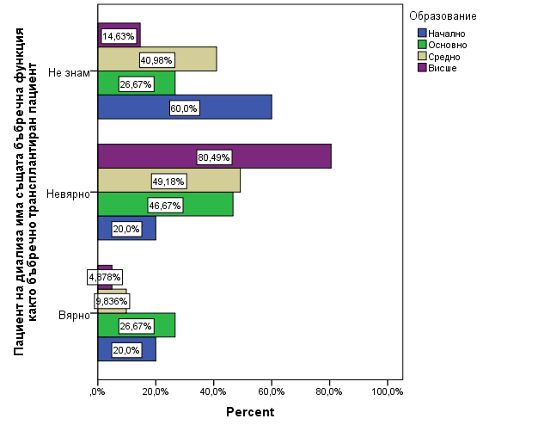
Fig. 29. Distribution of the answers by educational degree.

Half of the subjects were not informed about kidney transplantation in patients after the age of 75 (Fig. 30), and no difference was found between the study groups, gender and educational level.

Fig. 30

Almost half of the respondents confirmed that the donor can refuse to give a kidney on the day of the operation (49.6%) (Fig. 31).

Fig. 31.

There was a significant difference in the opinion of the respondents according to the studied group (p = 0.015), as the most informed are the patients with transplantation (77.3%), and the most uninformed are the patients in the pre-dialysis stage (60.0%) (Fig. 32).

Fig. 32. The donor may refuse to give a kidney on the day of surgery according to the study group

A significant difference in the opinion of the surveyed persons was found in terms of educational level (p = 0.036), as the most informed are the persons with higher education (Fig. 33). There was no difference in the opinion of the respondents according to gender.

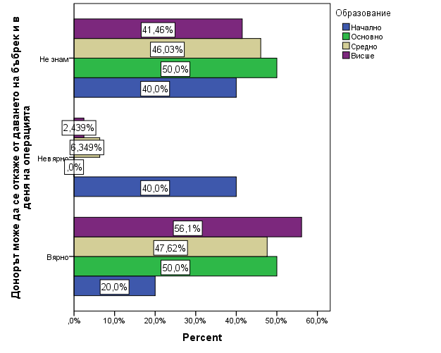
Fig. 33. The donor may refuse to donate a kidney on the day of the operation according to the educational degree

Only half of the respondents indicated that the life expectancy of transplant patients was longer than that of dialysis patients (53.7%) (Fig. 34), with no difference in opinion according to gender and educational level. This was found that the tranplanted group (p = 0.004), are being the most informed about life expectancy (Fig. 35).

Fig. 34.

Fig. 35. Overall, the life expectancy of transplant patients is longer than that of dialysis patients according to the study group.

More than 2/3 (67.2%) of the respondents support the opinion that kidney transplant patients should take medications that suppress their immune system in order for the transplanted kidney to work (Fig. 36), without distinguishing between gender, educational level and the study group.

Fig. 36.

Regarding the payment of medicines to transplant patients, the opinion of the respondents is mixed, with an equal share of patients disagreeing with the statement that transplant patients have to pay for their medicines themselves and the same part do not have information on the issue (Fig. 37). There was no difference in the opinion of the respondents according to gender, educational degree and the studied group.

Fig. 37.

Less than half of the surveyed persons agree with the statement that in Bulgaria the patient must have started dialysis treatment before he has the right to be transplanted (44.8%) (Fig. 38), and no significant difference was established according to gender.
It is noteworthy that there is a significant difference in the opinion of the subjects according to the group (p <0.001), as half of the patients undergoing hemodialysis support the statement (54.35%), while only 31.82% of the group of transplanted patients (Fig. 39).
Also interesting are the results in terms of educational level where 66.67% of people with secondary education support this statement, while those with primary and higher education have the lowest relative share (p = 0.002) (Fig. 40).

Fig. 38.

Fig. 39. In Bulgaria, the patient must have started dialysis treatment before being entitled to a transplant according to the study group.

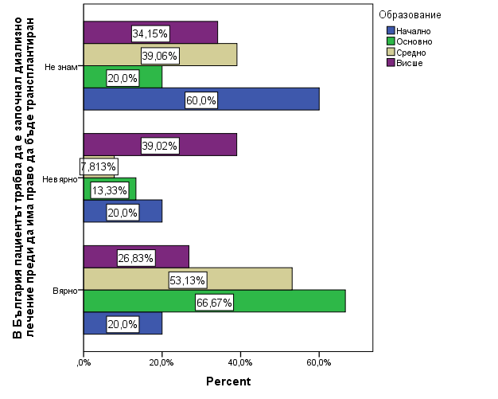
Fig. 40. In Bulgaria, the patient must have started dialysis treatment before being entitled to a transplant according to educational level.

Just over half of the subjects denied the claim that when a patient is registered in the waiting list for a kidney transplant, it is no longer necessary to be examined until the day of the possible transplant (54.4%) (Fig. 41). There was no difference in the opinion of the respondents according to gender, educational degree and the studied group.
Slightly more than 1/3 (37.9%) are of the opinion that it is not true that if a patient waits long enough, a suitable kidney will always appear (Fig. 42), with a significant difference according to the study group. = 0.006), where the relative share of transplant patients who support this statement prevails (63.64%) (Fig. 43).

Fig. 41.

Fig. 42.

Fig. 43. If a patient waits long enough, a suitable kidney will always appear according to the study group

The opinion of the respondents is different regarding the registration of the patient in the waiting list, as 44.7% do not agree with the statement that after being registered in the waiting list for transplantation, the patient waits at least 2 years before a suitable kidney appears. (Fig. 44).
There was a significant difference in the opinion of the subjects according to the group (p = 0.013), the highest share of those who disagreed with the statement were the transplant patients (59.09%), followed by those in the pre-dialysis stage (55.56%) (Fig. 45).
Another difference that was found was in terms of gender (p = 0.034), with men more disagreeing than women with the statement in question (Fig. 46).

Fig. 44.

Fig. 45. After being registered in the waiting list for transplantation, the patient waits at least 2 years before a suitable kidney appears, according to the study group.

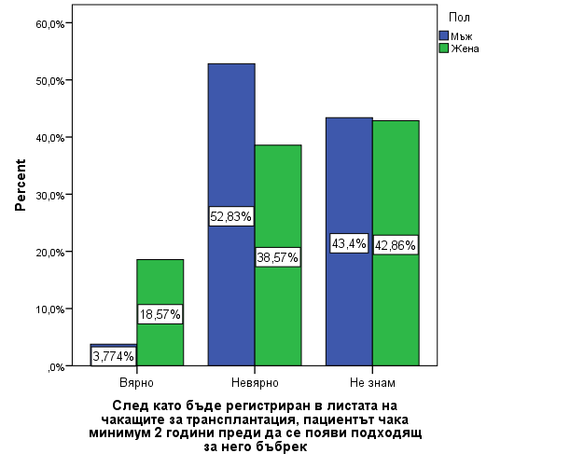
Fig. 46. After being registered in the waiting list for transplantation, the patient waits at least 2 years before a suitable kidney appears, by sex.

More than 3/4 (78.2%) of the respondents do not know how many years kidney transplantation have been performed by living donors. Only 7.6% are informed that these interventions have been performed for more than 50 years (Fig. 47). There is no difference according to gender, educational degree and study group.
Also, about 2/3 (64.8%) of the respondents do not know how long the kidneys function from living and cadaveric donors (Fig. 48), and there is no difference in awareness regarding gender, educational level and the study group.
Gaps in awareness are also found regarding the consent for donation (Fig. 49), as only 36.9% are informed that by law anyone who has not indicated his explicit disagreement in his lifetime can be a potential donor in case of sudden death.
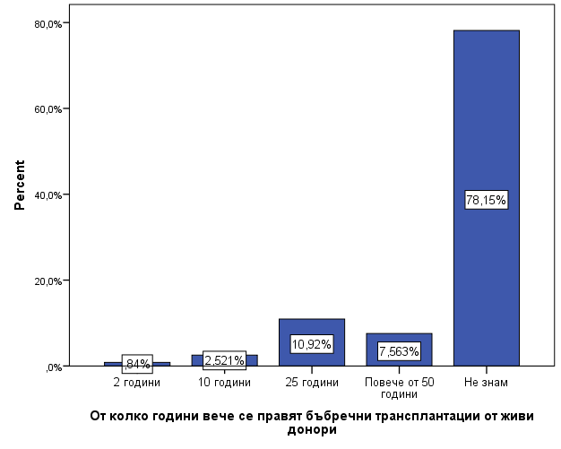
Fig. 47.

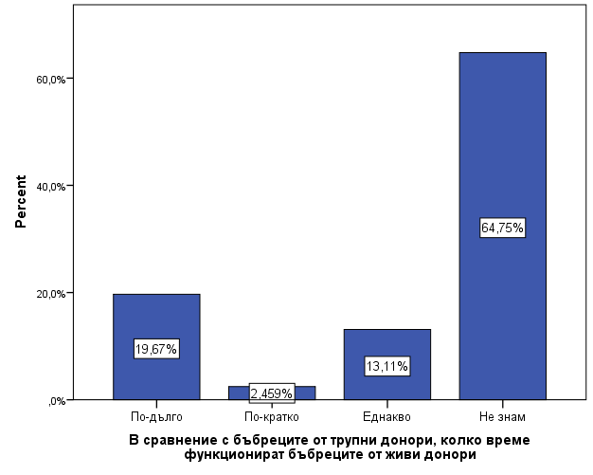
Fig. 48.

Fig. 49.

Less than half of the surveyed persons were informed that in Bulgaria the preparation, operation and follow-up of the donor and recipient after the kidney transplantation are paid in full from the budget of the Ministry of Health (43.9%) (Fig. 50). There is no difference in the awareness of the surveyed persons according to gender, educational degree and the studied group.
It is encouraging that 68.0% of respondents are of the opinion that in the event of brain death of a loved one, they would agree to have his organs used for transplantation (Fig. 51).
However, there was a significant difference in the opinion of the respondents regarding the donation of organs to their deceased relatives according to the study group (p <0.001) (Fig. 52). A moderate correlation was also found between the studied indicators (r = -0.304; p = 0.001).

Fig. 50.

Fig. 51.

Fig. 52. In the event of a brain death of a loved one, would you agree to his / her organs being used for transplantation, according to the study group

The results of fig. 52 show that patients with CKD and their relatives are more likely to agree to donate organs to their relatives in the event of brain death than the healthy control group.
Of those who gave a negative answer to the question related to organ donation to their loved ones in the event of brain death, 10% do so for religious reasons and 20.0% for emotional reasons and suspicion of abuse in hospitals. The others cannot give a reason.
Less than ¼ (23.3%) of the respondents are informed that in Bulgaria the donors do not pay their own fees for the research for compatibility with the recipients (Fig. 53), as the majority are uninformed on this issue. There is no difference according to gender, educational degree and study group.
Less than half of the respondents are familiar with the kidney transplant procedure and are aware that it is not necessary to remove the patient's own kidneys before the transplant (41.0%) (Fig. 54).

Fig. 53.

Fig. 54.

There was a significant difference in the opinion of the respondents regarding the removal of the patient's own kidneys before the kidney transplantation according to the studied group (p = 0.003) (Fig. 55). Most familiar with the situation are transplant patients who have already undergone the procedure and are aware that it is not necessary to remove the patient's own kidneys (71.43%).

Fig. 55. Before a kidney transplantation is performed, the patient's own kidneys must be removed, according to the study group.

About 3/4 (74.8%) of the subjects believe that kidney transplant patients have a better quality of life than patients on hemodialysis or peritoneal dialysis (Fig. 56). This opinion is shared by all transplant patients and the majority of patients undergoing hemodialysis (74.47%) and healthy controls (69.44%) (p = 0.036) (Fig. 57).

Fig. 56.

Fig. 57. Do you think that kidney transplant patients have a better quality of life than hemodialysis or peritoneal dialysis patients, according to the study group

  - Assessing people's awareness of hemodialysis as a method of replacement therapy

More than half of the respondents are aware that dialysis patients shouldn’t drink a lot of water to start their kidneys working better (59.8%) (Fig. 58).

Fig. 58.

There was a significant difference in the opinion of the subjects on the issue of drinking plenty of water for better kidney function in patients on dialysis according to the studied groups (p <0.001), and healthy controls are the least familiar with this problem. (Fig. 59). All patients with CKD are aware that high water consumption by dialysis patients is not associated with improved kidney function. However, there is a phenomenon that about 20% of dialysis patients can not answer this question.

Fig. 59. Dialysis patients need to drink plenty of water to start their kidneys working better, according to the study groups

More than ¾ (77.2%) are aware that in order to perform hemodialysis it is first necessary to provide access to the patient's blood circulation (Fig. 60). There was a significant difference in the knowledge of the respondents on this issue according to the studied group (p = 0.014) and the educational degree (p = 0.005), as well as a moderate relationship between the awareness of the respondents and education (r = 0.322; p <0.001). Again, transplant patients (100%) were most informed, followed by hemodialysis patients (82.6%) (Fig. 61).
On the other hand, it was found that a higher educational degree correlates with better awareness of the researched problem (Fig. 62). Persons with higher education are the most informed (94.87%).

Fig. 60.

Fig. 61. In order to perform hemodialysis, it is first necessary to provide access to the patient's blood circulation, according to the study group.
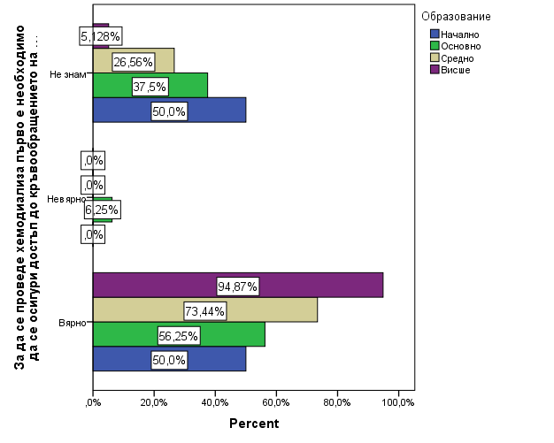
Fig. 62. In order to perform hemodialysis, it is first necessary to provide access to the patient's blood circulation according to the educational level.

According to 88.5% of the respondents, hemodialysis patients should visit a hemodialysis center 2-3 times a week for the rest of their lives, without any difference according to gender, educational degree and study group (Fig. 63).
Less than half (48.4%) of the subjects were informed that hemodialysis did not completely replace the function of a healthy kidney (Fig. 64). On this issue, a significant difference was found between the opinion of the individuals in the studied groups (p = 0.040), as the most informed were the patients with transplantation (68.2%), and the least informed were the patients in predialysis stage (36.8%) and healthy controls. (37.1%) (Fig. 65).

Fig. 63.

Fig. 64.

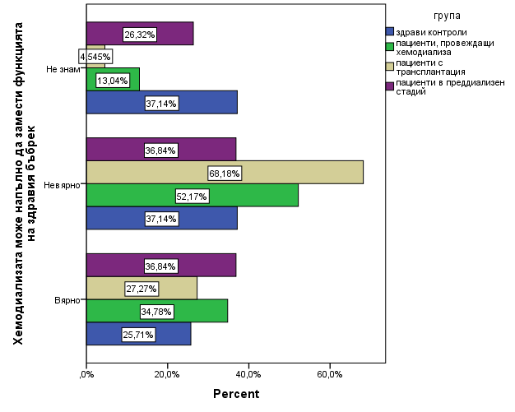
Fig. 65. Hemodialysis can completely replace the function of a healthy kidney, according to the study group

Regarding the start of replacement therapy, it was found that respondents were largely uninformed (Fig. 66), with only 16.4% aware that the start of treatment was not only associated with an increase in serum creatinine.
There was a significant difference in the awareness of patients on this issue according to the studied groups (p = 0.003), as well as a weak, prone to moderate dependence (r = 0.282; p = 0.002), which shows that the awareness of individuals is correlated with the type of the conducted therapy (Fig. 67).

Fig. 66.

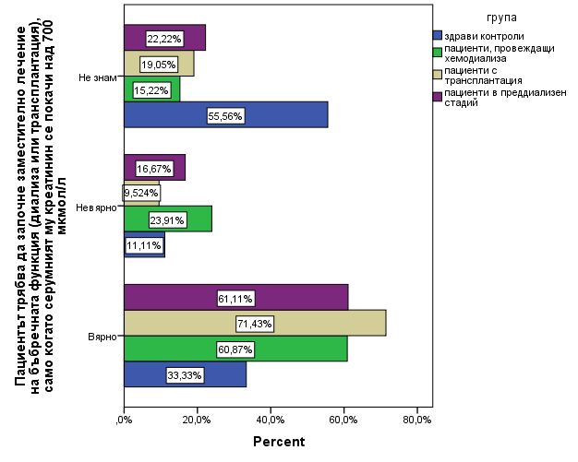
Fig. 67. The patient should start replacement therapy for renal function (dialysis or transplantation) only when his serum creatinine rises above 700 μmol / l, according to the study group.

Slightly less than half of the subjects (47.6%) believe that it is not true that hemodialysis patients have a better quality of life than those on peritoneal dialysis or kidney transplantation (Fig. 68).

Фиг. 68.

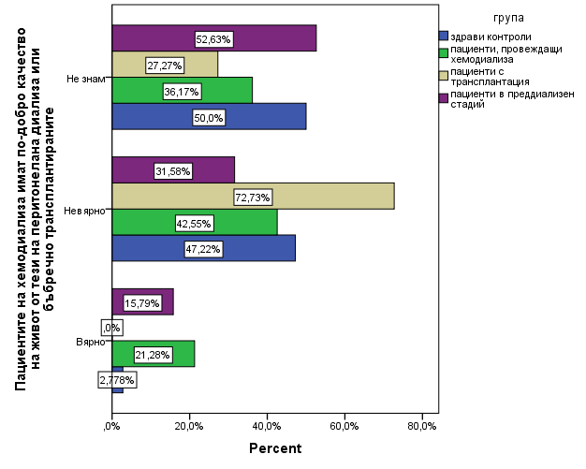
Fig. 69. Hemodialysis patients have a better quality of life than those on peritoneal dialysis or kidney transplantation, according to the study group

There was a significant difference in the opinion of the subjects about the quality of life in patients undergoing hemodialysis according to the studied groups (p = 0.013) and educational degree (p = 0.003). The most informed are the patients with transplantation (72.7%) (Fig. 69) and those with higher education (64.1%) (Fig. 70).

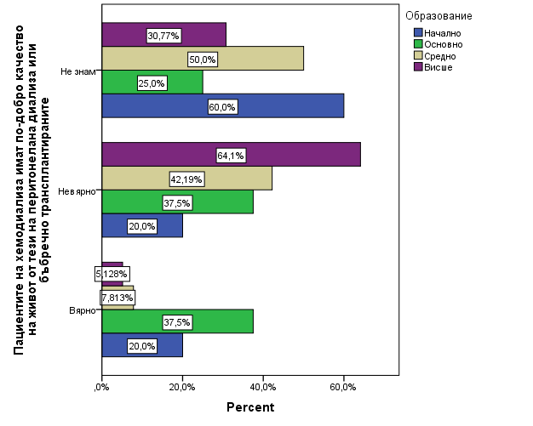
Fig. 70. Hemodialysis patients have a better quality of life than those on peritoneal dialysis or those with kidney transplantation, according to education

Only 30.9% of patients are aware that hemodialysis patients are more likely to suffer from depression than peritoneal dialysis and kidney transplant patients. More than half are unaware of this effect of substitution treatment (Fig. 71). There is no difference in the awareness of the surveyed persons according to gender, educational level and the studied influenza.

Fig. 71.

.4. Assess the level of awareness of peritoneal dialysis as a method of replacement therapy
Less than half of the respondents were informed that one of the most common complications of peritoneal dialysis is peritonitis (44.2%) (Fig. 72). There is no difference in awareness on this issue according to gender, educational level and the study group.
More than 2/3 (67.0%) of the subjects are not familiar with the benefits of peritoneal dialysis (Fig. 73). A significant difference in awareness was found according to the studied group (p = 0.003) (Fig. 74).

Fig. 72.

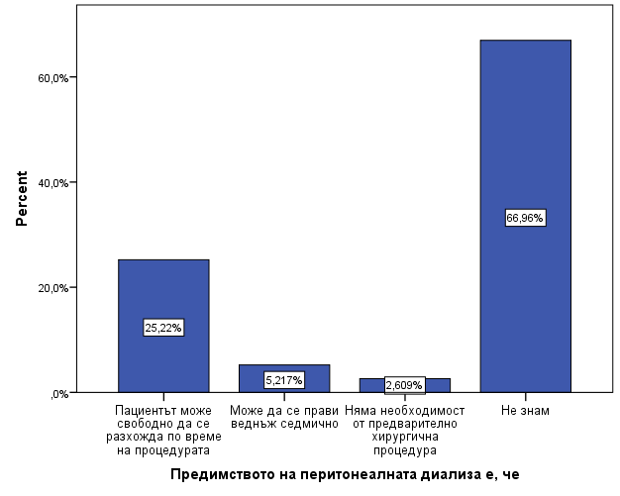
Fig. 73.

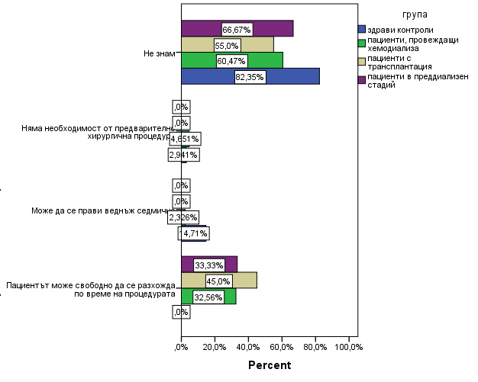
Fig. 74. The advantage of peritoneal dialysis is that: (…) according to the study group

Less than half of the respondents are aware that peritoneal dialysis is a method for "clearing" toxins through the abdominal wall (44.5%) (Fig. 74). A significant difference was found according to the study group (p <0.001). A slight tendency to a moderate relationship between the two indicators was also found (r = 0.281; p = 0.002) (Fig. 75). No significant difference was found according to gender and educational level.
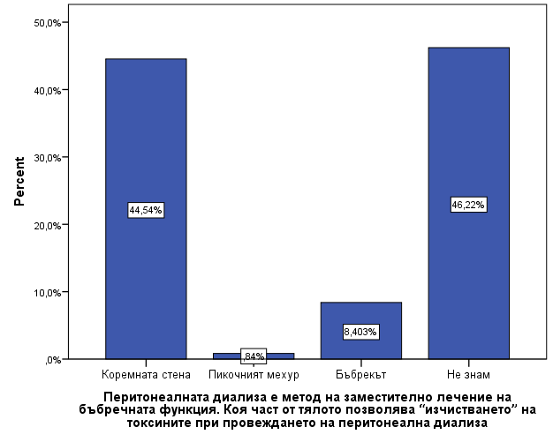
Fig. 74.

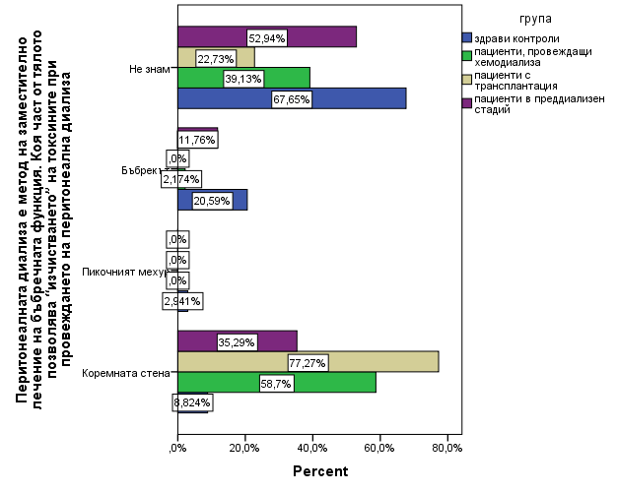
Fig. 75. Peritoneal dialysis is a method of replacement treatment of renal function. Which part of the body allows the "cleansing" of toxins during peritoneal dialysis, according to the study group

Half of the subjects were unfamiliar with the peritoneal dialysis procedure (53.4%) (Fig. 76).

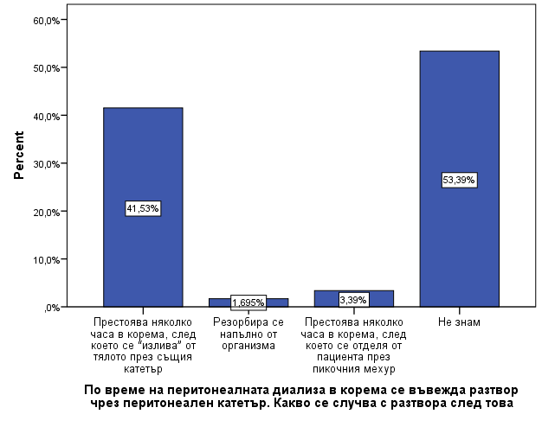
Fig. 76.

There was a significant difference in the awareness of the subjects about the nature of the procedure for peritoneal dialysis (p <0.001), as well as moderate dependence (r = 0.362; p <0.001) (Fig. 77). The most informed are the patients with transplantation (63.6%), followed by those who perform hemodialysis (54.4%).

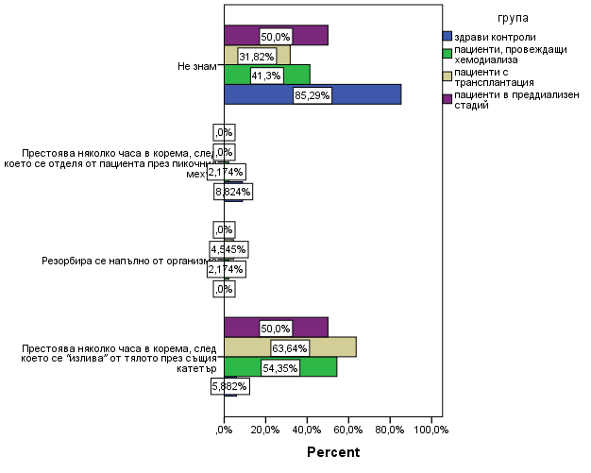
Fig. 77. During peritoneal dialysis, a solution is introduced into the abdomen through a peritoneal catheter. What happens to the solution after that?

More than 1/3 (36.1%) are of the opinion that patients on periotneal dialysis do not have a better quality of life than those on hemodialysis and kidney transplantation (Fig. 78). A significant difference was found between the subjects' opinions on the quality of life in patients undergoing peritoneal dialysis (p = 0.002) (Fig. 79). The largest relative share of people with a negative opinion is that of transplant patients (63.6%). Another significant difference that was found in the opinion about the quality of life is in terms of educational level (p = 0.002), as people with higher education have the highest share of negative answers (60.5%) (Fig. 80).

Fig. 78.

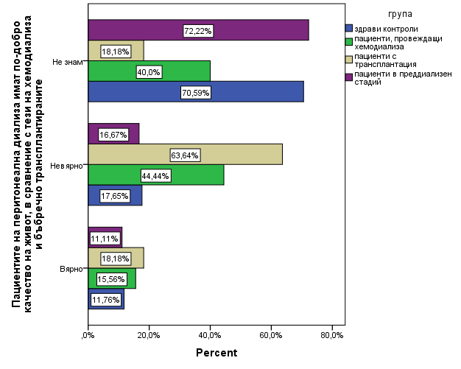
Fig. 79. Peritoneal dialysis patients have a better quality of life than hemodialysis and kidney transplant patients according to the study groups.
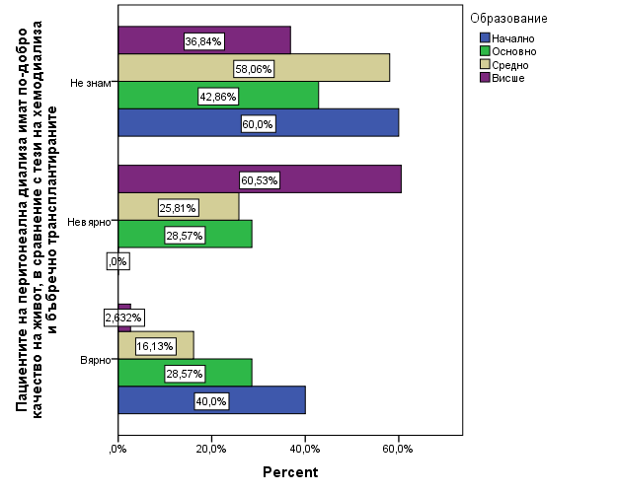
Fig. 80. Peritoneal dialysis patients have a better quality of life than hemodialysis and renal transplant recipients, according to education

A significant proportion of respondents believe that kidney transplantation is the best method of replacement therapy for renal function, which offers the best quality of life (89.7%) (Fig. 81). It is impressive that there is no difference in the opinion of the surveyed persons according to the group to which they belong, but there is a difference in their opinion regarding the educational degree (p = 0.002), and a weak dependence was found between the two indicators (r = 0.242 ; p = 0.008).

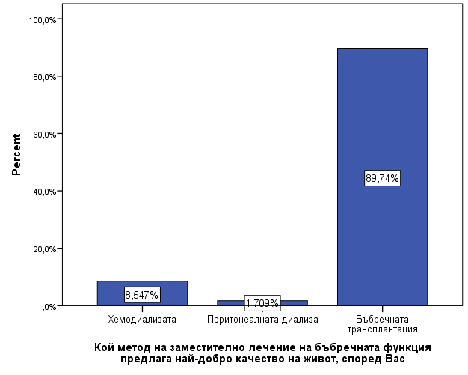
Fig. 81.

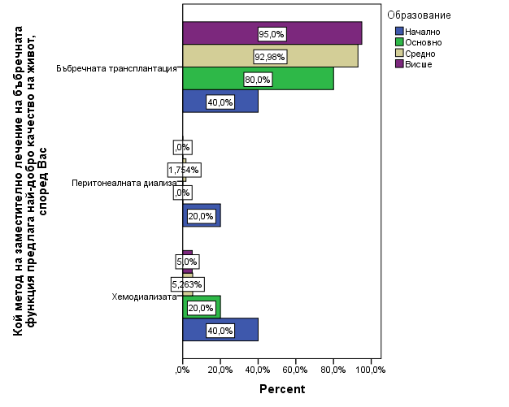
Fig. 82. Which method of renal replacement therapy offers the best quality of life, according to educational degree
DISCUSSION

Patients with kidney disease, whether monitored on an outpatient basis, at hemodialysis centers, or on regular hospital visits to a nephrologist, have different levels of health culture and transplant awareness. The first step in the present study is to create a reliable and objective tool that is able to accurately measure health awareness among the selected population.
The resources used to research and create a working model include ideas, textbooks and aids, videos and brochures that can be used by primary and secondary care practitioners and could reduce the health literacy requirements of their patients. Internet search engines such as Google scholar, Research Gate, PubMed were reviewed as information databases using keywords such as "health culture", "awareness", "patient education", "kidney transplantation". The search focused on identifying health education materials related to the specific features of the research problem in this paper, rather than a comprehensive assessment of health culture, as this is outside the scope of this toolkit, unlike other related studies aimed at determining the level. of the general health culture of the population (DeWalt et al, 2010), (Baur, C. et al 2011).
Based on the analysis, the model that is most suitable for the current research work was determined - The Rotterdam Renal Replacement Knowledge-Test (R3K-T) (Ismail S.Y et al 2011). In order to carry out correct validation, the Cronbach’s reliability coefficient was calculated for each of the five parts of the developed survey.Установи се, че надеждността на модифицирания въпросник по отношение на общите въпроси за ХБЗ е по-голяма в сравнение с тази на разработения от Ismail S.Y и колектив оригинален въпросник (съответно Cronbach’α = 0.673 за собственото изследване и Cronbach’α =0.37 за R3K-T).
В частта с въпросите оценяващи информираността за бъбречната трансплантация надеждността на двата въпросника се доближава, като в собственото изследване коефициентът е малко по-нисък (съответно Cronbach’α = 0.824 за собственото изследване и Cronbach’α =0.86 за R3K-T).
The reliability of the questions used in the section examining patients' awareness of hemodialysis in the present study was higher than that of R3K-T (Cronbach'α = 0.593 for own study and Cronbach'α = 0.41 for R3K-T, respectively).
On the other hand, the reliability in terms of the study of patients' awareness of peritoneal dialysis in both questionnaires is the same.
For the quality of life survey questions, the reliability of both questionnaires was low, with the modified questionnaire characterized by lower reliability (Cronbach’α = 0.404 for own study and Cronbach’α = 0.59 for R3K-T, respectively). This can be explained by the fact that quality of life assessment is a comprehensive area for which specially designed questionnaires are used. On the other hand, the results are reliable enough to give researchers the necessary information on how patients, based on the overall information base and knowledge they have, assess quality of life.

Summary of the level of awareness of the respondents

The global epidemic of kidney disease reciprocally continues to grow in parallel with chronic conditions such as diabetes, hypertension, and obesity (Szczech LA, et al. 2009). To summarize from the present study, it is noteworthy that the majority of respondents (81.5%) make a link between the increasing rate of chronic non-communicable diseases (such as diabetes) and the increased risk of developing kidney damage (the highest percentage of correctly the respondents were people with higher educational qualifications (p = 0.027) A similar study by Benjamin O. et al in 2021 confirmed this thesis, according to Oguma Y et al (2004) and subsequently Löllgen H et al. ) the higher frequency of correct respondents is probably due to the fact that diabetes enjoys wider public attention and more information campaigns, which makes people perceive it as a risk factor for other diseases.
However, the overall health awareness of the respondents regarding chronic kidney disease remains low. Based on the data obtained from the statistical analysis, it was found that the respondents have low knowledge of key symptoms and syndromes in the manifestation of kidney disease. While the majority understands the relationship between systemic salt use and the development of CKD, other equally important factors such as obesity, smoking and systemic use of painkillers and alcohol remain unclear to nearly 1/3 of respondents. In a related study, Vassilevski and colleagues (2010) found that 23.2% of the population consumed alcohol regularly and 13.8% consumed it every day, and this percentage of people did not associate these harmful habits with an increased incidence of chronic kidney disease.
An interesting observation is the fact that 1/3 of the respondents associate kidney disease only with the presence of pain. The percentage of ignorant people is mainly in healthy controls, but it is noteworthy that it occurs in dialysis patients (27%) and in nearly 30% of patients in the pre-dialysis stage, which indicates a serious misunderstanding of their own disease. Such a pattern was also found in a study by Takure, A. O and team (2016) among a population of hemodialysis patients in Nigeria, a phenomenon that was not found by Ismail S.Y et al 2011 in the development of R3K-T in Norway. This would also explain why kidney disease is mainly associated with kidney stones or kidney crisis. Regarding this part of the surveyed hemodialysis patients, who answered positively to this question, after further research it was found that the cause that led to TBZ of these individuals was BKB and chronic tubulo-interstitial nephritis, which may explain their association.
The belief regarding proteinuria as a normal phenomenon (the presence of "foam" in the excreted urine) is similar. 60% of healthy controls do not know the answer to this question, and again over 20% of dialysis patients consider this to be normal.
Another finding was that only 68.8% of respondents confirmed that the kidneys maintained a normal hemoglobin level, with a significant difference in the opinion of patients according to the study groups (p = 0.045). Transplant patients are most informed about kidney function, while in the group of patients who do not know this information, healthy controls have the largest relative share. It is noteworthy that even in the group of dialysis patients receiving hemodialysis treatment, only 56.7% understand the relationship between anemia and ESRD (although all undergo replacement therapy with ECA). This finding also confirms the results in the literature database that hemodialysis patients are widely affected by low health culture, a study by Gazmararian, J et al, 2003.
The observed trend of limited health literacy in kidney disease not only among healthy controls but among the dialysis population is a phenomenon that is often described in other studies - Cavanaugh KL et al. 2010. This finding is also confirmed in the present study. The prevalence of limited health literacy in this study is similar to that described in other, smaller studies in patients undergoing dialysis replacement therapy, specifically hemodialysis (Grubbs V, Gregorich SE, Perez-Stable EJ, 2009), (Pollock JB , Jaffery JB, 2007) and also reflects findings similar to the general population.
Predictors of limited health literacy in hemodialysis patients, such as education and ethnicity, are similar to those in patients with other chronic diseases (Paasche-Orlow MK et al. 2005). In addition, in the present study, “signals” were found in hemodialysis patients who were reluctant to complete the questionnaire due to a sense of embarrassment at not knowing the answers described in a similar study by Cavanaugh KL et al. (2015) among 254 dialysis patients. Reactions such as "I do not wear glasses", "my hands are shaking" or "I have vision problems" were common among the interviewed patients, and are a possible expression of concomitant depressive syndrome (Todorova T., Paskalev D., 2017).
The huge number of studies showing that kidney transplantation is better than dialysis due to the longer and better quality of life it provides, (United States Renal Data System. 2019 USRDS), (Ogutmen B, Yildirim A, 2006), (von der Lippe N et al, 2014) are also confirmed by our study. The results confirm these data, with 89.7% of those surveyed believing that kidney transplantation is associated with a better quality of life. However, most patients with CKD still start directly with, and often remain on, dialysis.
The results of the study show that patients who remain on dialysis and those with CKD are not well informed about their choice of treatment and have suboptimal levels of knowledge about different types of treatment or believe in myths about transplantation and dialysis due to lack of accurate information. for their benefits and risks (Hays R, Waterman AD., 2008). For these reasons, improving knowledge about the types of substitution treatment and making informed decisions for all patients with CKD is crucial.
Some curious findings among the analyzed answers confirm the thesis of low health culture.
Respondents' opinion on the preservation of renal function in the donation of 1 kidney is mixed. A high rate of uncertainty was found, both among healthy individuals and among patients with CKD in the pre-dialysis and dialysis stages. There was a significant difference in the opinion of the respondents in the studied groups (p = 0.004), as the patients with transplantation are logically most familiar with the preservation of renal function after kidney donation and transplantation. The explanation for this is that most of them were transplanted from a living donor. The low percentage of those who answered correctly among the patients with CKD G1-G4 and those on hemodialysis, who are also the potential candidate recipients, is impressive. A similar phenomenon was observed by Finkelstein FO et al. in 2018. In addition, again, people with higher education are most aware that donating a kidney does not lead to loss of kidney function.
Very large gaps in health awareness among all groups of respondents were found in the part of the survey concerning the legal aspect of kidney transplantation. Only half (55.7%) are aware that by law kidney transplantation in Bulgaria is allowed in a relationship between donor and recipient (recipient) to the first lateral line (first cousin) or between spouses with at least 3 years of legal relationship, or in other words are aware of the cases in which BT can be performed between "relatives". The percentage of those who do not know is again formed by healthy respondents and patients in the pre-dialysis stage. Again in this column the statement about low health culture was confirmed and among the dialysis patients - 2/3 do not know the correct answer. Green, J. A et al., Conducted a 2013 survey of a dialysis population of 146 patients on the legislative aspect of this procedure, also found a similarly high rate of ignorance among prospective recipients - 52.6%. An interesting fact that was established in the present study is that among transplant patients there are those who are not familiar with the legislative system of Bulgaria on organ transplantation. A possible explanation for this result is that some BT survivors have been transplanted abroad.
A key gap in the health literacy of all four groups is that only 19.5% of the respondents know the definition of cross-donation. Patients with a kidney transplant know the correct meaning of cross-donation (p <0.001), which is logical given the fact that these patients are familiar with the procedure given their treatment. A significant difference in the opinion about cross-donation is also established with regard to the educational degree (p = 0.028), as the persons with higher education are most familiar with the essence of cross-donation. Also, less than 20% of respondents are aware that cross-donation is legal in Bulgaria. There was a significant difference in the opinion of the respondents in the four studied groups (p = 0.003), which shows that even transplant patients are not well informed about the legal conduct of cross-donation.
The results obtained so far show the great need to create strategies to raise patients' awareness about kidney transplantation. The established limited health literacy not only among healthy controls, but especially among dialysis and pre-dialysis patients, is probably also a result of limited access to health information and care. This in turn can be a significant barrier for patients to learn adequately about their disease and may partly explain the observed trends in limiting the number of successful kidney transplants with a relatively constant increase in hemodialysis patients. (Cavanaugh KL, Wingard RL, et al., 2009).
In a study by Vasileva V. (2021) among patients undergoing hemodialysis in 10 different dialysis centers (private and public) it was found that only 9.5% of them share the systematic conduct of health education. On the other hand, 58.1% of the surveyed patients indicated that they had not received any theoretical training during the waiting period for the kidney transplantation, and no pre-transplantation training program had been developed in the studied non-university dialysis centers.
The results of the present study confirm those of V. Vasileva that patients who are undergoing BT or have already undergone transplantation are most informed about issues related to the nature of the procedure, risk factors, innovations in the treatment process and legislation.
According to the results of the present study, patients undergoing BT are best acquainted with the influence of risk factors such as smoking, alcohol and salty foods, being overweight and taking certain medications. V. Vasileva also reports an unsatisfactory level of awareness and health culture among the studied dialysis patients, as 59% have difficulties in controlling bad habits, 76.2% have a problem with adherence to the diet for people with CKD, and 61.9% lead - recently sedentary lifestyle (Vasileva V., 2021). These conclusions can be made in our development. Among hemodialysis patients, gaps in health awareness were identified on issues such as recommended daily water intake, belief in comparability between hemodialysis and healthy kidney function, and misunderstanding of the relationship between frequent analgesic intake and renal impairment.
Early identification of uninformed CBD patients is crucial to personalize the approaches needed to reduce illiteracy, and identifying new risk factors can guide new care strategies. Health literacy can be an important factor in the care of patients with kidney disease. There are few studies characterizing health literacy and examining the relationship between literacy and health outcomes in patients with kidney disease. (Devraj R, et al. 2009), (Coresh J, Selvin E, Stevens LA, 2007).
Patients with lower health literacy may be less likely to find out about their kidney disease, less likely to be referred in a timely manner for nephrological care and treatment, and often reach the need for replacement therapy. emergency hemodialysis treatment. In a study of patients in primary care, all of whom had or were at high risk of chronic kidney disease (diabetes, hypertension or familial burden), it was found that low health literacy was associated with poor awareness of to the patient about the possibility of developing chronic kidney disease. (Boulware LE, et al., 2009). Despite the lack of specific data on this issue, it can be assumed that based on the established low health culture and healthy controls are threatened by the development of CKD, which will be detected late. With regard to the dialysis population, a similar conclusion can be drawn due to the fact that the majority of patients started emergency dialysis using a vascular catheter and not through the permanent arteriovenous access typical of "prepared patients".
The mechanisms by which a patient's literacy level can directly affect his or her own health and risk of death are different, for example: in-depth knowledge of the specific disease, improved communication with health authorities, and ultimately greater self-involvement. and personal responsibility for one's own health and life. (Devraj R, 2009). The problem is that in Bulgaria the paternalistic model of healthcare is still widespread - the specialist dictates the course of treatment, and the patient "blindly" follows it without committing to his problem. Even the lack of basic skills such as the ability to read and write is becoming common in clinical practice. During our study, we came across a total of 14 people who could not read / write and needed help in completing the questionnaire (10 people on hemodialysis, 3 with CKD G1-G4 and one from the group of healthy controls). The latter also serves as a basis to confirm the thesis that the dialysis population, along with healthy controls, demonstrates the lowest level of health awareness - a fact that directly affects adherence to the peculiarities of dialysis treatment, compliance with specific dietary recommendations and subsequently predetermines successful transition. to kidney transplantation (Cavanaugh KL, 2009), (Ford JC, Pope JF, Hunt AE, Gerald B 2004), (Gorban-Brennan N, et al., 2004).
However, the question of who will inform patients with CKD remains controversial. On the one hand, the nurse spends more time with patients performing the individual manipulations, on the other hand, the nephrologist has the necessary knowledge about the risk factors, the current condition of the patient and possible alternatives for treatment and prognosis of the disease. For this reason, clinicians need a useful tool to implement strategies that support the care of people with limited health literacy. Printed materials are commonly used to educate patients about self-care recommendations; however, many materials do not follow clear guidelines for communication and are written at a high and inaccessible level of reading, which can be a barrier to information for patients with limited health literacy. (Hill-Briggs F, et al, 2008).
The development and pilot testing of a Guide for CKD Patients suggests that the research team has identified the key content of current knowledge and resources in the field of health literacy and has configured the information in a way that is practically useful. The team also learned that carrying out these actions in practice requires a significant commitment from medical professionals and is likely to take several months to implement, as new protocols and procedures need to be adopted. For this reason, in order to avoid conflict situations, we made recommendations and guidelines for the creation of a Guide for people with CKD.

Development of a Guide for Patients with Chronic Kidney Disease and treatment methods based on which the patient can make an informed choice

With the development of technology and raising patient awareness, as well as WHO recommendations for the prevention of socially significant and chronic non-communicable diseases, as well as good medical practice for many diseases, various information materials have been created for patients.
On the other hand, despite the increasing incidence of chronic kidney disease and the many complications associated with their late diagnosis, this group does not fall into the National Program for Prevention of Chronic Noncommunicable Diseases (2014 - 2020). 2014 - 2020).
According to global experience and data, efforts to control chronic kidney disease have shown significant results after investing in prevention in many countries. Experience has shown that limiting the main risk factors leads to a significant reduction in morbidity and mortality from this disease, respectively to a reduction in the disability of those patients, who at some point become a burden on the health, social and economic systems.
The most effective way to achieve this goal is prevention in the form of integrated care programs to reduce risk factors, early diagnosis, treatment and rehabilitation of patients, and improve quality of life.
Integrated care for patients with chronic kidney disease may be one of the most effective approaches to addressing the problems of this cohort of patients. These concerns combine different professionals and strategies, and can be used in policy making, networking partnerships and information support at all levels. In integrated care, there is a collaboration between the various components of health and social systems, such as health promotion, social services, and health care offered in pre-hospital and hospital care. They include cross-cutting actions that implement health policies, including coordinated actions addressing the main determinants of health.
The basis of prevention programs is the limitation of risk factors. Early public awareness of chronic kidney disease aims to reduce the impact of risk factors and lead a healthy lifestyle through a number of measures. Awareness has a significant effect on both individuals and society as a whole and can lead to behavioral changes leading to "benefits for all".
Based on the results of the study, it was found that patients with chronic kidney disease are not sufficiently informed and there is a need to create a synthesized information database in the form of a Guide, with the main issues and problems regarding risk factors, prevention, treatment and disease follow-up.
The main goal of the guide for patients with chronic kidney disease is to improve the health of these patients and improve their quality of life by reducing complications and disability and increasing the duration of the pre-dialysis stage and overall survival.

PRINCIPLES AND STRATEGIES OF THE PATIENT GUIDE (Table 2)

- Integrated multidisciplinary approach
- Implementation of activities for health promotion, prevention, implementation of intervention modules to reduce risk factors in all age and occupational groups, etc., using different strategies in creating a system for coordination of preventive activities of specialists and their work in a team
- Building a dialogue and partnership with all stakeholders, active involvement of professional and non-governmental organizations and associations, media, etc.
- Using the scientific approach based on modern, scientifically proven facts and concepts; use of the existing scientific knowledge and experience in the field of prevention, creation of models for prevention, development of new research in this direction, provision of new knowledge about the practice, evaluation and control of the results, etc.

Based on the proposed strategies and the collected results, an algorithm plan was prepared for the preparation of a Manual for the patient with chronic kidney disease (Table 2).

Tabl.2

Raising awareness of key aspects of prevention, diagnosis, treatment and follow-up of patients with CKD and types of substitution treatment
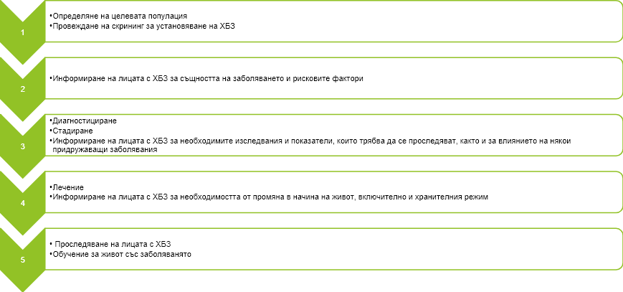

CONCLUSIONS

- The difference in the levels of awareness of the examined persons regarding CKD according to the educational degree and the conducted treatment has been proved, as the persons with higher education and kidney transplantation are the most informed.
- Healthy controls show the lowest levels of awareness regarding CKD, treatment and factors associated with it.
- A significant proportion of respondents do not have a realistic assessment of the impact of risk factors, such as smoking, obesity and the use of painkillers on kidney health.
- Persons with CKD are not fully acquainted with the legislation of the Republic of Bulgaria regarding donation, as more than half of the respondents are not aware of their rights as patients with CKD in terms of payment for medical services and medicines.
- The patients who are about to have a kidney transplant or have already undergone such a procedure are best acquainted with the procedure of kidney donation and transplantation.
- The majority of patients undergoing dialysis treatment are well acquainted with the procedures related to the preparation and conduct of the treatment itself, but cannot distinguish between hemodialysis and peritoneal dialysis.
- Approximately ¾ of the subjects confirm the literature data that kidney transplantation improves the quality of life of patients with CKD compared to other types of replacement therapy.

CONCLUSION

Chronic kidney disease is part of the modern pandemic of chronic, non-communicable diseases, which occupies one of the leading in frequency and cause of death among the world's population. CKD affects nearly 850 million people worldwide and is the 6th leading cause of death. Stagnant lifestyles, bad habits, and increasing incidence of diabetes make the prognosis for kidney disease pessimistic. The financial burden that undiagnosed kidney problems and subsequently end-stage renal disease entails puts even highly developed economies to a severe test. Hemodialysis treatment, for example, as a method of substitution treatment is one of the most financially burdensome health care costs, and the percentage of patients with terminal CKD on hemodialysis is also increasing. These trends call for drastic measures to curb kidney disease.
One of the ways to improve the situation is to raise the health culture of the population on these issues. Studies in this direction show that the health culture of the population in terms of kidney disease, and alternative methods of substitution treatment are extremely low. Health literacy is also low among patients with CKD and dialysis patients, especially when it comes to kidney transplantation. It turns out that a large percentage of patients, candidate recipients, who only after a successful kidney transplant for the first time face some aspects of the posttransplant period, such as continuous immunosuppressive therapy and possible disease complications, for example. This is subsequently a prerequisite for poor cooperation on the part of the patients and, in general, a poor prognosis for the graft and the person.
Determining the current awareness regarding kidney transplantation is important on the overall prognosis of the disease and is a prerequisite for the detection of "pitfalls" in communication with the patient and possible BT, which directly reflects on the quality of life of recipients.
The results of the present work confirmed the hypothesis of low health literacy of the population with regard to chronic kidney disease and methods for replacement therapy of renal function. The established high percentage of ignorance among the pre-dialysis and dialysis patients themselves, who are the future candidate recipients, proved that the need to take measures both locally and nationally is of paramount importance. With the elaboration of the present dissertation the beginning of the creation of a specialized Guide, aimed at the patients themselves, which aims to improve the general health culture of those affected and thus the overall prognosis for those affected by this "silent" pandemic.
CONTRIBUTION

Contributions of a theoretical nature
- A detailed analysis of the nature and role of CKD in terms of public health and the burden it carries on both patients and the health system has been made.
- A detailed review of the literature data on awareness and health literacy of the population about CKD, risk factors, types of treatment and their role in improving the quality of life.
- There is a difference in the awareness of people who are directly affected by the disease and those without health problems.

Contributions of a practical nature
- The main omissions and misconceptions regarding the information and health knowledge of the subjects about the nature of CKD, the treatment, the risk factors, the change in the quality of life and the legislation of the country in connection with organ transplantation are identified.
- An algorithm has been developed and proposed for the preparation of a manual for prevention, diagnosis, treatment and follow-up of patients with CKD.
- The main guidelines in the development of the Guidelines for patients with CKD and the methods of treatment on the basis of which the patient to make an informed choice are presented.

PUBLICATIONS

- Petrov A., Benkova-Petrova M., Staykova S., Petrov P., Nenova D., Dimieva-Dineva J., Koleva T., Zhelyazkov K., Damyanova D., Ivanova B., Ahmed E., Koleva R. Distribution of chronic kidney disease among the population of Varna, Valchi Dol municipality and Avren municipality, Current nephrology, issue. 1, Volume 13, 2019, 16-19
- Petrov A. Awareness as a factor for improving quality of life in patients with chronic kidney diseases. Varna medical forum, T.10, 2021, pp. 5
- Petrov A. General health awareness and culture of persons with chronic kidney diseases and their influence on the treatment process. Varna medical forum, T.10, 2021, pp. 13

