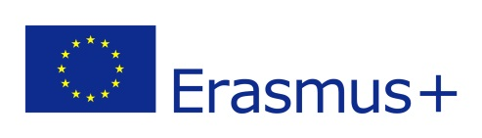 | MEDICAL UNIVERSITY – VARNA  “Prof. Dr. Paraskev Stoyanov”  55, Marin Drinov Str., 9002 Varna, Bulgaria  Tel.: +359 52/ 65 00 57, Fax: +359 52/ 65 00 19  e-mail: uni@mu-varna.bg, www.mu-varna.bg | 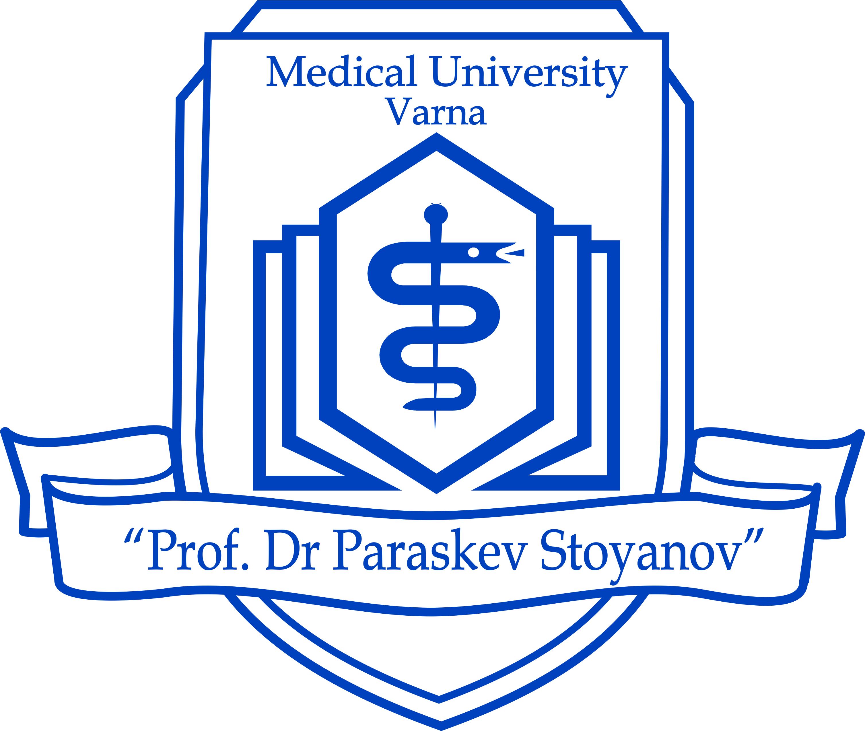

APPLICATION FORM
for incoming Erasmus students

ACADEMIC YEAR 20…./20…..  FIELD OF STUDY: | (Photo)

STUDENT’S PERSONAL DATA
Family name(s): ............................................................................................................................
First name (s): ...............................................................................................................................
Date and Place of Birth: ……………...........................................................................................
Sex: .........................................................Nationality:...................................................................
Permanent address:……………………………..........…………………………………………..
E-mail:…………………………..……………Phone/Mobile:…………...……………..….........

EMERGENCY CONTACT (Fluent in English)
Full name: ………………………………………………………………………………………..
Affinity (eg. mother, friend):……………………………………………………………………..
Phone/Mobile: ………………………………Email:…………………………………………….
Address: ………………………………………………………………………………………….
Type of mobility: Erasmus study mobility  Erasmus traineeship 
Duration of mobility: …………….months
Period of mobility: from (dd/mm/yy)………………… to (dd/mm/yy)………………………
Expected date of arrival in Varna: ……………………………..……….
I need accommodation in students’ dormitory: Yes ☐ No ☐

RECEIVING INSTITUTION
Medical University “Prof. Dr. Paraskev Stoyanov” - Varna
Address: 55, Marin Drinov Str., 9002 Varna, Bulgaria
Erasmus Code: BG VARNA03
Institutional Coordinator: Prof. Todorka Kostadinova, PhD
Phone: +359 52 677 089; E-mail: erasmus@mu-varna.bg

SENDING INSTITUTION
Name:…………………………………………………………………………………………
Address:……………………………………………………………………………………… Erasmus Code:………………………………………………………………………………..
Institutional Coordinator - name, phone, e-mail:………………………….………………….
……………………………………………………………………………………………..….
Departmental Coordinator - name, phone, e-mail: ……………………………………………
…………………………………………………………………………………………………

CURRENT STUDIES (AT SENDING INSTITUTION)
Field of Study: ………………………………………………………………………………..
Study cycle (degree to be obtained): Bachelor ☐ Master ☐ Doctoral (PhD) ☐
Duration of the study programme at sending institution: ……………………………………
Current year of academic study:…………………...................................................................
Please note: Academic Transcripts are required!

LANGUAGE COMPETENCE
Mother tongue:…………………………….

Please indicate your language skills other than mother tongue:
1. Language: …………………….. | Limited A1 ☐ A2 ☐ | Moderate B1 ☐ B2 ☐ | Fluent C1 ☐ C2 ☐
2. Language: …………………….. | Limited A1 ☐ A2 ☐ | Moderate B1 ☐ B2 ☐ | Fluent C1 ☐ C2 ☐
3. Language: …………………….. | Limited A1 ☐ A2 ☐ | Moderate B1 ☐ B2 ☐ | Fluent C1 ☐ C2 ☐

DECLARATION OF CONSENT OF THE STUDENT
I certify that the information given in this application form is correct.
I have taken notice and I agree that the information on this form will be stored electronically and used by Medical University - Varna in accordance with the provisions of the Data Protection Act and Regulation (EU) 2016/679 of the European Parliament and of the Council of 27 April 2016 on the protection of natural persons with regard to the processing of personal data and on the free movement of such data (GDPR) for the purpose of application and participation in the ERASMUS+ Programme.
I take knowledge of the necessary insurance for my Erasmus mobility period at Medical University - Varna: European Health Insurance Card, medical insurance, liability insurance and accident insurance.
If I get accommodation, I will observe the rules and the regulations of the students’ dormitory.

Student's signature:……………………………………………….. Date: …………………………………

