Acid-Base Indicators
Useful Weak Acids and Bases
What is an acid-base indicator?
An acid-base indicator is a weak acid or a weak base. The undissociated form of the indicator is a different color than the iogenic form of the indicator. An Indicator does not change color from pure acid to pure alkaline at specific hydrogen ion concentration, but rather, color change occurs over a range of hydrogen ion concentrations. This range is termed the color change interval. It is expressed as a pH range.
How is an indicator used?
Weak acids are titrated in the presence of indicators which change under slightly alkaline conditions. Weak bases should be titrated in the presence of indicators which change under slightly acidic conditions.
What are some common acid-base indicators?
Several acid-base indicators are listed below, some more than once if they can be used over multiple pH ranges. Quantity of indicator in aqueous (aq.) or alcohol (alc.) solution is specified. Tried-and-true indicators include: thymol blue, tropeolin OO, methyl yellow, methyl orange, bromphenol blue, bromcresol green, methyl red, bromthymol blue, phenol red, neutral red, phenolphthalein, thymolphthalein, alizarin yellow, tropeolin O, nitramine, and trinitrobenzoic acid. Data in this table are for sodium salts of thymol blue, bromphenol blue, tetrabromphenol blue, bromcresol green, methyl red, bromthymol blue, phenol red, and cresol red.
Indicator | pH Range | Quantity per 10 ml | Acid | Base
Thymol Blue | 1.2-2.8 | 1-2 drops 0.1% soln. in aq. | red | yellow
Pentamethoxy red | 1.2-2.3 | 1 drop 0.1% soln. in 70% alc. | red-violet | colorless
Tropeolin OO | 1.3-3.2 | 1 drop 1% aq. soln. | red | yellow
2,4-Dinitrophenol | 2.4-4.0 | 1-2 drops 0.1% soln. in 50% alc. | colorless | yellow
Methyl yellow | 2.9-4.0 | 1 drop 0.1% soln. in 90% alc. | red | yellow
Methyl orange | 3.1-4.4 | 1 drop 0.1% aq. soln. | red | orange
Bromphenol blue | 3.0-4.6 | 1 drop 0.1% aq. soln. | yellow | blue-violet
Tetrabromphenol blue | 3.0-4.6 | 1 drop 0.1% aq. soln. | yellow | blue
Alizarin sodium sulfonate | 3.7-5.2 | 1 drop 0.1% aq. soln. | yellow | violet
α-Naphthyl red | 3.7-5.0 | 1 drop 0.1% soln. in 70% alc. | red | yellow
p-Ethoxychrysoidine | 3.5-5.5 | 1 drop 0.1% aq. soln. | red | yellow
Bromcresol green | 4.0-5.6 | 1 drop 0.1% aq. soln. | yellow | blue
Methyl red | 4.4-6.2 | 1 drop 0.1% aq. soln. | red | yellow
Bromcresol purple | 5.2-6.8 | 1 drop 0.1% aq. soln. | yellow | purple
Chlorphenol red | 5.4-6.8 | 1 drop 0.1% aq. soln. | yellow | red
Bromphenol blue | 6.2-7.6 | 1 drop 0.1% aq. soln. | yellow | blue
p-Nitrophenol | 5.0-7.0 | 1-5 drops 0.1% aq. soln. | colorless | yellow
Azolitmin | 5.0-8.0 | 5 drops 0.5% aq. soln. | red | blue
Phenol red | 6.4-8.0 | 1 drop 0.1% aq. soln. | yellow | red
Neutral red | 6.8-8.0 | 1 drop 0.1% soln. in 70% alc. | red | yellow
Rosolic acid | 6.8-8.0 | 1 drop 0.1% soln. in 90% alc. | yellow | red
Cresol red | 7.2-8.8 | 1 drop 0.1% aq. soln. | yellow | red
α-Naphtholphthalein | 7.3-8.7 | 1-5 drops 0.1% soln. in 70% alc. | rose | green
Tropeolin OOO | 7.6-8.9 | 1 drop 0.1% aq. soln. | yellow | rose-red
Thymol blue | 8.0-9.6 | 1-5 drops 0.1% aq. soln. | yellow | blue
Phenolphthalein | 8.0-10.0 | 1-5 drops 0.1% soln. in 70% alc. | colorless | red
α-Naphtholbenzein | 9.0-11.0 | 1-5 drops 0.1% soln. in 90% alc. | yellow | blue
Thymolphthalein | 9.4-10.6 | 1 drop 0.1% soln. in 90% alc. | colorless | blue
Nile blue | 10.1-11.1 | 1 drop 0.1% aq. soln. | blue | red
Alizarin yellow | 10.0-12.0 | 1 drop 0.1% aq. soln. | yellow | lilac
Salicyl yellow | 10.0-12.0 | 1-5 drops 0.1% soln. in 90% alc. | yellow | orange-brown
Diazo violet | 10.1-12.0 | 1 drop 0.1% aq. soln. | yellow | violet
Tropeolin O | 11.0-13.0 | 1 drop 0.1% aq. soln. | yellow | orange-brown
Nitramine | 11.0-13.0 | 1-2 drops 0.1% soln in 70% alc. | colorless | orange-brown
Poirrier's blue | 11.0-13.0 | 1 drop 0.1% aq. soln. | blue | violet-pink
Trinitrobenzoic acid | 12.0-13.4 | 1 drop 0.1% aq. soln. | colorless | orange-red
Primary References:
Lange's Handbook of Chemistry, 8th Edition, Handbook Publishers Inc., 1952.
Volumetric Analysis, Kolthoff & Stenge, Interscience Publishers, Inc., New York, 1942 and 1947.
Titrations
How can we know the concentration of some solution of interest? One answer to this problem lies in the method of titration. In titration we will make use of a second solution known as a standard solution which has the following characteristics:
- The second solution contains a chemical which reacts in a defined way, with known stoichiometry, with the solute of the first solution
- The concentration of the solute in this second solution is known.
Classic titrations include so-called acid-base titrations. In these experiments a solution of an acid with an unknown concentration is titrated with a solution of known concentration of base (or vice versa). For example, we may have a solution of hydrochloric acid (HCl) of unknown concentration and a standard solution of NaOH. To a fixed amount of the HCl solution is added incremental amounts of the NaOH solution until the acid is completely neutralized - i.e. a stoichiometrically equivalent quantity of HCl and NaOH have been combined. This is known as the equivalence point in the titration. By knowing the concentration of the standard solution, and the amount added to achieve stoichiometric equivalency, we can determine the amount of moles of HCl in the original sample volume.
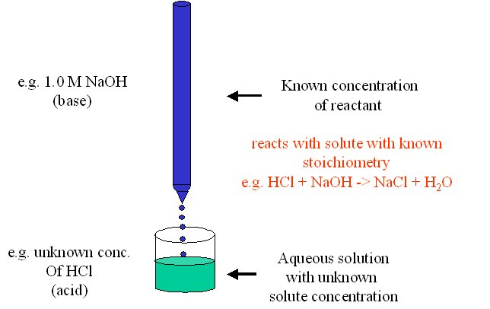
How do we know when we have reached the equivalence point in such a titration experiment? In this type of acid-base titration, so called indicator-dyes are used. For example phenolphthalein is colorless in acidic solutions and turns red in basic solutions. Thus, in the above experiment we will add a small amount of this indicator-dye and add base until we barely begin to see a color change to red.
Mike's Handy Science Tip
Phenolphthalein is not only useful in acid-base titrations, but its also a darn good laxative used to be the active ingredient in ExLax. Just thought you'd like to know...
25 mls of a solution of HCl with an unknown concentration is titrated with a standard solution of 0.5 M NaOH. The phenolphthalein indicator dye begins to turn color after the addition of 2.8 mls of standard solution. What is the concentration of the HCl?
Balanced equation for the reaction:
HCl + NaOH -> NaCL + H₂O
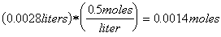of NaOH was added
Since the stoichiometry of the NaOH and HCl is 1:1, the sample of HCl must have contained 0.0014 moles of HCl. The concentration of the HCl solution is therefore:
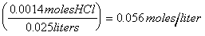, or 0.056 M
