Solution Chemistry
Assoc. Prof. Lubomir Makedonski, PhD
Medical University of Varna

Lecture’s Objective

Solution
- General Properties of solution
- Solvents Other Than Water

Factors Affecting Solubility of a Solute
- Strength of Solutions

Solution Concentration
- Colligative properties of solutions
General Properties
A solution is a homogeneous mixture of two or more substances evenly distributed in each other. A liquid solution consists of two parts: the solid, liquid, or gaseous material that has dissolved the solute, and a liquid material in which it has dissolved the solvent.
When a crystal of salt is placed in water, which is then stirred, the crystal dissolves and a clear solution is formed. When more salt is added to salt-water solution, it too dissolves, making the solution more concentrated than the previous one. Even more salt can be dissolved in the water to make it a much more concentrated salt solution. Thus, one of properties of solutions is that they have a variable composition.
When salt dissolved in water to make salt water, the solution formed is clear and colorless. When sugar is dissolved in water, again a clear, colorless solution is formed. When copper sulfate is dissolved in water, it also forms a clear solution. However, the solutions formed with the salt and the sugar are colorless, whereas that formed with cooper sulfate is blue. Solutions are always clear. They may or may not have a color. Clear merely means that the solution is transparent to light.
When a solution is allowed to stand undisturbed for a long period of time, no crystals of solute settle out, provided the solvent is not allowed to evaporate. This is another property of solutions – the solute not settle out.
The salt in salt – water solution can be recovered by allowing the water to evaporate; the same is true of the sugar in a sugar solution. In general, solutions can be separated by physical means.

The properties of solutions are summarized as follows:
- Solutions consist of s soluble materials (the solute) dissolved in a liquid (the solvent)
- Solutions have a variable composition
- Solutions are clear
- Solution are homogeneous
- Solutions can be separated by physical means

Solvents Other Than Water

Solvents other than water are also used. One common solvent used in hospitals is alcohol. An alcohol solution used medically is called a tincture. Tincture of iodine contains iodine dissolved in alcohol. Tincture of green soap contains potassium soap dissolved in alcohol.

Factors Affecting Solubility of a Solute

Temperature

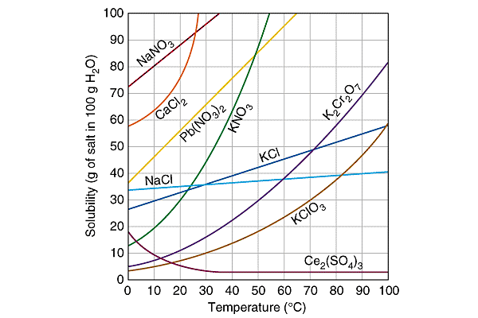

Most solid solutes are more soluble in hot water than in cold water. Figure shows that KNO₃ becomes much more soluble as the temperature increases; NaCl shows little change in solubility.

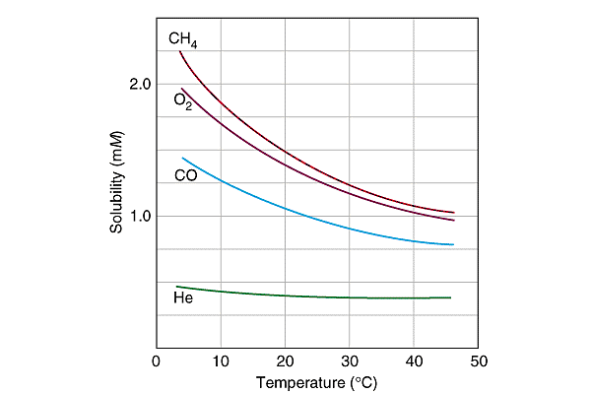

Gases dissolve in liquids like solids, but usually have much simpler behavior. For example, gases are less soluble at high temperature than at low temperature.
Pressure
A change in pressure has no noticeable effect on the solubility of a solid or liquid solute in a given solvent but will affect the solubility of a gaseous solute. The greater the pressure, the greater the solubility of a gas in a liquid.
Surface Area
Although surface area does not affect the amount of solute that will dissolve, it does affect the rate of dissolution. The greater the amount of surface area, the quicker a solute will dissolve in a solvent. Thus, to make a solid solute dissolve faster we frequently powder it, thereby increasing the surface area.
Stirring
The rate at which a solute dissolves can also be increased by stirring the mixture. The process of stirring brings fresh solvent into contact with the solute and so permits more rapid solution.

Nature of Solvent
In general, polar liquids dissolve polar compounds and nonpolar liquids dissolve nonpolar compounds. Water is a polar liquid and dissolves polar compounds such as sodium chloride (NaCl).
A special type of alloy consists of a metal dissolved in mercury, a liquid metal. An alloy containing mercury is called an amalgam. If silver is dissolved in mercury, a silver amalgam is produced. This substance was used in dental work to fill a cavity in a tooth.
Strength of Solutions
Saturated
Suppose a small amount of salt is placed in a beaker of water. When the mixture is stirred, all the salt will dissolve. If more and more salt is added with stirring, a point will soon be reached where some of the salt settles to the bottom of the beaker. This type of solution is called a saturated solution.
Unsaturated

An unsaturated solution contains less of a solute than it could hold under normal conditions. Suppose that a saturated solution of glucose in a certain amount of water contains 25 g of glucose. An unsaturated glucose solution would be one that contained less than 25 g of glucose in the same amount of water.

Supersaturated

Under certain conditions a solvent can be made to dissolve more solute than its saturated solution can hold under the same conditions. A supersaturated solution can be prepared by adding excess solute to s saturated solution, heating that mixture, filtering off the excess solute, and then allowing the liquid to cool slowly.

