ALDEHYDES AND KETONES
Assoc. Prof. Lubomir Makedonski,PhD
Medical University of Varna

Aldehydes and ketones as carbonyl compounds
Aldehydes and ketones are simple compounds which contain a carbonyl group - a carbon-oxygen double bond. They are simple in the sense that they don't have other reactive groups like -OH or -Cl attached directly to the carbon atom in the carbonyl group - as you might find, for example, in carboxylic acids containing -COOH.
Examples of aldehydes
In aldehydes, the carbonyl group has a hydrogen atom attached to it together with either
- a second hydrogen atom
- or, more commonly, a hydrocarbon group which might be an alkyl group or one containing a benzene ring.
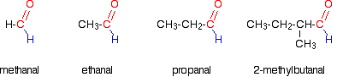
Notice that these all have exactly the same end to the molecule. All that differs is the complexity of the other group attached.
The name counts the total number of carbon atoms in the longest chain - including the one in the carbonyl group. If you have side groups attached to the chain, notice that you always count from the carbon atom in the carbonyl group as being number 1
Names
Aldehydes
All aldehydes contain the group:
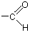
The names of aldehydes end in al.
Examples of ketones
In ketones, the carbonyl group has two hydrocarbon groups attached. Again, these can be either alkyl groups or ones containing benzene rings. Again, we'll concentrated on those containing alkyl groups just to keep things simple.
Notice that ketones never have a hydrogen atom attached to the carbonyl group.
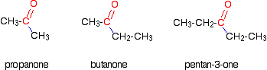
Propanone is normally written CH3COCH3. Notice the need for numbering in the longer ketones. In pentanone, the carbonyl group could be in the middle of the chain or next to the end - giving either pentan-3-one or pentan-2-one.
Names
Ketones
Ketones contain a carbon-oxygen double bond just like aldehydes, but this time it's in the middle of a carbon chain. There isn't a hydrogen atom attached to the group as there is in aldehydes.
Ketones are shown by the ending one.

Bonding and reactivity
Bonding in the carbonyl group
Oxygen is far more electronegative than carbon and so has a strong tendency to pull electrons in a carbon-oxygen bond towards itself. One of the two pairs of electrons that make up a carbon-oxygen double bond is even more easily pulled towards the oxygen. That makes the carbon-oxygen double bond very highly polar.
Important reactions of the carbonyl group
The slightly positive carbon atom in the carbonyl group can be attacked by nucleophiles. A nucleophile is a negatively charged ion (for example, a cyanide ion, CN⁻), or a slightly negatively charged part of a molecule (for example, the lone pair on a nitrogen atom in ammonia, NH₃).
During the reaction, the carbon-oxygen double bond gets broken. The net effect of all this is that the carbonyl group undergoes addition reactions, often followed by the loss of a water molecule. This gives a reaction known as addition-elimination or condensation
Where aldehydes and ketones differ
An aldehyde differs from a ketone by having a hydrogen atom attached to the carbonyl group. This makes the aldehydes very easy to oxidizes
For example, ethanal, CH₃CHO, is very easily oxidized to either ethanoic acid, CH₃COOH, or ethanoate ions, CH₃COO⁻.
Ketones don't have that hydrogen atom and are resistant to oxidation. They are only oxidised by powerful oxidising agents which have the ability to break carbon-carbon bonds.

Physical properties
Boiling points
Methanal is a gas (boiling point -21°C), and ethanal has a boiling point of +21°C. That means that ethanal boils at close to room temperature.
The other aldehydes and the ketones are liquids, with boiling points rising as the molecules get bigger.
The size of the boiling point is governed by the strengths of the intermolecular forces.
Solubility in water
The small aldehydes and ketones are freely soluble in water but solubility falls with chain length. For example, methanal, ethanal and propanone - the common small aldehydes and ketones - are miscible with water in all proportions.
The reason for the solubility is that although aldehydes and ketones can't hydrogen bond with themselves, they can hydrogen bond with water molecules.
One of the slightly positive hydrogen atoms in a water molecule can be sufficiently attracted to one of the lone pairs on the oxygen atom of an aldehyde or ketone for a hydrogen bond to be formed.
There will also, of course, be dispersion forces and dipole-dipole attractions between the aldehyde or ketone and the water molecules.
Forming these attractions releases energy which helps to supply the energy needed to separate the water molecules and aldehyde or ketone molecules from each other before they can mix together.
As chain lengths increase, the hydrocarbon "tails" of the molecules (all the hydrocarbon bits apart from the carbonyl group) start to get in the way.
By forcing themselves between water molecules, they break the relatively strong hydrogen bonds between water molecules without replacing them by anything as good. This makes the process energetically less profitable, and so solubility decreases.
MAKING ALDEHYDES AND KETONES
Oxidising alcohols to make aldehydes and ketones
If you now think about where they are coming from, you will get an aldehyde if your starting molecule looks like this:
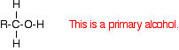
In other words, if you start from a primary alcohol, you will get an aldehyde.
You will get a ketone if your starting molecule looks like this:
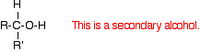
. . . where R and R' are both alkyl groups.
Secondary alcohols oxidise to give ketones.
Making aldehydes
Aldehydes are made by oxidising primary alcohols. There is, however, a problem.
The aldehyde produced can be oxidised further to a carboxylic acid by the acidified potassium dichromate(VI) solution used as the oxidising agent. In order to stop at the aldehyde, you have to prevent this from happening.
To stop the oxidation at the aldehyde, you . . .
- use an excess of the alcohol. That means that there isn't enough oxidising agent present to carry out the second stage and oxidise the aldehyde formed to a carboxylic acid.
- distil off the aldehyde as soon as it forms. Removing the aldehyde as soon as it is formed means that it doesn't stay in the mixture to be oxidised further.
- If you used ethanol as a typical primary alcohol, you would produce the aldehyde ethanal, CH₃CHO.
The full equation for this reaction is fairly complicated, and you need to understand about electron-half-equations in order to work it out.
Secondary alcohols
Secondary alcohols are oxidised to ketones. There is no further reaction which might complicate things. For example, if you heat the secondary alcohol propan-2-ol with sodium or potassium dichromate(VI) solution acidified with dilute sulphuric acid, you get propanone formed.
Playing around with the reaction conditions makes no difference whatsoever to the product.
Using the simple version of the equation:
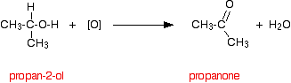
SIMPLE ADDITION TO ALDEHYDES AND KETONES
This page looks at the addition of hydrogen cyanide and sodium hydrogensulphite (sodium bisulphite) to aldehydes and ketones.
Addition of hydrogen cyanide to aldehydes and ketones
The reactions
Hydrogen cyanide adds across the carbon-oxygen double bond in aldehydes and ketones to produce compounds known as hydroxynitriles. These used to be known as cyanohydrins.
For example, with ethanal (an aldehyde) you get 2-hydroxypropanenitrile:
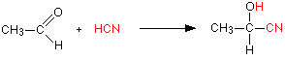
With propanone (a ketone) you get 2-hydroxy-2-methylpropanenitrile:
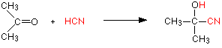
The reaction isn't normally done using hydrogen cyanide itself, because this is an extremely poisonous gas. Instead, the aldehyde or ketone is mixed with a solution of sodium or potassium cyanide in water to which a little sulphuric acid has been added. The pH of the solution is adjusted to about 4 - 5, because this gives the fastest reaction. The reaction happens at room temperature.
The solution will contain hydrogen cyanide (from the reaction between the sodium or potassium cyanide and the sulphuric acid), but still contains some free cyanide ions. This is important for the mechanism.
THE NUCLEOPHILIC ADDITION OF HYDROGEN CYANIDE TO ALDEHYDES AND KETONES

This page gives you the facts and simple, uncluttered mechanisms for the nucleophilic addition reactions between carbonyl compounds (specifically aldehydes and ketones) and hydrogen cyanide, HCN. If you want the mechanisms explained to you in detail, there is a link at the bottom of the page.
Aldehydes and ketones behave identically in their reaction with hydrogen cyanide, and so will be considered together - although equations and mechanisms will be given for both types of compounds for the sake of completeness.

The reaction of aldehydes and ketones with hydrogen cyanide
The facts
Hydrogen cyanide adds across the carbon-oxygen double bond in aldehydes and ketones to produce compounds known as hydroxynitriles.
For example, with ethanal (an aldehyde) you get 2-hydroxypropanenitrile:
With propanone (a ketone) you get 2-hydroxy-2-methylpropanenitrile:
The reaction isn't normally done using hydrogen cyanide itself, because this is an extremely poisonous gas. Instead, the aldehyde or ketone is mixed with a solution of sodium or potassium cyanide in water to which a little sulphuric acid has been added. The pH of the solution is adjusted to about 4 - 5, because this gives the fastest reaction.
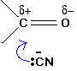
The solution will contain hydrogen cyanide (from the reaction between the sodium or potassium cyanide and the sulphuric acid), but still contains some free cyanide ions. This is important for the mechanism.
The mechanisms
These are examples of nucleophilic addition.
The carbon-oxygen double bond is highly polar, and the slightly positive carbon atom is attacked by the cyanide ion acting as a nucleophile.
The mechanism for the addition of HCN to propanone
In the first stage, there is a nucleophilic attack by the cyanide ion on the slightly positive carbon atom.
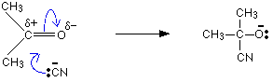
The negative ion formed then picks up a hydrogen ion from somewhere - for example, from a hydrogen cyanide molecule.
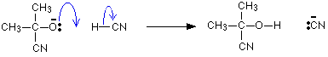
The hydrogen ion could also come from the water or the H₃O⁺ ions present in the slightly acidic solution. You don't need to remember all of these. One equation is perfectly adequate.
Uses of the reaction
The product molecules contain two functional groups:
- the -OH group which behaves like a simple alcohol and can be replaced by other things like chlorine, which can in turn be replaced to give, for example, an -NH₂ group;
- the -CN group which is easily converted into a carboxylic acid group -COOH.
For example, starting from a hydroxynitrile made from an aldehyde, you can quite easily produce relatively complicated molecules like 2-amino acids - the amino acids which are used to construct proteins.
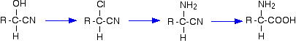
Addition of sodium hydrogensulphite to aldehydes and ketones
Sodium hydrogensulphite used to be known as sodium bisulphite, and you might well still come across it in organic textbooks under this name - or using the bisulfite spelling.

The reactions
This reaction only works well for aldehydes. In the case of ketones, one of the hydrocarbon groups attached to the carbonyl group needs to be a methyl group. Bulky groups attached to the carbonyl group get in the way of the reaction happening.
The aldehyde or ketone is shaken with a saturated solution of sodium hydrogensulphite in water. Where the product is formed, it separates as white crystals.
In the case of ethanal, the equation is:
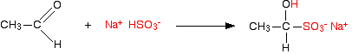
. . . and with propanone, the equation is:
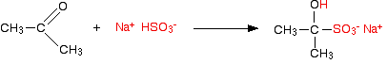
These compounds are rarely named systematically, and are usually known as "hydrogensulphite (or bisulphite) addition compounds".
Uses of the reaction
The reaction is usually used during the purification of aldehydes (and any ketones that it works for). The addition compound can be split easily to regenerate the aldehyde or ketone by treating it with either dilute acid or dilute alkali.
If you have an impure aldehyde, for example, you could shake it with a saturated solution of sodium hydrogensulphite to produce the crystals. These crystals could easily be filtered and washed to remove any other impurities. Addition of dilute acid, for example, would then regenerate the original aldehyde.
It would, of course, still need to be separated from the excess acid and assorted inorganic products of the reaction - but that is beyond the scope of this page!
REDUCTION OF ALDEHYDES AND KETONES
The reducing agents
Despite the fearsome names, the structures of the two reducing agents are very simple. In each case, there are four hydrogens ("tetrahydido") around either aluminium or boron in a negative ion (shown by the "ate" ending).
The "(III)" shows the oxidation state of the aluminium or boron, and is often left out because these elements only ever show the +3 oxidation state in their compounds. To make the names shorter, that's what I shall do for the rest of this page.
The formulae of the two compounds are LiAlH₄ and NaBH₄.
Their structures are:
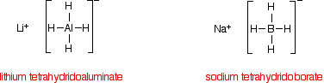
In each of the negative ions, one of the bonds is a co-ordinate covalent (dative covalent) bond using the lone pair on a hydride ion (H⁻) to form a bond with an empty orbital on the aluminium or boron.
The overall reactions
The reduction of an aldehyde
You get exactly the same organic product whether you use lithium tetrahydridoaluminate or sodium tetrahydridoborate.
For example, with ethanal you get ethanol:
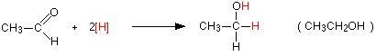
Notice that this is a simplified equation - perfectly acceptable to UK A level examiners. [H] means "hydrogen from a reducing agent".
In general terms, reduction of an aldehyde leads to a primary alcohol.
The reduction of a ketone
Again the product is the same whichever of the two reducing agents you use.
For example, with propanone you get propan-2-ol:
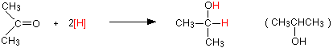
Reduction of a ketone leads to a secondary alcohol.
OXIDATION OF ALDEHYDES AND KETONES
Why do aldehydes and ketones behave differently?
You will remember that the difference between an aldehyde and a ketone is the presence of a hydrogen atom attached to the carbon-oxygen double bond in the aldehyde. Ketones don't have that hydrogen.
The presence of that hydrogen atom makes aldehydes very easy to oxidise. Or, put another way, they are strong reducing agents.
Because ketones don't have that particular hydrogen atom, they are resistant to oxidation. Only very strong oxidising agents like potassium manganate(VII) solution (potassium permanganate solution) oxidise ketones - and they do it in a destructive way, breaking carbon-carbon bonds.
Provided you avoid using these powerful oxidising agents, you can easily tell the difference between an aldehyde and a ketone. Aldehydes are easily oxidised by all sorts of different oxidising agents: ketones aren't.
What is formed when aldehydes are oxidised?
It depends on whether the reaction is done under acidic or alkaline conditions. Under acidic conditions, the aldehyde is oxidised to a carboxylic acid. Under alkaline conditions, this couldn't form because it would react with the alkali. A salt is formed instead.
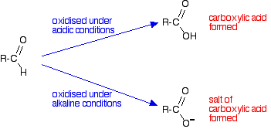
Building equations for the oxidation reactions
If you need to work out the equations for these reactions, the only reliable way of building them is to use electron-half-equations.
The half-equation for the oxidation of the aldehyde obviously varies depending on whether you are doing the reaction under acidic or alkaline conditions.
Under acidic conditions it is:
. . . and under alkaline conditions:
These half-equations are then combined with the half-equations from whatever oxidising agent you are using. Examples are given in detail below.
Specific examples
In each of the following examples, we are assuming that you know that you have either an aldehyde or a ketone. There are lots of other things which could also give positive results.
Assuming that you know it has to be one or the other, in each case, a ketone does nothing. Only an aldehyde gives a positive result.
Using acidified potassium dichromate(VI) solution
A small amount of potassium dichromate(VI) solution is acidified with dilute sulphuric acid and a few drops of the aldehyde or ketone are added. If nothing happens in the cold, the mixture is warmed gently for a couple of minutes - for example, in a beaker of hot water.

The orange dichromate(VI) ions have been reduced to green chromium(III) ions by the aldehyde. In turn the aldehyde is oxidised to the corresponding carboxylic acid.
The electron-half-equation for the reduction of dichromate(VI) ions is:
Combining that with the half-equation for the oxidation of an aldehyde under acidic conditions:
. . . gives the overall equation:
Using Tollens' reagent (the silver mirror test)
Tollens' reagent contains the diamminesilver(I) ion, [Ag(NH₃)₂]⁺.
This is made from silver(I) nitrate solution. You add a drop of sodium hydroxide solution to give a precipitate of silver(I) oxide, and then add just enough dilute ammonia solution to redissolve the precipitate.
To carry out the test, you add a few drops of the aldehyde or ketone to the freshly prepared reagent, and warm gently in a hot water bath for a few minutes.
Aldehydes reduce the diamminesilver(I) ion to metallic silver. Because the solution is alkaline, the aldehyde itself is oxidised to a salt of the corresponding carboxylic acid.
The electron-half-equation for the reduction of of the diamminesilver(I) ions to silver is:
Combining that with the half-equation for the oxidation of an aldehyde under alkaline conditions:
. . . gives the overall equation:
Using Fehling's solution or Benedict's solution
Fehling's solution and Benedict's solution are variants of essentially the same thing. Both contain complexed copper(II) ions in an alkaline solution.
Fehling's solution contains copper(II) ions complexed with tartrate ions in sodium hydroxide solution. Complexing the copper(II) ions with tartrate ions prevents precipitation of copper(II) hydroxide.
Benedict's solution contains copper(II) ions complexed with citrate ions in sodium carbonate solution. Again, complexing the copper(II) ions prevents the formation of a precipitate - this time of copper(II) carbonate.
Both solutions are used in the same way. A few drops of the aldehyde or ketone are added to the reagent, and the mixture is warmed gently in a hot water bath for a few minutes.
Aldehydes reduce the complexed copper(II) ion to copper(I) oxide. Because the solution is alkaline, the aldehyde itself is oxidised to a salt of the corresponding carboxylic acid.
The equations for these reactions are always simplified to avoid having to write in the formulae for the tartrate or citrate ions in the copper complexes. The electron-half-equations for both Fehling's solution and Benedict's solution can be written as:
Combining that with the half-equation for the oxidation of an aldehyde under alkaline conditions:
. . . gives the overall equation:
ADDITION-ELIMINATION REACTIONS OF ALDEHYDES AND KETONES
The reaction with 2,4-dinitrophenylhydrazine
2,4-dinitrophenylhydrazine is often abbreviated to 2,4-DNP or 2,4-DNPH. A solution of 2,4-dinitrophenylhydrazine in a mixture of methanol and sulphuric acid is known as Brady's reagent.
What is 2,4-dinitrophenylhydrazine?
Although the name sounds complicated, and the structure looks quite complicated, it is actually very easy to work out.
Start with the formula of hydrazine. That's almost all you need to remember!
Hydrazine is:
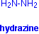

In phenylhydrazine, one of the hydrogens is replaced by a phenyl group, C₆H₅. This is based on a benzene ring.
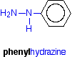
attached to the phenyl group in the 2- and 4- positions. The corner with the nitrogen attached is counted as the number 1 position, and you just number clockwise around the ring.
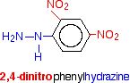
Doing the reaction
Details vary slightly depending on the nature of the aldehyde or ketone, and the solvent that the 2,4-dinitrophenylhydrazine is dissolved in. Assuming you are using Brady's reagent (a solution of the 2,4-dinitrophenylhydrazine in methanol and sulphuric acid):
Add either a few drops of the aldehyde or ketone, or possibly a solution of the aldehyde or ketone in methanol, to the Brady's reagent. A bright orange or yellow precipitate shows the presence of the carbon-oxygen double bond in an aldehyde or ketone.
This is the simplest test for an aldehyde or ketone.
The chemistry of the reaction
The overall reaction is given by the equation:
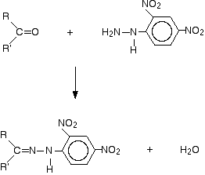

R and R' can be any combination of hydrogen or hydrocarbon groups (such as alkyl groups). If at least one of them is a hydrogen, then the original compound is an aldehyde. If both are hydrocarbon groups, then it is a ketone.
Look carefully at what has happened.
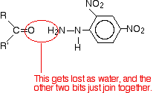
Provided you take care to draw the two starting molecules lined up right, working out the structure of the product is easy.
The product is known as a "2,4-dinitrophenylhydrazone". Notice that all that has changed is the ending from "-ine" to "-one". That's possibly confusing!
The product from the reaction with ethanal would be called ethanal 2,4-dinitrophenylhydrazone; from propanone, you would get propanone 2,4-dinitrophenylhydrazone - and so on. That's not too difficult!
The reaction is known as a condensation reaction. A condensation reaction is one in which two molecules join together with the loss of a small molecule in the process. In this case, that small molecule is water.
In terms of mechanisms, this is a nucleophilic addition-elimination reaction. The 2,4-dinitrophenylhydrazine first adds across the carbon-oxygen double bond (the addition stage) to give an intermediate compound which then loses a molecule of water (the elimination stage).
Using the reaction
The reaction has two uses in testing for aldehydes and ketones.
- First, you can just use it to test for the presence of the carbon-oxygen double bond. You only get an orange or yellow precipitate from a carbon-oxygen double bond in an aldehyde or ketone.
- Secondly, you can use it to help to identify the specific aldehyde or ketone.
The precipitate is filtered and washed with, for example, methanol and then recrystallised from a suitable solvent which will vary depending on the nature of the aldehyde or ketone. For example, you can recrystallise the products from the small aldehydes and ketones from a mixture of ethanol and water.
The crystals are dissolved in the minimum quantity of hot solvent. When the solution cools, the crystals are re-precipitated and can be filtered, washed with a small amount of solvent and dried. They should then be pure.
If you then find the melting point of the crystals, you can compare it with tables of the melting points of 2,4-dinitrophenylhydrazones of all the common aldehydes and ketones to find out which one you are likely to have got.
Some other similar reactions
If you go back and look at the equations, nothing in the 2,4-dinitrophenylhydrazine changes during the reaction apart from the -NH₂ group. You can get a similar reaction if the -NH₂ group is attached to other things.
In each case, the reaction would look like this:
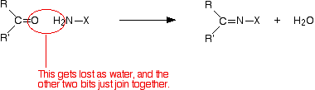
In what follows, all that changes is the nature of the "X".
with hydrazine
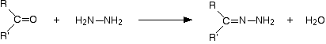
The product is a "hydrazone". If you started from propanone, it would be propanone hydrazone.

