ALKENES
Assoc.prof. Lubomir Makedonski
Medical University of Varna
ALKENES INTRODUCING

What are alkenes?
Formulae
Alkenes are a family of hydrocarbons (compounds containing carbon and hydrogen only) containing a carbon-carbon double bond. The first two are:
ethene | C₂H₄
propene | C₃H₆
You can work out the formula of any of them using: C_{n}H_{2n}
The table is limited to the first two, because after that there are isomers which affect the names.

Isomerism in the alkenes
Structural isomerism
All the alkenes with 4 or more carbon atoms in them show structural isomerism. This means that there are two or more different structural formulae that you can draw for each molecular formula.
For example, with C₄H₈, it isn't too difficult to come up with these three structural isomers:
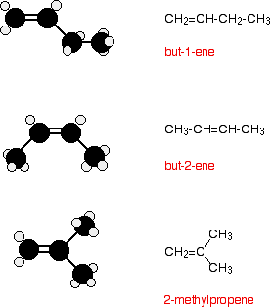
There is, however, another isomer. But-2-ene also exhibits geometric isomerism.
Geometric (cis-trans) isomerism
The carbon-carbon double bond doesn't allow any rotation about it. That means that it is possible to have the CH₃ groups on either end of the molecule locked either on one side of the molecule or opposite each other.
These are called cis-but-2-ene (where the groups are on the same side) or trans-but-2-ene (where they are on opposite sides).
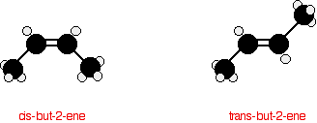
Physical properties of the alkenes
Boiling Points
The boiling point of each alkene is very similar to that of the alkane with the same number of carbon atoms. Ethene, propene and the various butenes are gases at room temperature. All the rest that you are likely to come across are liquids.
In each case, the alkene has a boiling point which is a small number of degrees lower than the corresponding alkane. The only attractions involved are Van der Waals dispersion forces, and these depend on the shape of the molecule and the number of electrons it contains. Each alkene has 2 fewer electrons than the alkane with the same number of carbons.
Solubility
Alkenes are virtually insoluble in water, but dissolve in organic solvents.
Chemical Reactivity
Bonding in the alkenes
We just need to look at ethene, because what is true of C=C in ethene will be equally true of C=C in more complicated alkenes.
Ethene is often modelled like this:
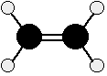
The double bond between the carbon atoms is, of course, two pairs of shared electrons. What the diagram doesn't show is that the two pairs aren't the same as each other.
One of the pairs of electrons is held on the line between the two carbon nuclei as you would expect, but the other is held in a molecular orbital above and below the plane of the molecule. A molecular orbital is a region of space within the molecule where there is a high probability of finding a particular pair of electrons.
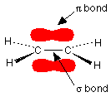
In this diagram, the line between the two carbon atoms represents a normal bond - the pair of shared electrons lies in a molecular orbital on the line between the two nuclei where you would expect them to be. This sort of bond is called a sigma bond.
The other pair of electrons is found somewhere in the shaded part above and below the plane of the molecule. This bond is called a pi bond. The electrons in the pi bond are free to move around anywhere in this shaded region and can move freely from one half to the other.
The pi electrons are not as fully under the control of the carbon nuclei as the electrons in the sigma bond and, because they lie exposed above and below the rest of the molecule, they are relatively open to attack by other things.

The reactions of alkenes
Like any other hydrocarbons, alkenes burn in air or oxygen, but these reactions are unimportant. Alkenes are too valuable to waste in this way.
The important reactions all centre around the double bond. Typically, the pi bond breaks and the electrons from it are used to join the two carbon atoms to other things. Alkenes undergo addition reactions.
For example, using a general molecule X-Y . . .
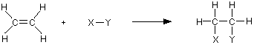
The rather exposed electrons in the pi bond are particularly open to attack by things which carry some degree of positive charge. These are called electrophiles. If you explore the rest of the alkene menu, you will find lots of examples of this kind.
MAKING ALKENES IN THE LAB
Dehydration of alcohols using aluminium oxide as catalyst
The dehydration of ethanol to give ethene
This is a simple way of making gaseous alkenes like ethene. If ethanol vapour is passed over heated aluminium oxide powder, the ethanol is essentially cracked to give ethene and water vapour.
The dehydration of ethanol to give ethene
Ethanol is heated with an excess of concentrated sulphuric acid at a temperature of 170°C. The gases produced are passed through sodium hydroxide solution to remove the carbon dioxide and sulphur dioxide produced from side reactions.
The ethene is collected over water.
The concentrated sulphuric acid is a catalyst. Write it over the arrow rather than in the equation.
THE HYDROGENATION OF ALKENES
This page looks at the reaction of the carbon-carbon double bond in alkenes with hydrogen in the presence of a metal catalyst. This is called hydrogenation. It includes the manufacture of margarine from animal or vegetable fats and oils.
The hydrogenation of ethene
Ethene reacts with hydrogen in the presence of a finely divided nickel catalyst at a temperature of about 150°C. Ethane is produced.
This is a fairly pointless reaction because ethene is a far more useful compound than ethane! However, what is true of the reaction of the carbon-carbon double bond in ethene is equally true of it in much more complicated cases.
THE HALOGENATION OF ALKENES
Reactions where the chlorine or bromine are in solution (for example, "bromine water") are slightly more complicated and are treated separately at the end.
Simple reactions involving halogens
In each case, we will look at ethene as typical of all of the alkenes. There are no complications as far as the basic facts are concerned as the alkenes get bigger.
Ethene and fluorine
Ethene reacts explosively with fluorine to give carbon and hydrogen fluoride gas.
Ethene and chlorine or bromine or iodine
In each case you get an addition reaction. For example, bromine adds to give 1,2-dibromoethane.
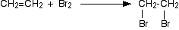
The reaction with bromine happens at room temperature. If you have a gaseous alkene like ethene, you can bubble it through either pure liquid bromine or a solution of bromine in an organic solvent like tetrachloromethane. The reddish-brown bromine is decolourised as it reacts with the alkene.
A liquid alkene (like cyclohexene) can be shaken with liquid bromine or its solution in tetrachloromethane.
Chlorine reacts faster than bromine, but the chemistry is similar. Iodine reacts much, much more slowly, but again the chemistry is similar. You are much more likely to meet the bromine case than either of these.
Alkenes and bromine water
Using bromine water as a test for alkenes
If you shake an alkene with bromine water (or bubble a gaseous alkene through bromine water), the solution becomes colourless. Alkenes decolourise bromine water.
The chemistry of the test
This is complicated by the fact that the major product isn't 1,2-dibromoethane. The water also gets involved in the reaction, and most of the product is 2-bromoethanol.
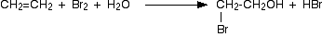
However, there will still be some 1,2-dibromoethane formed, so at this sort of level you can probably get away with quoting the simpler equation:
ALKENES and HYDROGEN HALIDES
Symmetrical alkenes (like ethene or but-2-ene) are dealt with first. These are alkenes where identical groups are attached to each end of the carbon-carbon double bond. The extra problems associated with unsymmetrical ones like propene are covered in a separate section afterwards.

Addition to symmetrical alkenes
What happens?
All alkenes undergo addition reactions with the hydrogen halides. A hydrogen atom joins to one of the carbon atoms originally in the double bond, and a halogen atom to the other.
For example, with ethene and hydrogen chloride, you get chloroethane:
With but-2-ene you get 2-chlorobutane:
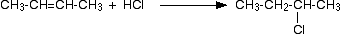
What happens if you add the hydrogen to the carbon atom at the right-hand end of the double bond, and the chlorine to the left-hand end? You would still have the same product.
The chlorine would be on a carbon atom next to the end of the chain - you would simply have drawn the molecule flipped over in space.
That would be different of the alkene was unsymmetrical - that's why we have to look at them separately.
Conditions
The alkenes react with gaseous hydrogen halides at room temperature. If the alkene is also a gas, you can simply mix the gases. If the alkene is a liquid, you can bubble the hydrogen halide through the liquid.
Alkenes will also react with concentrated solutions of the gases in water. A solution of hydrogen chloride in water is, of course, hydrochloric acid. A solution of hydrogen bromide in water is hydrobromic acid - and so on.
There are, however, problems with this. The water will also get involved in the reaction and you end up with a mixture of products
Reaction rates
Variation of rates when you change the halogen
Reaction rates increase in the order HF - HCl - HBr - HI. Hydrogen fluoride reacts much more slowly than the other three, and is normally ignored in talking about these reactions.
When the hydrogen halides react with alkenes, the hydrogen-halogen bond has to be broken. The bond strength falls as you go from HF to HI, and the hydrogen-fluorine bond is particularly strong. Because it is difficult to break the bond between the hydrogen and the fluorine, the addition of HF is bound to be slow.
Variation of rates when you change the alkene
This applies to unsymmetrical alkenes as well as to symmetrical ones. For simplicity the examples given below are all symmetrical ones- but they don't have to be.
Reaction rates increase as the alkene gets more complicated - in the sense of the number of alkyl groups (such as methyl groups) attached to the carbon atoms at either end of the double bond.
For example:
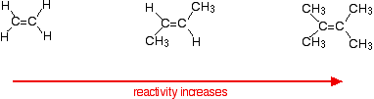
There are two ways of looking at the reasons for this - both of which need you to know about the mechanism for the reactions.
Alkenes react because the electrons in the pi bond attract things with any degree of positive charge. Anything which increases the electron density around the double bond will help this.
Alkyl groups have a tendency to "push" electrons away from themselves towards the double bond. The more alkyl groups you have, the more negative the area around the double bonds becomes.
The more negatively charged that region becomes, the more it will attract molecules like hydrogen chloride.
The more important reason, though, lies in the stability of the intermediate ion formed during the reaction. The three examples given above produce these carbocations (carbonium ions) at the half-way stage of the reaction:
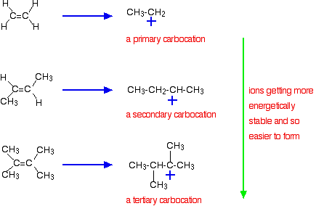
The stability of the intermediate ions governs the activation energy for the reaction. As you go towards the more complicated alkenes, the activation energy for the reaction falls. That means that the reactions become faster.
Addition to unsymmetrical alkenes
What happens?
In terms of reaction conditions and the factors affecting the rates of the reaction, there is no difference whatsoever between these alkenes and the symmetrical ones described above. The problem comes with the orientation of the addition - in other words, which way around the hydrogen and the halogen add across the double bond.
Orientation of addition
If HCl adds to an unsymmetrical alkene like propene, there are two possible ways it could add. However, in practice, there is only one major product.
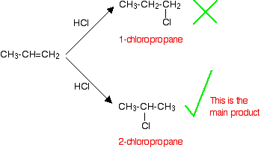
This is in line with Markovnikov's Rule which says:
When a compound HX is added to an unsymmetrical alkene, the hydrogen becomes attached to the carbon with the most hydrogens attached to it already.
In this case, the hydrogen becomes attached to the CH₂ group, because the CH₂ group has more hydrogens than the CH group.
Notice that only the hydrogens directly attached to the carbon atoms at either end of the double bond count. The ones in the CH₃ group are totally irrelevant.
A special problem with hydrogen bromide
Unlike the other hydrogen halides, hydrogen bromide can add to a carbon-carbon double bond either way around - depending on the conditions of the reaction.
If the hydrogen bromide and alkene are entirely pure
In this case, the hydrogen bromide adds on according to Markovnikov's Rule. For example, with propene you would get 2-bromopropane.
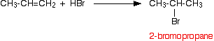
That is exactly the same as the way the other hydrogen halides add.

If the hydrogen bromide and alkene contain traces of organic peroxides
Oxygen from the air tends to react slowly with alkenes to produce some organic peroxides, and so you don't necessarily have to add them separately. This is therefore the reaction that you will tend to get unless you take care to exclude all air from the system.
In this case, the addition is the other way around, and you get 1-bromopropane:
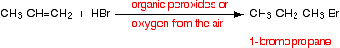
This is sometimes described as an anti-Markovnikov addition or as the peroxide effect.
Organic peroxides are excellent sources of free radicals. In the presence of these, the hydrogen bromide reacts with alkenes using a different (faster) mechanism. For various reasons, this doesn't happen with the other hydrogen halides.
This reaction can also happen in this way in the presence of ultra-violet light of the right wavelength to break the hydrogen-bromine bond into hydrogen and bromine free radicals.

ALKENES and SULPHURIC ACID
The addition of sulphuric acid to alkenes
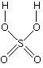
The reaction with ethene
Alkenes react with concentrated sulphuric acid in the cold to produce alkyl hydrogensulphates. Ethene reacts to give ethyl hydrogensulphate.
The structure of the product molecule is sometimes written as CH₃CH₂HSO₄, but the version in the equation is better because it shows how all the atoms are linked up. You may also find it written as CH₃CH₂OSO₃H.
Confused by all this? Don't be!
All you need to do is to learn the structure of sulphuric acid. A hydrogen from the sulphuric acid joins on to one of the carbon atoms, and the rest joins on to the other one. Make sure that you can see how the structure of the sulphuric acid relates to the various ways of writing the formula for the product.
The reaction with propene
This is typical of the reaction with unsymmetrical alkenes. An unsymmetrical alkene has different groups at either end of the carbon-carbon double bond.
If sulphuric acid adds to an unsymmetrical alkene like propene, there are two possible ways it could add. You could end up with one of two products depending on which carbon atom the hydrogen attaches itself to.
However, in practice, there is only one major product.
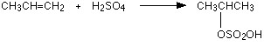
This is in line with Markovnikov's Rule which says:
When a compound HX is added to an unsymmetrical alkene, the hydrogen becomes attached to the carbon with the most hydrogens attached to it already.
In this case, the hydrogen becomes attached to the CH₂ group, because the CH₂ group has more hydrogens than the CH group.
Notice that only the hydrogens directly attached to the carbon atoms at either end of the double bond count. The ones in the CH₃ group are totally irrelevant.

Using these reactions to make alcohols
Making ethanol
Ethene is passed into concentrated sulphuric acid to make ethyl hydrogensulphate (as above). The product is diluted with water and then distilled.
The water reacts with the ethyl hydrogensulphate to produce ethanol which distils off.
Making propan-2-ol
More complicated alkyl hydrogensulphates react with water in exactly the same way. For example:
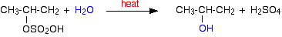
Notice that the position of the -OH group is determined by where the HSO₄ group was attached. You get propan-2-ol rather than propan-1-ol because of the way the sulphuric acid originally added across the double bond in propene.
Using these reactions
These reactions were originally used as a way of manufacturing alcohols from alkenes in the petrochemical industry. These days, alcohols like ethanol or propan-2-ol tend to be manufactured by direct hydration of the alkene because it is cheaper and easier.
ALKENES and POTASSIUM MANGANATE(VII)
Oxidation of alkenes
Experimental details
Alkenes react with potassium manganate(VII) solution in the cold. The colour change depends on whether the potassium manganate(VII) is used under acidic or alkaline conditions.
If the potassium manganate(VII) solution is acidified with dilute sulphuric acid, the purple solution becomes colourless.
If the potassium manganate(VII) solution is made slightly alkaline (often by adding sodium carbonate solution), the purple solution first becomes dark green and then produces a dark brown precipitate.
Chemistry of the reaction
We'll look at the reaction with ethene. Other alkenes react in just the same way.
Manganate(VII) ions are a strong oxidising agent, and in the first instance oxidise ethene to ethane-1,2-diol (old name: ethylene glycol).
Looking at the equation purely from the point of view of the organic reaction:
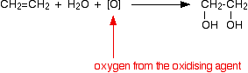
The full equation depends on the conditions.
Under acidic conditions, the manganate(VII) ions are reduced to manganese(II) ions.
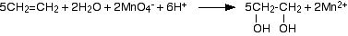
Under alkaline conditions, the manganate(VII) ions are first reduced to green manganate(VI) ions . . .
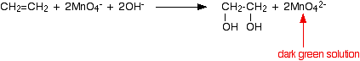
. . . and then further to dark brown solid manganese(IV) oxide (manganese dioxide).
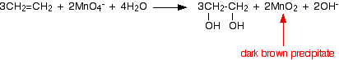
This last reaction is also the one you would get if the reaction was done under neutral conditions. You will notice that there are neither hydrogen ions nor hydroxide ions on the left-hand side of the equation.

THE DIRECT HYDRATION OF ALKENES
Manufacturing ethanol
Ethanol is manufactured by reacting ethene with steam. The reaction is reversible.
Only 5% of the ethene is converted into ethanol at each pass through the reactor. By removing the ethanol from the equilibrium mixture and recycling the ethene, it is possible to achieve an overall 95% conversion.
A flow scheme for the reaction looks like this:

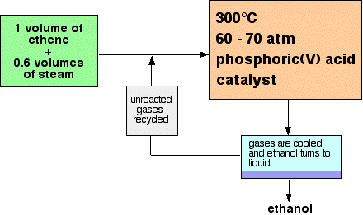
THE POLYMERISATION OF ALKENES
Poly(ethene) (polythene or polyethylene)
Low density poly(ethene): LDPE
Manufacture
In common with everything else on this page, this is an example of addition polymerisation.
An addition reaction is one in which two or more molecules join together to give a single product. During the polymerisation of ethene, thousands of ethene molecules join together to make poly(ethene) - commonly called polythene.
The number of molecules joining up is very variable, but is in the region of 2000 to 20000.
Conditions
Temperature: | about 200°C
Pressure: | about 2000 atmospheres
Initiator: | a small amount of oxygen as an impurity
Properties and uses
Low density poly(ethene) has quite a lot of branching along the hydrocarbon chains, and this prevents the chains from lying tidily close to each other. Those regions of the poly(ethene) where the chains lie close to each other and are regularly packed are said to be crystalline. Where the chains are a random jumble, it is said to be amorphous. Low density poly(ethene) has a significant proportion of amorphous regions.
One chain is held to its neighbours in the structure by van der Waals dispersion forces. Those attractions will be greater if the chains are close to each other. The amorphous regions where the chains are inefficiently packed lower the effectiveness of the van der Waals attractions and so lower the melting point and strength of the polymer. They also lower the density of the polymer (hence: "low density poly(ethene)").
Low density poly(ethene) is used for familiar things like plastic carrier bags and other similar low strength and flexible sheet materials.

High density poly(ethene): HDPE
Manufacture
This is made under quite different conditions from low density poly(ethene).
Conditions
Temperature: | about 60°C
Pressure: | low - a few atmospheres
Catalyst: | Ziegler-Natta catalysts or other metal compounds
Ziegler-Natta catalysts are mixtures of titanium compounds like titanium(III) chloride, TiCl₃, or titanium(IV) chloride, TiCl₄, and compounds of aluminium like aluminium triethyl, Al(C₂H₅)₃. There are all sorts of other catalysts constantly being developed.
These catalysts work by totally different mechanisms from the high pressure process used to make low density poly(ethene). The chains grow in a much more controlled - much less random - way.
Properties and uses
High density poly(ethene) has very little branching along the hydrocarbon chains - the crystallinity is 95% or better. This better packing means that van der Waals attractions between the chains are greater and so the plastic is stronger and has a higher melting point. Its density is also higher because of the better packing and smaller amount of wasted space in the structure.
High density poly(ethene) is used to make things like plastic milk bottles and similar containers, washing up bowls, plastic pipes and so on. Look for the letters HDPE near the recycling symbol.

Poly(propene) (polypropylene): PP
Poly(propene) is manufactured using Ziegler-Natta and other modern catalysts. There are three variants on the structure of poly(propene) which you may need to know about, but we'll start from the beginning with a general structure which fits all of them.
The general structure
If your syllabus simply mentions the structure of poly(propene) with no more detail, this is adequate.
The trick is to think about the shape of the propene in the right way:
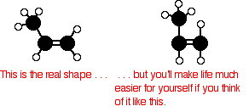
Now line lots of them up in a row and join them together. Notice that the double bonds are all replaced by single bonds in the process.
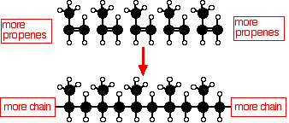
In a simple equation form, this is normally written as:
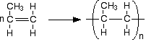

Poly(chloroethene) (polyvinyl chloride): PVC
Poly(chloroethene) is commonly known by the initials of its old name, PVC.
Structure
Poly(chloroethene) is made by polymerising chloroethene, CH₂=CHCl. Working out its structure is no different from working out the structure of poly(propene) (see above). As long as you draw the chloroethene molecule in the right way, the structure is pretty obvious.
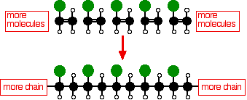

The equation is usually written:
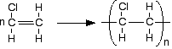
It doesn't matter which carbon you attach the chlorine to in the original molecule. Just be consistent on both sides of the equation.
The polymerisation process produces mainly atactic polymer molecules - with the chlorines orientated randomly along the chain. The structure is no different from atactic poly(propene) - just replace the CH₃ groups by chlorine atoms.
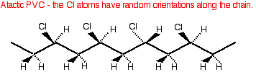
Because of the way the chlorine atoms stick out from the chain at random, and because ot their large size, it is difficult for the chains to lie close together. Poly(chloroethene) is mainly amorphous with only small areas of crystallinity.
Properties and uses
You normally expect amorphous polymers to be more flexible than crystalline ones because the forces of attraction between the chains tend to be weaker. However, pure poly(chloroethene) tends to be rather hard and rigid.
This is because of the presence of additional dipole-dipole interactions due to the polarity of the carbon-chlorine bonds. Chlorine is more electronegative than carbon, and so attracts the electrons in the bond towards itself. That makes the chlorine atoms slightly negative and the carbons slightly positive.
These permanent dipoles add to the attractions due to the temporary dipoles which produce the dispersion forces.
Plasticisers are added to the poly(chloroethene) to reduce the effectiveness of these attractions and make the plastic more flexible. The more plasticiser you add, the more flexible it becomes.
Poly(chloroethene) is used to make a wide range of things including guttering, plastic windows, electrical cable insulation, sheet materials for flooring and other uses, footwear, clothing, and so on and so on.

Poly(tetrafluoroethene): PTFE
You may have come across this under the brand names of Teflon or Fluon.
Structure
Structurally, PTFE is just like poly(ethene) except that each hydrogen in the structure is replaced by a fluorine atom.
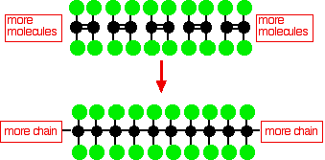

The PTFE chains tend to pack well and PTFE is fairly crystalline. Because of the fluorine atoms, the chains also contain more electrons (for an equal length) than a corresponding poly(ethene) chain. Taken together (the good packing and the extra electrons) that means that the van der Waals dispersion forces will be stronger than in even high density poly(ethene).
Properties and uses
PTFE has a relatively high melting point (due to the strength of the attractions between the chains) and is very resistant to chemical attack. The carbon chain is so wrapped up in fluorine atoms that nothing can get at it to react with it. This makes it useful in the chemical and food industries to coat vessels and make them resistant to almost everything which might otherwise corrode them.
Equally important is that PTFE has remarkable non-stick properties - which is the basis for its most familiar uses in non-stick kitchen and garden utensils. For the same reason, it can also be used in things like low-friction bearings

