AMINO ACIDS
Assoc. Prof. Lubomir Makedonski
Medical University of Varna

What are amino acids?
Structures and names
Amino acids are exactly what they say they are! They are compounds containing an amino group, -NH₂, and a carboxylic acid group, -COOH.
The biologically important amino acids have the amino group attached to the carbon atom next door to the -COOH group. They are known as 2-amino acids. They are also known (slightly confusingly) as alpha-amino acids. These are the ones we will concentrated on.
The two simplest of these amino acids are 2-aminoethanoic acid and 2-aminopropanoic acid.
Because of the biological importance of molecules like these, they are normally known by their traditional biochemical names.
The general formula for a 2-amino acid is:
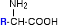
. . . where "R" can be quite a complicated group containing other active groups like -OH, -SH, other amine or carboxylic acid groups, and so on. It is definitely NOT necessarily a simple hydrocarbon group!
Amino acids Classification
I. Amino acids Classification according to R – group (biochemical):
1. Unpolar R - group
2. Polar uncharged R – group
3. Negative charge R – group
4. Positive charge R – group
II. Amino acids Classification according to chemical structure:
1. Aliphatic Amino Acids
- glycine,
- alanine
Hydrophobic
- valine - beta-branched
- leucine
- isoleucine - beta-branched, second chiral center
α -imino acid
- proline - containing a pyrrolidine ring

2. Aromatic Amino Acids
All are considered hydrophobic. However, tyrosine and tryptophan also can form hydrogen bonds.
- phenylalanine
- tyrosine
- tryptophan - containing an indole group

3. Sulfur-containing
- both are considered hydrophobic. Cysteine can form disulfide bonds with another cysteine.
- cysteine - containing a thiol group
- methionine - containing a thioether group
4. Aliphatic hydroxyl-containing
- serine
- threonine - beta-branched, second chiral center
5. Basic
- lysine - containing a primary amine
- arginine - containing a guanidino group
- histidine - containing an imidazole group
6. Acidic
- aspartate
- glutamate
7. Amide Derivatives (of the acidic amino acids)
- asparagine
- glutamine
Physical properties
Melting points
The amino acids are crystalline solids with surprisingly high melting points. It is difficult to pin the melting points down exactly because the amino acids tend to decompose before they melt. Decomposition and melting tend to be in the 200 - 300°C range.
For the size of the molecules, this is very high. Something unusual must be happening.
If you look again at the general structure of an amino acid, you will see that it has both a basic amine group and an acidic carboxylic acid group.
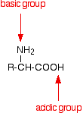
There is an internal transfer of a hydrogen ion from the -COOH group to the -NH₂ group to leave an ion with both a negative charge and a positive charge.
This is called a zwitterion.
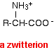
This is the form that amino acids exist in even in the solid state. Instead of the weaker hydrogen bonds and other intermolecular forces that you might have expected, you actually have much stronger ionic attractions between one ion and its neighbours.
These ionic attractions take more energy to break and so the amino acids have high melting points for the size of the molecules.
Solubility
Amino acids are generally soluble in water and insoluble in non-polar organic solvents such as hydrocarbons.
This again reflects the presence of the zwitterions. In water, the ionic attractions between the ions in the solid amino acid are replaced by strong attractions between polar water molecules and the zwitterions. This is much the same as any other ionic substance dissolving in water.
The extent of the solubility in water varies depending on the size and nature of the "R" group.
The lack of solubility in non-polar organic solvents such as hydrocarbons is because of the lack of attraction between the solvent molecules and the zwitterions. Without strong attractions between solvent and amino acid, there won't be enough energy released to pull the ionic lattice apart.

Optical activity
If you look yet again at the general formula for an amino acid, you will see that (apart from glycine, 2-aminoethanoic acid) the carbon at the centre of the structure has four different groups attached. In glycine, the "R" group is another hydrogen atom.
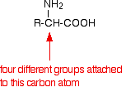
This is equally true if you draw the structure of the zwitterion instead of this simpler structure.
Because of these four different groups attached to the same carbon atom, amino acids (apart from glycine) are chiral.
The lack of a plane of symmetry means that there will be two stereoisomers of an amino acid (apart from glycine) - one the non-superimposable mirror image of the other.
For a general 2-amino acid, the isomers are:
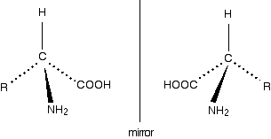
All the naturally occurring amino acids have the right-hand structure in this diagram. This is known as the "L-" configuration. The other one is known as the "D-" configuration.
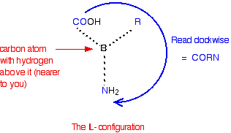
You can't tell by looking at a structure whether that isomer will rotate the plane of polarisation of plane polarised light clockwise or anticlockwise. All the naturally occurring amino acids have the same L- configuration, but they include examples which rotate the plane clockwise (+) and those which do the opposite (-).

For example:
- (+)alanine
- (-)cysteine
- (-)tyrosine
- (+)valine
It is quite common for natural systems to only work with one of the optical isomers (enantiomers) of an optically active substance like the amino acids. It isn't too difficult to see why that might be. Because the molecules have different spatial arrangements of their various groups, only one of them is likely to fit properly into the active sites on the enzymes they work with.

THE ACID-BASE BEHAVIOUR OF AMINO ACIDS
For simplicity, the page only looks at amino acids which contain a single -NH₂ group and a single -COOH group.
Amino acids as zwitterions
Zwitterions in simple amino acid solutions
An amino acid has both a basic amine group and an acidic carboxylic acid group.
There is an internal transfer of a hydrogen ion from the -COOH group to the -NH₂ group to leave an ion with both a negative charge and a positive charge.
This is called a zwitterion.
This is the form that amino acids exist in even in the solid state. If you dissolve the amino acid in water, a simple solution also contains this ion.

Adding an alkali to an amino acid solution
If you increase the pH of a solution of an amino acid by adding hydroxide ions, the hydrogen ion is removed from the -NH₃⁺ group.
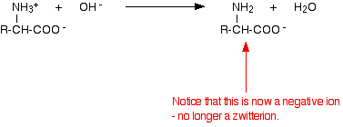

Adding an acid to an amino acid solution
If you decrease the pH by adding an acid to a solution of an amino acid, the -COO⁻ part of the zwitterion picks up a hydrogen ion.
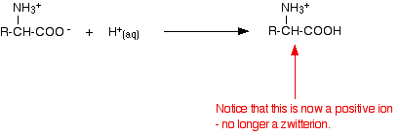
This time, during electrophoresis, the amino acid would move towards the cathode (the negative electrode).

Shifting the pH from one extreme to the other
Suppose you start with the ion we've just produced under acidic conditions and slowly add alkali to it.
That ion contains two acidic hydrogens - the one in the -COOH group and the one in the -NH₃⁺ group.
The more acidic of these is the one in the -COOH group, and so that is removed first - and you get back to the zwitterion.
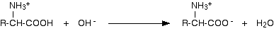
So when you have added just the right amount of alkali, the amino acid no longer has a net positive or negative charge. That means that it wouldn't move towards either the cathode or anode during electrophoresis.
The pH at which this lack of movement during electrophoresis happens is known as the isoelectric point of the amino acid. This pH varies from amino acid to amino acid.
If you go on adding hydroxide ions, you will get the reaction we've already seen, in which a hydrogen ion is removed from the -NH₃⁺ group.
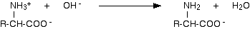
You can, of course, reverse the whole process by adding an acid to the ion we've just finished up with.
That ion contains two basic groups - the -NH₂ group and the -COO⁻ group. The -NH₂ group is the stronger base, and so picks up hydrogen ions first. That leads you back to the zwitterion again.
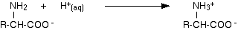
. . . and, of course, you can keep going by then adding a hydrogen ion to the -COO⁻ group.
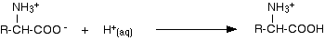

Why isn't the isoelectric point of an amino acid at pH 7?
When an amino acid dissolves in water, the situation is a little bit more complicated than we tend to pretend at this level. The zwitterion interacts with water molecules - acting as both an acid and a base.
As an acid:
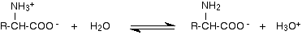
The -NH₃⁺ group is a weak acid and donates a hydrogen ion to a water molecule. Because it is only a weak acid, the position of equilibrium will lie to the left.
As a base:
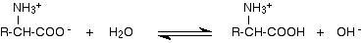
The -COO⁻ group is a weak base and takes a hydrogen ion from a water molecule. Again, the equilibrium lies to the left.
When you dissolve an amino acid in water, both of these reactions are happening.
But . . .
The positions of the two equilibria aren't identical - they vary depending on the influence of the "R" group. In practice, for the simple amino acids we have been talking about, the position of the first equilibrium lies a bit further to the right than the second one.
That means that there will be rather more of the negative ion from the amino acid in the solution than the positive one.
In those circumstances, if you carried out electrophoresis on the unmodified solution, there would be a slight drift of amino acid towards the positive electrode (the anode).
To stop that, you need to cut down the amount of the negative ion so that the concentrations of the two ions are identical. You can do that by adding a very small amount of acid to the solution, moving the position of the first equilibrium further to the left.
Typically, the pH has to be lowered to about 6 to achieve this. For glycine, for example, the isoelectric point is pH 6.07; for alanine, 6.11; and for serine, 5.68.
The titration curve
The titration curve for alanine, shown below, demonstrates this relationship. At a pH lower than 2, both the carboxylate and amine functions are protonated, so the alanine molecule has a net positive charge. At a pH greater than 10, the amine exists as a neutral base and the carboxyl as its conjugate base, so the alanine molecule has a net negative charge. At intermediate pH's the zwitterion concentration increases, and at a characteristic pH, called the isoelectric point (pI), the negatively and positively charged molecular species are present in equal concentration. This behavior is general for simple (difunctional) amino acids. Starting from a fully protonated state, the pKa's of the acidic functions range from 1.8 to 2.4 for -CO2H, and 8.8 to 9.7 for -NH3(+). The isoelectric points range from 5.5 to 6.2. Titration curves show the neutralization of these acids by added base, and the change in pH during the titration.
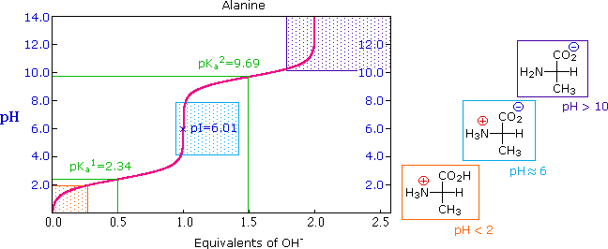
The distribution of charged species in a sample can be shown experimentally by observing the movement of solute molecules in an electric field, using the technique of electrophoresis. For such experiments an ionic buffer solution is incorporated in a solid matrix layer, composed of paper or a crosslinked gelatin-like substance. A small amount of the amino acid, peptide or protein sample is placed near the center of the matrix strip and an electric potential is applied at the ends of the strip, as shown in the following diagram. The solid structure of the matrix retards the diffusion of the solute molecules, which will remain where they are inserted, unless acted upon by the electrostatic potential. In the example shown here, four different amino acids are examined simultaneously in a pH 6.00 buffered medium. To see the result of this experiment.
At pH 6.00 alanine and isoleucine exist on average as neutral zwitterionic molecules, and are not influenced by the electric field. Arginine is a basic amino acid. Both base functions exist as "onium" conjugate acids in the pH 6.00 matrix. The solute molecules of arginine therefore carry an excess positive charge, and they move toward the cathode. The two carboxyl functions in aspartic acid are both ionized at pH 6.00, and the negatively charged solute molecules move toward the anode in the electric field. Structures for all these species are shown to the right of the display.
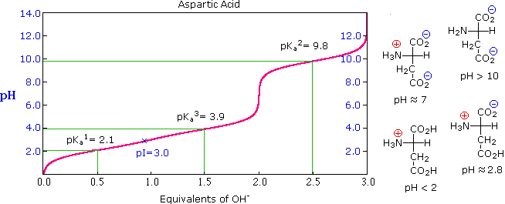
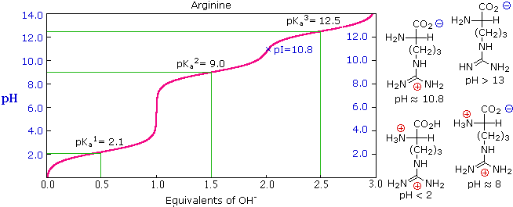

3. The Isoelectric Point
The isoelectric point, pI, is the pH of an aqueous solution of an amino acid (or peptide) at which the molecules on average have no net charge. In other words, the positively charged groups are exactly balanced by the negatively charged groups. For simple amino acids such as alanine, the pI is an average of the pK_{a}'s of the carboxyl (2.34) and ammonium (9.69) groups. Thus, the pI for alanine is calculated to be: (2.34 + 9.69)/2 = 6.02, the experimentally determined value. If additional acidic or basic groups are present as side-chain functions, the pI is the average of the pK_{a}'s of the two most similar acids. To assist in determining similarity we define two classes of acids. The first consists of acids that are neutral in their protonated form (e.g. CO₂H & SH). The second includes acids that are positively charged in their protonated state (e.g. -NH₃⁺). In the case of aspartic acid, the similar acids are the alpha-carboxyl function (pK_{a} = 2.1) and the side-chain carboxyl function (pK_{a} = 3.9), so pI = (2.1 + 3.9)/2 = 3.0. For arginine, the similar acids are the guanidinium species on the side-chain (pK_{a} = 12.5) and the alpha-ammonium function (pK_{a} = 9.0), so the calculated pI = (12.5 + 9.0)/2 = 10.75.
THE STRUCTURE OF PROTEINS
The primary structure of proteins

Peptides and polypeptides
Glycine and alanine can combine together with the elimination of a molecule of water to produce a dipeptide. It is possible for this to happen in one of two different ways - so you might get two different dipeptides.
Either:
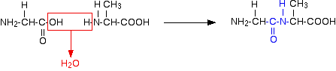
Or:
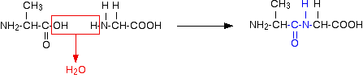
In each case, the linkage shown in blue in the structure of the dipeptide is known as a peptide link. In chemistry, this would also be known as an amide link, but since we are now in the realms of biochemistry and biology, we'll use their terms.
If you joined three amino acids together, you would get a tripeptide. If you joined lots and lots together (as in a protein chain), you get a polypeptide.
A protein chain will have somewhere in the range of 50 to 2000 amino acid residues. You have to use this term because strictly speaking a peptide chain isn't made up of amino acids. When the amino acids combine together, a water molecule is lost. The peptide chain is made up from what is left after the water is lost - in other words, is made up of amino acid residues.
By convention, when you are drawing peptide chains, the -NH₂ group which hasn't been converted into a peptide link is written at the left-hand end. The unchanged -COOH group is written at the right-hand end.
The end of the peptide chain with the -NH₂ group is known as the N-terminal, and the end with the -COOH group is the C-terminal.
A protein chain (with the N-terminal on the left) will therefore look like this:

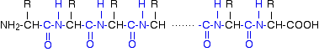

The "R" groups come from the 20 amino acids which occur in proteins. The peptide chain is known as the backbone, and the "R" groups are known as side chains.
The primary structure of proteins
Now there's a problem! The term "primary structure" is used in two different ways.
At its simplest, the term is used to describe the order of the amino acids joined together to make the protein. In other words, if you replaced the "R" groups in the last diagram by real groups you would have the primary structure of a particular protein.
This primary structure is usually shown using abbreviations for the amino acid residues. These abbreviations commonly consist of three letters or one letter.
Using three letter abbreviations, a bit of a protein chain might be represented by, for example:
If you look carefully, you will spot the abbreviations for glycine (Gly) and alanine (Ala) amongst the others.
If you followed the protein chain all the way to its left-hand end, you would find an amino acid residue with an unattached -NH₂ group. The N-terminal is always written on the left of a diagram for a protein's primary structure - whether you draw it in full or use these abbreviations.
The wider definition of primary structure includes all the features of a protein which are a result of covalent bonds. Obviously, all the peptide links are made of covalent bonds, so that isn't a problem.
But there is an additional feature in proteins which is also covalently bound. It involves the amino acid cysteine.
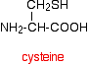
If two cysteine side chains end up next to each other because of folding in the peptide chain, they can react to form a sulphur bridge. This is another covalent link and so some people count it as a part of the primary structure of the protein.
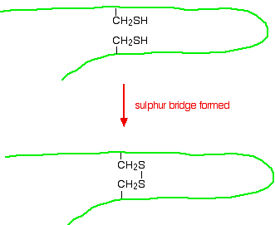
Because of the way sulphur bridges affect the way the protein folds, other people count this as a part of the tertiary structure (see below). This is obviously a potential source of confusion!
The secondary structure of proteins
Within the long protein chains there are regions in which the chains are organised into regular structures known as alpha-helices (alpha-helixes) and beta-pleated sheets. These are the secondary structures in proteins.
These secondary structures are held together by hydrogen bonds. These form as shown in the diagram between one of the lone pairs on an oxygen atom and the hydrogen attached to a nitrogen atom:
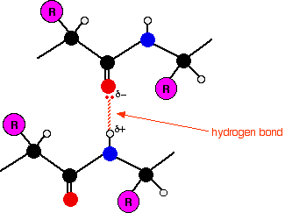

The tertiary structure of proteins
What is tertiary structure?
The tertiary structure of a protein is a description of the way the whole chain (including the secondary structures) folds itself into its final 3-dimensional shape. This is often simplified into models like the following one for the enzyme dihydrofolate reductase. Enzymes are, of course, based on proteins.
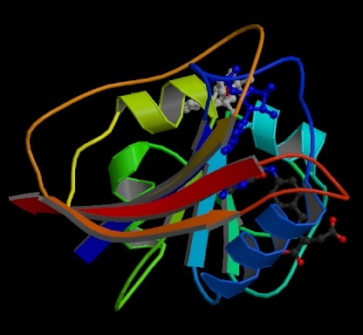
The model shows the alpha-helices in the secondary structure as coils of "ribbon". The beta-pleated sheets are shown as flat bits of ribbon ending in an arrow head. The bits of the protein chain which are just random coils and loops are shown as bits of "string".
The colour coding in the model helps you to track your way around the structure - going through the spectrum from dark blue to end up at red.
You will also notice that this particular model has two other molecules locked into it (shown as ordinary molecular models). These are the two molecules whose reaction this enzyme catalyses.

What holds a protein into its tertiary structure?
The tertiary structure of a protein is held together by interactions between the the side chains - the "R" groups. There are several ways this can happen.
Ionic interactions
Some amino acids (such as aspartic acid and glutamic acid) contain an extra -COOH group. Some amino acids (such as lysine) contain an extra -NH₂ group.
You can get a transfer of a hydrogen ion from the -COOH to the -NH₂ group to form zwitterions just as in simple amino acids.
You could obviously get an ionic bond between the negative and the positive group if the chains folded in such a way that they were close to each other.
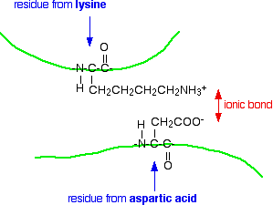
Hydrogen bonds
Notice that we are now talking about hydrogen bonds between side groups - not between groups actually in the backbone of the chain.
Lots of amino acids contain groups in the side chains which have a hydrogen atom attached to either an oxygen or a nitrogen atom. This is a classic situation where hydrogen bonding can occur.
For example, the amino acid serine contains an -OH group in the side chain. You could have a hydrogen bond set up between two serine residues in different parts of a folded chain.
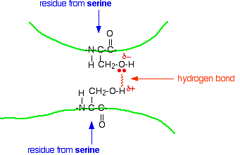
You could easily imagine similar hydrogen bonding involving -OH groups, or -COOH groups, or -CONH₂ groups, or -NH₂ groups in various combinations - although you would have to be careful to remember that a -COOH group and an -NH₂ group would form a zwitterion and produce stronger ionic bonding instead of hydrogen bonds.

