ARYL HALIDES (HALOGENOARENES)

Assoc. Prof. Lubomir Makedonski
Medical University of Varna

The structure of chlorobenzene
We'll look in some detail at the structure of chlorobenzene. Bromobenzene and iodobenzene are just the same.
The simplest way to draw the structure of chlorobenzene is:
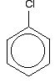
. . . but to understand chlorobenzene properly, you need to dig a bit deeper than this.
There is an interaction between the delocalised electrons in the benzene ring and one of the lone pairs on the chlorine atom. This overlaps with the delocalised ring electron system . . .
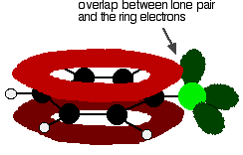
. . . giving a structure rather like this:
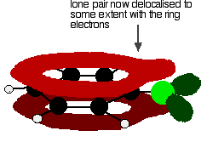
This delocalisation is by no means complete, but it does have a significant effect on the properties of both the carbon-chlorine bond and the polarity of the molecule.
The delocalisation introduces some extra bonding between the carbon and the chlorine, making the bond stronger. This has a major effect on the reactions of compounds like chlorobenzene.
There is also some movement of electrons away from the chlorine towards the ring. Chlorine is quite electronegative and usually draws electrons in the carbon-chlorine bond towards itself. In this case, this is offset to some extent by the movement of electrons back towards the ring in the delocalisation. The molecule is less polar than you would otherwise have expected.
Physical properties
Boiling points
Chlorobenzene, bromobenzene and iodobenzene are all oily liquids. The boiling points increase as the halogen atom gets bigger.
 | boiling point (°C)
C₆H₅Cl | 132
C₆H₅Br | 156
C₆H₅I | 189
The main attractions between the molecules will be van der Waals dispersion forces. These increase as the number of electrons in the molecule increases. This is the reason that the boiling points increase as the halogen atom gets bigger.
There will also be permanent dipole-dipole attractions involved in the chlorobenzene and bromobenzene, but very little in the iodobenzene. Iodine has much the same electronegativity as carbon.
These dipole-dipole attractions must be very unimportant relative to the dispersion forces because the most polar molecule (the chlorobenzene) has the lowest boiling point of the three.
Solubility in water
The aryl halides are insoluble in water. They are denser than water and form a separate lower layer.
The molecules are quite large compared with a water molecule. In order for chlorobenzene to dissolve it would have to break lots of existing hydrogen bonds between water molecules. You also have to break the quite strong van der Waals dispersion forces between chlorobenzene molecules. Both of these cost energy.
The only new forces between the chlorobenzene and the water would be van der Waals dispersion forces. These aren't as strong as hydrogen bonds (or the original dispersion forces in the chlorobenzene), and so you wouldn't get much energy released when they form.
It simply isn't energetically profitable for chlorobenzene (and the others) to dissolve in water.
MAKING ARYL HALIDES (HALOGENOARENES)
Making chlorobenzene
Benzene reacts with chlorine in the presence of a catalyst, replacing one of the hydrogen atoms on the ring by a chlorine atom.
The reaction happens at room temperature. The catalyst is either aluminium chloride or iron.
Strictly speaking iron isn't a catalyst, because it gets permanently changed during the reaction. It reacts with some of the chlorine to form iron(III) chloride, FeCl₃.
This compound acts as the catalyst and behaves exactly like aluminium chloride, AlCl₃, in this reaction.
The reaction between benzene and chlorine in the presence of either aluminium chloride or iron gives chlorobenzene.
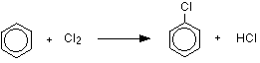
or, written more compactly:
Making bromobenzene
The reaction between benzene and bromine in the presence of either aluminium bromide (rather than aluminium chloride) or iron gives bromobenzene. Iron is usually used because it is cheaper and more readily available. If you use iron, it is first converted into iron(III) bromide by the reaction between the iron and bromine.
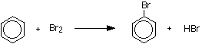
or:
Making iodobenzene
Iodobenzene can be made from the reaction of benzene with iodine if they are heated under reflux in the presence of concentrated nitric acid, but it is normally made from benzenediazonium chloride solution. That's what we will concentrate on here.
If you add cold potassium iodide solution to ice-cold benzenediazonium chloride solution, nitrogen gas is given off, and you get oily droplets of iodobenzene formed.
There is a simple reaction between the diazonium ions present in the benzenediazonium chloride solution and the iodide ions from the potassium iodide solution.
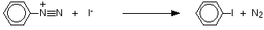
THE REACTIONS OF ARYL HALIDES (HALOGENOARENES)
Nucleophilic substitution reactions
A nucleophile can be either a negative ion or a molecule which carries a partial negative charge somewhere on it.
A nucleophilic substitution reaction is one in which a part of a molecule is replaced after it has been attacked by a nucleophile.
Nucleophilic substitution in the halogenoalkanes
Here is a quick summary of the two ways that halogenoalkanes can react with hydroxide ions. We'll compare these with the aryl halides afterwards.
The two different ways in which these reactions can happen depends on what kind of halogenoalkane you are talking about.
Here is the mechanism for the reaction involving bromoethane - a primary halogenoalkane. A hydroxide ion attacks the slightly positive carbon atom and pushes off the bromine as a bromide ion.
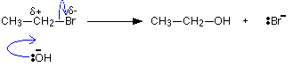
A tertiary halogenoalkane reacts differently.
The mechanism this time involves an initial ionization of the halogenoalkane:
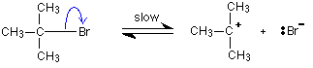
. . . followed by a very rapid attack by the hydroxide ion on the carbocation (carbonium ion) formed:
