Top of Form

Carbohydrates

Assoc. prof. Lubomir Makedonski, PhD
Medical University – Varna

Carbohydrates are the most abundant class of organic compounds found in living organisms. They originate as products of photosynthesis, an endothermic reductive condensation of carbon dioxide requiring light energy and the pigment chlorophyll.

n CO₂ + n H₂O + energy C_{n}H_{2n}O_{n} + n O₂

As noted here, the formulas of many carbohydrates can be written as carbon hydrates, C_{n}(H₂O)_{n}, hence their name. The carbohydrates are a major source of metabolic energy, both for plants and for animals that depend on plants for food.
Carbohydrates are called saccharides or, if they are relatively small, sugars.

Types of carbohydrates

The simplest carbohydrates are monosaccharide. A monosaccharide can be split or hydrolyzed into smaller carbohydrates. Disaccharides consist of two monosaccharide units joint together. For example, ordinary table sugar, sucrose( C₁₂H₂₂O₁₁) is a disaccharides that hydrolyses in the presence of an acid or an enzyme to give one molecule of glucose and one molecule of another monosaccharide, fructose.

H+ or enzyme
C₁₂H₂₂O₁₁ + H₂O C₆H₁₂O₆ + C₆H₁₂O₆

Polysaccharides are carbohydrates that are naturally accruing polymers containing many monosaccharide units. In the presence of an acid or an enzyme, polysaccharides can be completely hydrolyzed to yield many molecules of monosaccharide.

Monosaccharide + H₂O no hydrolysis
Disaccharides + H₂O two monosaccharide units
Polysaccharides + H₂O many monosaccharide units

Monosaacharadises

Monosaccharide are simple sugars that have a chain of three to eight carbon atoms, one in carbonyl group and the rest attached to hydroxyl group. There are two types of monosaccharide structures. In an aldose, the carbonyl group is one the first atom (-CHO), a ketose contains the carbonyl group on the second carbon atom as a ketone (C=0)
A monosaccharide with three carbon atoms is a triose, one with four carbons is a tetrose, a pentose has five carbons and a hexose contains six carbon atoms.

Monosaccharides are simple sugars

Complexity | Simple Carbohydrates  monosaccharides | Complex Carbohydrates  disaccharides, oligosaccharides  & polysaccharides

Size | Tetrose  C₄ sugars | Pentose  C₅ sugars | Hexose  C₆ sugars | Heptose  C₇ sugars | etc.

C=O Function | Aldose  sugars having an aldehyde function or an acetal equivalent.  Ketose  sugars having a ketone function or an acetal equivalent.

Reactivity | Reducing  sugars oxidized by Tollens' reagent (or Benedict's or Fehling's reagents).  Non-reducing  sugars not oxidized by Tollens' or other reagents.

Glucose
Carbohydrates have been given non-systematic names, although the suffix ose is generally used. The most common carbohydrate is glucose (C₆H₁₂O₆). Applying the terms defined above, glucose is a monosaccharide, an aldohexose (note that the function and size classifications are combined in one word) and a reducing sugar. The general structure of glucose and many other aldohexoses was established by simple chemical reactions.
Glucose also contains five hydroxyl groups, which officially makes it an alcohol. It is important to note on which “side” of the molecule the hydroxyl groups may be found because the mirror image molecule is not the same thing. Notice that all of the –OH groups except the one on the third carbon are on the right side. These hydroxyl groups function differently than hydroxide ions. Thus, the straight structure of glucose includes a carbonyl group (–C=O) on C-1, hydroxyl groups (–OH) on the right sides of carbons 2, 4, 5, and 6, and a hydroxyl group on the left side of C-3. Know how to draw this.
D glucose glucose L glucose
Fisher Projections

In reality, what we have drawn as a straight line structure is really a curved molecule. If you imagine C-3 and C-4 as being in the plane of the chalkboard/paper/computer screen, then C-1 and C-2 on the top end and C-5 and C-6 on the bottom end curve around to the back. In actuality, C-1 is very close to C-5. Because of this, glucose would rather form a ring. The O on C-1 releases one of its bonds to C-1, and instead, bonds to the H from the –OH on C-5. The O on C-5 then needs something else to bond to, as does C-1 (which is no longer sharing a double bond) so the two of them bond together, forming a ring. When the ring forms, the –OH groups on carbons 2, 4, and 5 that were on the right will be in the down positions, and the –OH on the right of C-3, will be “up.” When the ring closes, sometimes the “new” –OH on C-1 goes down (the - or alpha form) and sometimes it goes up (the - or beta form), but both of these are still glucose.

Cyclic Forms of Monosaccharides

The cyclic pyranose forms of various monosaccharides are often drawn in a flat projection known as a Haworth formula, after the British chemist, Norman Haworth.
As noted above, the preferred structural form of many monosaccharides may be that of a cyclic hemiacetal. Five and six-membered rings are favored over other ring sizes because of their low angle and eclipsing strain. Cyclic structures of this kind are termed furanose (five-membered) or pyranose (six-membered), reflecting the ring size relationship to the common heterocyclic compounds furan and pyran shown on the right. Ribose, an important aldopentose, commonly adopts a furanose structure, as shown in the following illustration. By convention for the D-family, the five-membered furanose ring is drawn in an edgewise projection with the ring oxygen positioned away from the viewer. The anomeric carbon atom (colored red here) is placed on the right. The upper bond to this carbon is defined as beta, the lower bond then is alpha.

α- D – glucose β- D- glucose
Haworth structure of glucose

Some Important monosaccharide
D-mannose D-galactose D-ribose D- deoxyribose

Ketoses

If a monosaccharide has a carbonyl function on one of the inner atoms of the carbon chain it is classified as a ketose. Dihydroxyacetone may not be a sugar, but it is included as the ketose analog of glyceraldehyde. The carbonyl group is commonly found at C-2, as illustrated by the following examples (chiral centers are colored red).
D-Fructose, the sweetest of the common natural sugars, is for example reduced to a mixture of D-glucitol (sorbitol) and D-mannitol, named after the aldohexoses from which they may also be obtained by analogous reduction. Mannitol is itself a common natural carbohydrate.
Although the ketoses are distinct isomers of the aldose monosaccharides, the chemistry of both classes is linked due to their facile interconversion in the presence of acid or base catalysts.

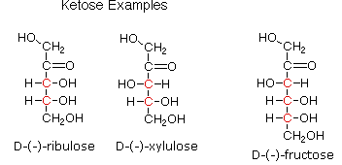

D-fructose fructose L-fructose
Fisher Projections

α- D – gfructose β- D- fructose
Haworth structure of glucose

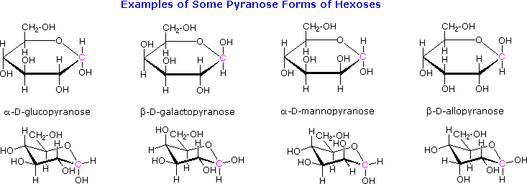

Disaccharides
When the alcohol component of a glycoside is provided by a hydroxyl function on another monosaccharide, the compound is called a disaccharide.
Monosaccharide can be linked into disaccharides by two ways:
- The glycoside hydroxide group of the first monosaccharide is linked with the ordinary (alcoholic) hydroxide group of the second one -reducing sugars ( because there is a free glycoside hydroxyl group)
Maltose – α-D-glucose + α-D-glucose; 1-4 α linkage
α-1,4 linkage
When a hydroxyl group in one monosaccharide reacts with hydroxyl group in another monosaccharide, a mono glycosidic bond forms and the products is a disaccharide. In maltose, the glycosidic bond that joins the two glucose molecules is designated as α-1,4 linkage to show that –OH on carbon 1 of α-D glucose bonds to C4 of the second glucose. In the second glucose molecules, the –OH group on C1 gives the α and β forms. Maltose is reducing sugar because the –OH on carbon 1 of the second glucose opens to give an aldehyde group.

Cellobiose - β-D-glucose + α-D-glucose: 1-4 β linkage

Cellobiose - 1-4 β linkage

Lactose - β-D-galactose + α-D-glucose; 1-4 β linkage
Lactose 1-4 β glycosidic bond
- The glycoside hydroxide group of the first monosaccharide is linked with the glycoside hydroxide group of the second one-non reducing sugars ( because there is no free glycoside hydroxyl group)
Sucrose - α-D- glucose + β-D-fructose

Sucrose- α, β-1,2-Glycosidic bond

SUGAR COMPARISON
Sugar | Carbohydrate | Monosaccharide or disaccharide | Additional information
Beet sugar (cane sugar) | Sucrose | Disaccharide (fructose and glucose) | Similar to white and powdered sugar, but varied degree of purification
Brown sugar | Sucrose | Disaccharide (fructose and glucose) | Similar to white and powdered sugar, but varied degree of purification
Corn syrup | Glucose | Monosaccharide
Fruit sugar | Fructose | Monosaccharide | Very sweet
High-fructose corn syrup | Fructose | Monosaccharide | Very sweet and inexpensive  Added to soft drinks and canned or frozen fruits
Honey | Fructose and glucose | Monosaccharides
Malt sugar | Maltose | Disaccharide (glucose and glucose) | Formed by the hydrolysis of starch, but sweeter than starch
Maple syrup | Sucrose | Disaccharide (fructose and glucose)
Milk sugar | Lactose | Disaccharide (glucose and galactose) | Made in mammary glands of most lactating animals
Powdered sugar | Sucrose | Disaccharide (fructose and glucose) | Similar to white and brown sugar, but varied degree of purification
White sugar | Sucrose | Disaccharide (fructose and glucose) | Similar to brown and powdered sugar, but varied degree of purification
SOURCE: Mahan and Escott-Stump, 2000; Northwestern University; Sizer and Whitney, 1997; and Wardlaw and Kessel, 2002.

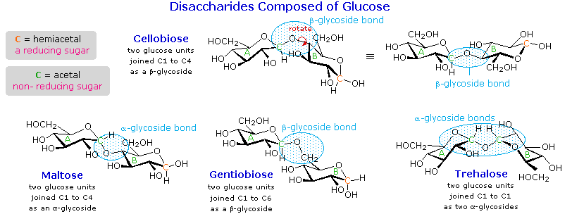
Polysaccharides
Polysaccharides are long chains of monosaccharides, like glucose molecules, all hooked together by 1-4 glycosidic linkages formed through dehydration synthesis. There are two main categories of polysaccharides. Storage polysaccharides include starches and related compounds in plants, and glycogen in animal liver and muscles. These giant molecules are made from repeating units of glucose in the configuration, so they can all join together in a straight chain. These are referred to as having -1-4 glycosidic linkages. Structural polysaccharides include cellulose and related compounds. Cellulose is found in plant cell walls and is the most abundant organic compound on Earth. This provides us with fiber in our diet, wood, and paper. Cellulose is formed from glucose in the configuration, and for the -1-4 glycosidic linkages to form, every other glucose molecule must flip up side down, as we saw in lactose.

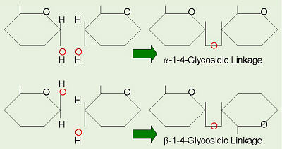
As the name implies, polysaccharides are large high-molecular weight molecules constructed by joining monosaccharide units together by glycosidic bonds. The most important compounds in this class, cellulose, starch and glycogen are all polymers of glucose. Since partial hydrolysis of cellulose gives varying amounts of cellobiose, we conclude the glucose units in this macromolecule are joined by beta-glycoside bonds between C-1 and C-4 sites of adjacent sugars. Partial hydrolysis of starch and glycogen produces the disaccharide maltose together with low molecular weight dextrans, polysaccharides in which glucose molecules are joined by alpha-glycoside links between C-1 and C-6, as well as the alpha C-1 to C-4 links found in maltose.
Over half of the total organic carbon in the earth's biosphere is in cellulose. Cotton fibres are essentially pure cellulose, and the wood of bushes and trees is about 50% cellulose. As a polymer of glucose, cellulose has the formula (C₆H₁₀O₅)_{n} where n ranges from 500 to 5,000, depending on the source of the polymer. The glucose units in cellulose are linked in a linear fashion, as shown in the drawing below

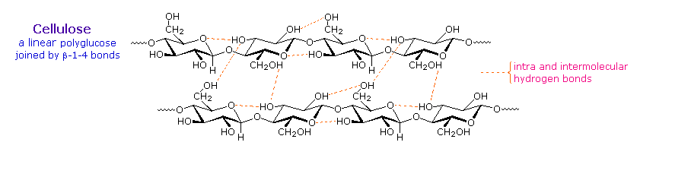
Starch
Starch is a polymer of glucose, found in roots, Most animals, including humans, depend on these plant starches for nourishment. The structure of starch is more complex than that of cellulose. The intact granules are insoluble in cold water, but grinding or swelling them in warm water causes them to burst.
The released starch consists of two fractions. About 20% is a water soluble material called amylose. Molecules of amylose are linear chains of several thousand glucose units joined by alpha C-1 to C-4 glycoside bonds. Amylose solutions are actually dispersions of hydrated helical micelles.
Unbranched chain of amylose

The majority of the starch is a much higher molecular weight substance, consisting of nearly a million glucose units, and called amylopectin. Molecules of amylopectin are branched networks built from C-1 to C-4 and C-1 to C-6 glycoside links, and are essentially water insoluble.
Branched-chain of amylopectin
Hydrolysis of starch, usually by enzymatic reactions, produces a syrupy liquid consisting largely of glucose. When cornstarch is the feedstock, this product is known as corn syrup. It is widely used to soften texture, add volume, prohibit crystallization and enhance the flavor of foods.
Glycogen is the glucose storage polymer used by animals. It has a structure similar to amylopectin, but is even more highly branched (about every tenth glucose unit). The degree of branching in these polysaccharides may be measured by enzymatic or chemical analysis.
There are three particularly important disaccharides: sucrose, maltose, and lactose. Sucrose is formed when glucose and fructose are held together by an alpha bond. It is found in sugar cane or sugar beets and is refined to make granulated table sugar. Varying the degree of purification alters the

Complex Carbohydrates
Complex carbohydrates, or polysaccharides, are composed of simple sugar units in long chains called polymers. Three polysaccharides are of particular importance in human nutrition: starch, glycogen, and dietary fiber.
Starch and glycogen are digestible forms of complex carbohydrates made of strands of glucose units linked by alpha bonds. Starch, often contained in seeds, is the form in which plants store energy, and there are two types: amylose and amylopectin. Starch represents the main type of digestible complex carbohydrate. Humans use an enzyme to break down the bonds linking glucose units, thereby releasing the sugar to be absorbed into the bloodstream. At that point, the body can distribute glucose to areas that need energy, or it can store the glucose in the form of glycogen.

Glycogen is the polysaccharide used to store energy in animals, including humans. Like starch, glycogen is made up of chains of glucose linked by alpha bonds; but glycogen chains are more highly branched than starch. It is this highly branched structure that allows the bonds to be more quickly broken down by enzymes in the body. The primary storage sites for glycogen in the human body are the liver and the muscles.
Another type of complex carbohydrate is dietary fiber. In general, dietary fiber is considered to be polysaccharides that have not been digested at the point of entry into the large intestine. Fiber contains sugars linked by bonds that cannot be broken down by human enzymes, and are therefore
Pastas and whole-grain breads contain complex carbohydrates, which are long strands of glucose molecules. Nutritionists recommend that 55–60 percent of calories come from carbohydrates, and especially complex carbohydrates.
labeled as indigestible. Because of this, most fibers do not provide energy for the body. Fiber is derived from plant sources and contains polysaccharides such as cellulose, hemicellulose, pectin, gums, mucilages, and lignins.

The indigestible fibers cellulose, hemicellulose, and lignin make up the structural part of plants and are classified as insoluble fiber because they usually do not dissolve in water. Cellulose is a nonstarch carbohydrate polymer made of a straight chain of glucose molecules linked by beta bonds and can be found in whole-wheat flour, bran, and vegetables. Hemicellulose is a nonstarch carbohydrate polymer made of glucose, galactose, xylose, and other monosaccharides; it can be found in bran and whole grains. Lignin, a noncarbohydrate polymer containing alcohols and acids, is a woody fiber found in wheat bran and the seeds of fruits and vegetables.
In contrast, pectins, mucilages, and gums are classified as soluble fibers because they dissolve or swell in water. They are not broken down by human enzymes, but instead can be metabolized (or fermented) by bacteria present in the large intestine. Pectin is a fiber made of galacturonic acid and other monosaccharides. Because it absorbs water and forms a gel, it is often used in jams and jellies. Sources of pectin include citrus fruits, apples, strawberries, and carrots. Mucilages and gums are similar in structure. Mucilages are dietary fibers that contain galactose, manose, and other monosaccharides; and gums are dietary fibers that contain galactose, glucuronic acid, and other monosaccharides. Sources of gums include oats, legumes, guar, and barley.

Exchange System

The exchange system is composed of lists that describe carbohydrate, fat, and protein content, as well as caloric content, for designated portions of specific foods. This system takes into account the presence of more than one type of nutrient in any given food. Exchange lists are especially useful for individuals who require careful diet planning, such as those who monitor intake of calories or certain nutrients. It is particularly useful for diabetics, for whom carbohydrate intake must be carefully controlled, and was originally developed for planning diabetic diets.

Diabetes, Carbohydrate-Modified Diets, and Carbohydrate Counting

Diabetes is a condition that alters the way the body handles carbohydrates. In terms of diet modifications, diabetics can control blood sugar levels by appropriately managing the carbohydrates, proteins, and fats in their meals. The amount of carbohydrates, not necessarily the source, is the primary issue. Blood glucose levels after a meal can be related to the process of food preparation, the amount of food eaten, fat intake, sugar absorption, and the combination of foods in the meal or snack.
One method of monitoring carbohydrate levels—carbohydrate counting—assigns a certain number of carbohydrate grams or exchanges to specific foods. Calculations are used to determine insulin need, resulting in better control of blood glucose levels with a larger variety of foods. Overall, diabetic diets can include moderate amounts of sugar, as long as they are carefully monitored.

