DERIVATIVES OF CARBOXYLIC ACIDS
ESTERS

Assoc. Prof. Lubomir Makedonski
Medical University of Varna

What are esters?
Esters are derived from carboxylic acids. A carboxylic acid contains the -COOH group, and in an ester the hydrogen in this group is replaced by a hydrocarbon group of some kind. This could be an alkyl group like methyl or ethyl, or one containing a benzene ring like phenyl.
A common ester - ethyl ethanoate
The most commonly discussed ester is ethyl ethanoate. In this case, the hydrogen in the -COOH group has been replaced by an ethyl group. The formula for ethyl ethanoate is:
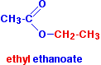
Notice that the ester is named the opposite way around from the way the formula is written. The "ethanoate" bit comes from ethanoic acid. The "ethyl" bit comes from the ethyl group on the end.
A few more esters
In each case, be sure that you can see how the names and formulae relate to each other.
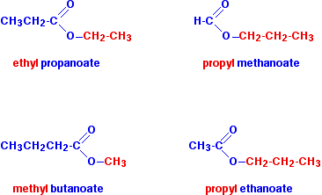

Notice that the acid is named by counting up the total number of carbon atoms in the chain - including the one in the -COOH group. So, for example, CH₃CH₂COOH is propanoic acid, and CH₃CH₂COO is the propanoate group.
Fats and oils
Differences between fats and oils
Animal and vegetable fats and oils are just big complicated esters. The difference between a fat (like butter) and an oil (like sunflower oil) is simply in the melting points of the mixture of esters they contain.
If the melting points are below room temperature, it will be a liquid - an oil. If the melting points are above room temperature, it will be a solid - a fat.
The causes of the differences in melting points will be discussed further down the page under physical properties.
A simple introduction to their structures
Fats and oils as big esters
Esters can be made from carboxylic acids and alcohols. This is discussed in detail on another page, but in general terms, the two combine together losing a molecule of water in the process.
We'll start with a very, very simple ester like ethyl ethanoate - not something complicated like a fat or oil!
The diagram shows the relationship between the ethanoic acid, the ethanol and the ester.
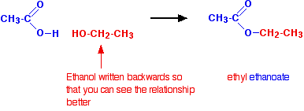
This isn't intended to be a full equation. Water, of course, is also produced.
Now lets make the alcohol a bit more complicated by having more than one -OH group. The diagram below shows the structure of propane-1,2,3-triol (old name: glycerol).
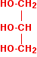
Just as with the ethanol in the previous equation, I've drawn this back-to-front to make the next diagrams clearer. Normally, it is drawn with the -OH groups on the right-hand side.
If you make an ester of this with ethanoic acid, you could attach three ethanoate groups.
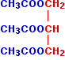
Now, make the acid chains much longer, and you finally have a fat.

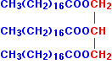
The acid CH₃(CH₂)₁₆COOH is called octadecanoic acid, but the old name is still commonly used. This is stearic acid.
The full name for the ester of this with propane-1,2,3-triol is propane-1,2,3-triyl trioctadecanoate. But the truth is that almost everybody calls it (not surprisingly!) by its old name of glyceryl tristearate.
Saturated and unsaturated fats and oils
If the fat or oil is saturated, it means that the acid that it was derived from has no carbon-carbon double bonds in its chain. Stearic acid is a saturated acid, and so glyceryl tristearate is a saturated fat.
If the acid has just one carbon-carbon double bond somewhere in the chain, it is called mono-unsaturated. If it has more than one carbon-carbon double bond, it is polyunsaturated.
Those same terms will then apply to the esters that are formed.
All of these are saturated acids, and so will form saturated fats and oils:
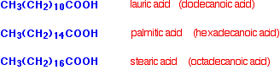
Oleic acid is a typical mono-unsaturated acid:
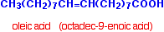
. . . and linoleic and linolenic acids are typical polyunsaturated acids.
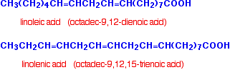
You might possibly have come across the terms "omega 6" and "omega 3" in the context of fats and oils.
Linoleic acid is an omega 6 acid. It just means that the first carbon-carbon double bond starts on the sixth carbon from the CH₃ end.
Linolenic acid is an omega 3 acid for the same reason.
Because of their relationship with fats and oils, all of the acids above are sometimes described as fatty acids.
Physical properties
Simple esters
I am thinking here about things like ethyl ethanoate.
Boiling points
The small esters have boiling points which are similar to those of aldehydes and ketones with the same number of carbon atoms.
Like aldehydes and ketones, they are polar molecules and so have dipole-dipole interactions as well as van der Waals dispersion forces. However, they don't form hydrogen bonds, and so their boiling points aren't anything like as high as an acid with the same number of carbon atoms.
For example:
molecule | type | boiling point (°C)
CH₃COOCH₂CH₃ | ester | 77.1
CH₃CH₂CH₂COOH | carboxylic acid | 164

Solubility in water
The small esters are fairly soluble in water but solubility falls with chain length.
For example:
ester | formula | solubility (g per 100 g of water)
ethyl methanoate | HCOOCH₂CH₃ | 10.5
ethyl ethanoate | CH₃COOCH₂CH₃ | 8.7
ethyl propanoate | CH₃CH₂COOCH₂CH₃ | 1.7

The reason for the solubility is that although esters can't hydrogen bond with themselves, they can hydrogen bond with water molecules.
One of the slightly positive hydrogen atoms in a water molecule can be sufficiently attracted to one of the lone pairs on one of the oxygen atoms in an ester for a hydrogen bond to be formed.
There will also, of course, be dispersion forces and dipole-dipole attractions between the ester and the water molecules.
Forming these attractions releases energy. This helps to supply the energy needed to separate water molecule from water molecule and ester molecule from ester molecule before they can mix together.
As chain lengths increase, the hydrocarbon parts of the ester molecules start to get in the way.
By forcing themselves between water molecules, they break the relatively strong hydrogen bonds between water molecules without replacing them by anything as good. This makes the process energetically less profitable, and so solubility decreases.
The physical properties of fats and oils
Solubility in water
None of these molecules are water soluble. The chain lengths are now so great that far too many hydrogen bonds between water molecules would have to be broken - so it isn't energetically profitable.
Melting points
The melting points determine whether the substance is a fat (a solid at room temperature) or an oil (a liquid at room temperature).
Fats normally contain saturated chains. These allow more effective van der Waals dispersion forces between the molecules. That means you need more energy to separate them, and so increases the melting points.
The greater the extent of the unsaturation in the molecules, the lower the melting points tend to be because the van der Waals dispersion forces are less effective.
Why should this be? We are talking about molecules of very similar sizes and so the potential for temporary dipoles should be much the same in all of them. What matters, though, is how close together the molecules can get.
van der Waals dispersion forces need the molecules to be able to pack closely together to be really effective. The presence of carbon-carbon double bonds in the chains gets in the way of tidy packing.
Here is a simplified diagram of a saturated fat:
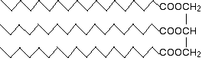

The hydrocarbon chains are, of course, in constant motion in the liquid, but it is possible for them to lie tidily when the substance solidifies. If the chains in one molecule can lie tidily, that means that neighbouring molecules can get close.
That increases the attractions between one molecule and its neighbours and so increases the melting point.

Unsaturated fats and oils have at least one carbon-carbon double bond in at least one chain.
There isn't any rotation about a carbon-carbon double bond and so that locks a permanent kink into the chain. That makes packing molecules close together more difficult. If they don't pack so well, the van der Waals forces won't work as well.
This effect is much worse for molecules where the hydrocarbon chains either end of the double bond are arranged cis to each other - in other words, both of them on the same side of the double bond:
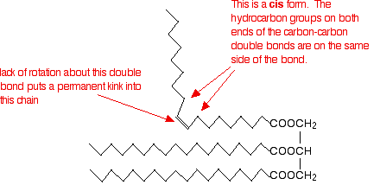

If they are on opposite sides of the double bond (the trans form) the effect isn't as marked. It is, however, rather more than the diagram below suggests because of the changes in bond angles around the double bond compared with the rest of the chain.
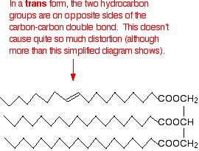

Trans fats and oils have higher melting points than cis ones because the packing isn't affected quite as much. Naturally occurring unsaturated fats and oils tend to be the cis form.
MAKING ESTERS
Making esters using carboxylic acids
This method can be used for converting alcohols into esters, but it doesn't work with phenols - compounds where the -OH group is attached directly to a benzene ring. Phenols react with carboxylic acids so slowly that the reaction is unusable for preparation purposes.
The chemistry of the reaction
Esters are produced when carboxylic acids are heated with alcohols in the presence of an acid catalyst. The catalyst is usually concentrated sulphuric acid. Dry hydrogen chloride gas is used in some cases, but these tend to involve aromatic esters (ones where the carboxylic acid contains a benzene ring).
The esterification reaction is both slow and reversible. The equation for the reaction between an acid RCOOH and an alcohol R'OH (where R and R' can be the same or different) is:
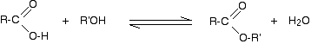
So, for example, if you were making ethyl ethanoate from ethanoic acid and ethanol, the equation would be:
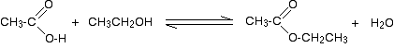
THE MECHANISM FOR THE ESTERIFICATION REACTION

The mechanism for the formation of ethyl ethanoate
A reminder of the facts
Ethanoic acid reacts with ethanol in the presence of concentrated sulphuric acid as a catalyst to produce the ester, ethyl ethanoate. The reaction is slow and reversible. To reduce the chances of the reverse reaction happening, the ester is distilled off as soon as it is formed.

The mechanism
All the steps in the mechanism below are shown as one-way reactions because it makes the mechanism look less confusing. The reverse reaction is actually done sufficiently differently that it affects the way the mechanism is written. You will find a link to the hydrolysis of esters further down the page if you are interested.
Step 1
In the first step, the ethanoic acid takes a proton (a hydrogen ion) from the concentrated sulphuric acid. The proton becomes attached to one of the lone pairs on the oxygen which is double-bonded to the carbon.
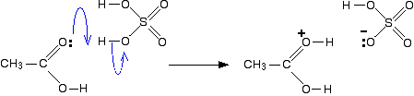
The transfer of the proton to the oxygen gives it a positive charge, but it is actually misleading to draw the structure in this way (although nearly everybody does!).
The positive charge is delocalised over the whole of the right-hand end of the ion, with a fair amount of positiveness on the carbon atom. In other words, you can think of an electron pair shifting to give this structure:
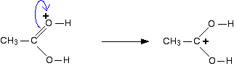
You could also imagine another electron pair shift producing a third structure:
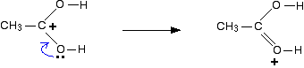
So which of these is the correct structure of the ion formed? None of them! The truth lies somewhere in between all of them. One way of writing the delocalised structure of the ion is like this:
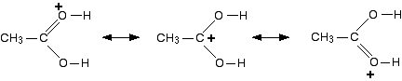
The double headed arrows are telling you that each of the individual structures makes a contribution to the real structure of the ion. They don't mean that the bonds are flipping back and forth between one structure and another. The various structures are known as resonance structures or canonical forms.
There will be some degree of positive charge on both of the oxygen atoms, and also on the carbon atom. Each of the bonds between the carbon and the two oxygens will be the same - somewhere between a single bond and a double bond.
For the purposes of the rest of this discussion, we are going to use the structure where the positive charge is on the carbon atom.
Step 2
The positive charge on the carbon atom is attacked by one of the lone pairs on the oxygen of the ethanol molecule.
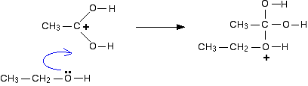
Step 3
What happens next is that a proton (a hydrogen ion) gets transferred from the bottom oxygen atom to one of the others. It gets picked off by one of the other substances in the mixture (for example, by attaching to a lone pair on an unreacted ethanol molecule), and then dumped back onto one of the oxygens more or less at random.
The net effect is:
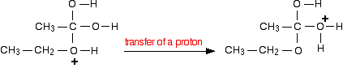
Step 4
Now a molecule of water is lost from the ion.
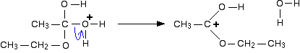
The product ion has been drawn in a shape to reflect the product which we are finally getting quite close to!
The structure for the latest ion is just like the one we discusssed at length back in step 1. The positive charge is actually delocalised all over that end of the ion, and there will also be contributions from structures where the charge is on the either of the oxygens:
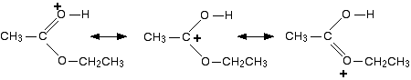
It is easier to follow what is happening if we keep going with the structure with the charge on the carbon.
Step 5
The hydrogen is removed from the oxygen by reaction with the hydrogensulphate ion which was formed way back in the first step.
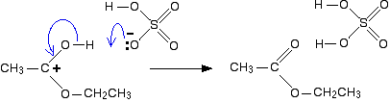
And there we are! The ester has been formed, and the sulphuric acid catalyst has been regenerated.

Making esters using acyl chlorides (acid chlorides)
This method will work for alcohols and phenols. In the case of phenols, the reaction is sometimes improved by first converting the phenol into a more reactive form.
The basic reaction
If you add an acyl chloride to an alcohol, you get a vigorous (even violent) reaction at room temperature producing an ester and clouds of steamy acidic fumes of hydrogen chloride.
For example, if you add the liquid ethanoyl chloride to ethanol, you get a burst of hydrogen chloride produced together with the liquid ester ethyl ethanoate.

The substance normally called "phenol" is the simplest of the family of phenols. Phenol has an -OH group attached to a benzene ring - and nothing else.
The reaction between ethanoyl chloride and phenol is similar to the ethanol reaction although not so vigorous. Phenyl ethanoate is formed together with hydrogen chloride gas.
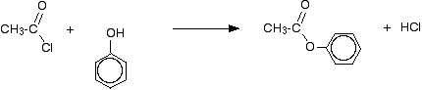
Improving the reactions between phenols and some less reactive acyl chlorides
Benzoyl chloride has the formula C₆H₅COCl. The -COCl group is attached directly to a benzene ring. It is much less reactive than simple acyl chlorides like ethanoyl chloride.
The phenol is first converted into the ionic compound sodium phenoxide (sodium phenate) by dissolving it in sodium hydroxide solution.
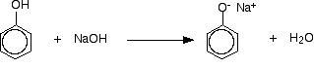
The phenoxide ion reacts more rapidly with benzoyl chloride than the original phenol does, but even so you have to shake it with benzoyl chloride for about 15 minutes. Solid phenyl benzoate is formed.
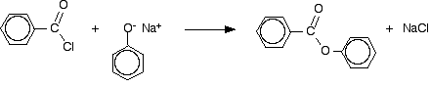

Making esters using acid anhydrides
This reaction can again be used to make esters from both alcohols and phenols. The reactions are slower than the corresponding reactions with acyl chlorides, and you usually need to warm the mixture.
In the case of a phenol, you can react the phenol with sodium hydroxide solution first, producing the more reactive phenoxide ion.

Taking ethanol reacting with ethanoic anhydride as a typical reaction involving an alcohol:
There is a slow reaction at room temperature (or faster on warming). There is no visible change in the colourless liquids, but a mixture of ethyl ethanoate and ethanoic acid is formed.

The reaction with phenol is similar, but will be slower. Phenyl ethanoate is formed together with ethanoic acid.
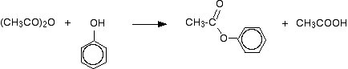
This reaction isn't important itself, but a very similar reaction is involved in the manufacture of aspirin (covered in detail on another page - link below).
If the phenol is first converted into sodium phenoxide by adding sodium hydroxide solution, the reaction is faster. Phenyl ethanoate is again formed, but this time the other product is sodium ethanoate rather than ethanoic acid.
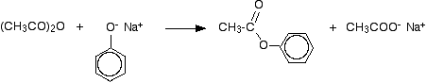

HYDROLYSING ESTERS
Hydrolysing simple esters
What is hydrolysis?
Technically, hydrolysis is a reaction with water. That is exactly what happens when esters are hydrolysed by water or by dilute acids such as dilute hydrochloric acid.
The alkaline hydrolysis of esters actually involves reaction with hydroxide ions, but the overall result is so similar that it is lumped together with the other two.
Hydrolysis using water or dilute acid
The reaction with pure water is so slow that it is never used. The reaction is catalysed by dilute acid, and so the ester is heated under reflux with a dilute acid like dilute hydrochloric acid or dilute sulphuric acid.
Here are two simple examples of hydrolysis using an acid catalyst.
First, hydrolysing ethyl ethanoate:
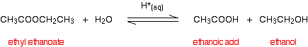

. . . and then hydrolysing methyl propanoate:
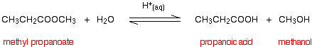

Notice that the reactions are reversible. To make the hydrolysis as complete as possible, you would have to use an excess of water. The water comes from the dilute acid, and so you would mix the ester with an excess of dilute acid.
THE MECHANISM FOR THE ACID CATALYSED HYDROLYSIS OF ESTERS

This page looks in detail at the mechanism for the hydrolysis of esters in the presence of a dilute acid (such as hydrochloric acid or sulphuric acid) acting as the catalyst. It uses ethyl ethanoate as a typical ester.

The mechanism for the hydrolysis of ethyl ethanoate
A reminder of the facts
Ethyl ethanoate is heated under reflux with a dilute acid such as dilute hydrochloric acid or dilute sulphuric acid. The ester reacts with the water present to produce ethanoic acid and ethanol.
Because the reaction is reversible, an equilibrium mixture is produced containing all four of the substances in the equation. In order to get as much hydrolysis as possible, a large excess of water can be used. The dilute acid provides both the acid catalyst and the water.

The mechanism
Hydrolysis using dilute alkali
This is the usual way of hydrolysing esters. The ester is heated under reflux with a dilute alkali like sodium hydroxide solution.
There are two big advantages of doing this rather than using a dilute acid. The reactions are one-way rather than reversible, and the products are easier to separate.
Taking the same esters as above, but using sodium hydroxide solution rather than a dilute acid:
First, hydrolysing ethyl ethanoate using sodium hydroxide solution:
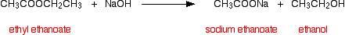

. . . and then hydrolysing methyl propanoate in the same way:
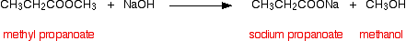

Notice that you get the sodium salt formed rather than the carboxylic acid itself.
This mixture is relatively easy to separate. Provided you use an excess of sodium hydroxide solution, there won't be any ester left - so you don't have to worry about that.
The alcohol formed can be distilled off. That's easy!
If you want the acid rather than its salt, all you have to do is to add an excess of a strong acid like dilute hydrochloric acid or dilute sulphuric acid to the solution left after the first distillation.
If you do this, the mixture is flooded with hydrogen ions. These are picked up by the ethanoate ions (or propanoate ions or whatever) present in the salts to make ethanoic acid (or propanoic acid, etc). Because these are weak acids, once they combine with the hydrogen ions, they tend to stay combined.
The carboxylic acid can now be distilled off.

Hydrolysing complicated esters to make soap
This next bit deals with the alkaline hydrolysis (using sodium hydroxide solution) of the big esters found in animal and vegetable fats and oils.
If the large esters present in animal or vegetable fats and oils are heated with concentrated sodium hydroxide solution exactly the same reaction happens as with the simple esters.
A salt of a carboxylic acid is formed - in this case, the sodium salt of a big acid such as octadecanoic acid (stearic acid). These salts are the important ingredients of soap - the ones that do the cleaning.
An alcohol is also produced - in this case, the more complicated alcohol, propane-1,2,3-triol (glycerol).

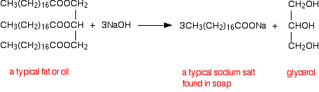

Because of its relationship with soap making, the alkaline hydrolysis of esters is sometimes known as saponification.

Lipids containing Glycerol

Triglycerides
Triglycerides are also called as Triacylglycerols or neutral fats. Triglycerides are:

- Triglycerides are non-polar, water insoluble fatty acid triesters of glycerol.

- Triglycerides function as energy reservoirs in animals (stored in adipose tissues- “remember love handles”) and thus the most abundant class of lipids.

- Triglycerides differ according to their identity and the position that the three fatty acid residues are esterified to glycerol.

- If the triglycerides have only one type of fatty acid then they are termed as simple triglycerides.

- The more common triglycerides contain more than one type of fatty acid and are termed mixed triglycerides.

- When acid hydrolyzed by acids, triglycerides yield three fatty acids and glycerol.

- When hydrolyzed by base, triglycerides yield salts of the three fatty acids and glycerol. This base hydrolysis is termed as saponification, and results in making soap.



Glycerophospholipids ( Phospholipids)

Glycerophospholipids (phosphoghlycerides) are major components of biological membranes. Phospholipids are made up of one or more fatty acids, glycerol, a phosphate and an alcohol attached to the phosphate.

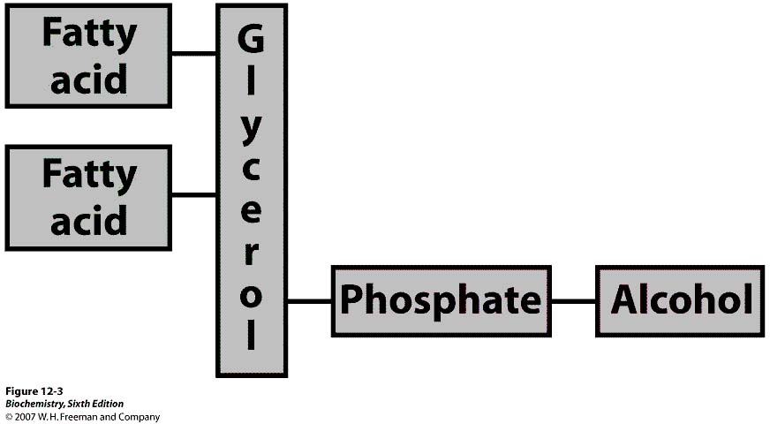

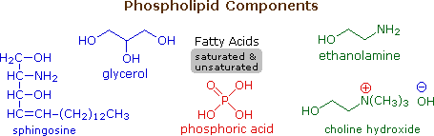

Phospholipids are the main constituents of cell membranes. They resemble the triglycerides in being ester or amide derivatives of glycerol or sphingosine with fatty acids and phosphoric acid. The phosphate moiety of the resulting phosphatidic acid is further esterified with ethanolamine, choline or serine in the phospholipid itselfNote that the fatty acid components (R & R') may be saturated or unsaturated.

In phosphoglycerides the hydroxyl groups at C1 and C2 of glycerol are esterified to the carboxyl groups of the two fatty acid chains. The C3 hydroxyl group of the glycerol backbone is esterified to the phosphoric acid.
When no such groups are added then it is called phosphatidic acid or phosphatidate- the simplest phosphoglyceride.

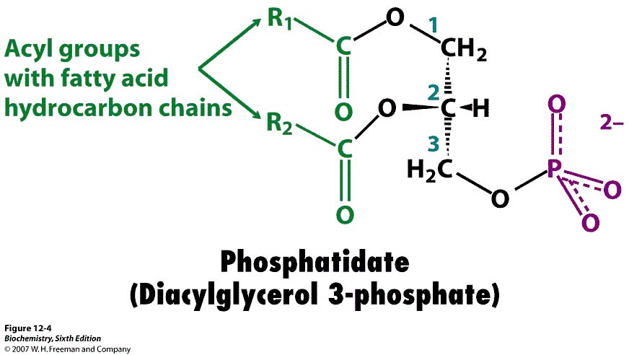

The major phosphoglycerides are derived from phosphatidate by the formation of an ester bond between the phosphate group of phosphatidate and the OH-group of one of the several alcohols such as serine, ethanolamine, choline, glycerol and inositol.

The resulting phospholipids are termed as phosphatidyl serine, phosphatidyl ethanolamine, phosphatidyl choline, phosphatidyl glycerol and phosphatidyl inositol respectively (collectively called as Lecithins).

α- lecithin.

α-кефалин

As ionic amphiphiles, phospholipids aggregate or self-assemble when mixed with water, but in a different manner than the soaps and detergents. Because of the two pendant alkyl chains present in phospholipids and the unusual mixed charges in their head groups, micelle formation is unfavorable relative to a bilayer structure. If a phospholipid is smeared over a small hole in a thin piece of plastic immersed in water, a stable planar bilayer of phospholipid molecules is created at the hole. As shown in the following diagram, the polar head groups on the faces of the bilayer contact water, and the hydrophobic alkyl chains form a nonpolar interior. The phospholipid molecules can move about in their half the bilayer, but there is a significant energy barrier preventing migration to the other side of the bilayer.
This bilayer membrane structure is also found in aggregate structures called liposomes. Liposomes are microscopic vesicles consisting of an aqueous core enclosed in one or more phospholipid layers. They are formed when phospholipids are vigorously mixed with water. Unlike micelles, liposomes have both aqueous interiors and exteriors.
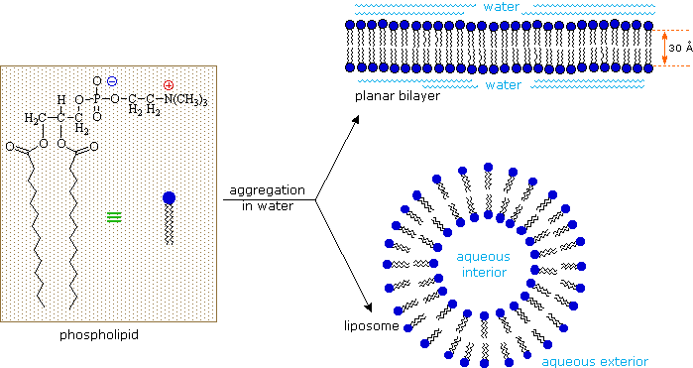
A cell may be considered a very complex liposome. The bilayer membrane that separates the interior of a cell from the surrounding fluids is largely composed of phospholipids, but it incorporates many other components, such as cholesterol, that contribute to its structural integrity. Protein channels that permit the transport of various kinds of chemical species in and out of the cell are also important components of cell membranes. A very nice dynamic Chime display of the gramicidin channel has been created by a collaboration of Canadian, French, Spanish and US scientists, and may be examined by Clicking Here.
The interior of a cell contains a variety of structures (organelles) that conduct chemical operations vital to the cells existence. Molecules bonded to the surfaces of cells serve to identify specific cells and facilitate interaction with external chemical entities.
The sphingomyelins are also membrane lipids. They are the major component of the myelin sheath surrounding nerve fibers. Multiple Sclerosis is a devastating disease in which the myelin sheath is lost, causing eventual paralysis.

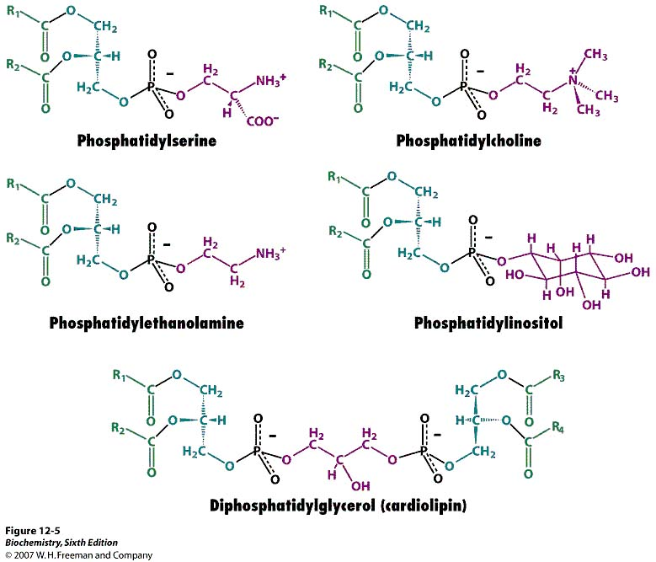

POLYESTERS

Poly(ethylene terephthalate)
What is a polyester?
A polyester is a polymer (a chain of repeating units) where the individual units are held together by ester linkages.
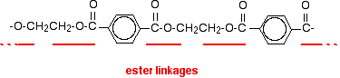
The diagram shows a very small bit of the polymer chain and looks pretty complicated. But it isn't very difficult to work out - and that's the best thing to do: work it out, not try to remember it. You will see how to do that in a moment.
The usual name of this common polyester is poly(ethylene terephthalate). The everyday name depends on whether it is being used as a fibre or as a material for making things like bottles for soft drinks.
When it is being used as a fibre to make clothes, it is often just called polyester. It may sometimes be known by a brand name like Terylene.
When it is being used to make bottles, for example, it is usually called PET.

Making polyesters as an example of condensation polymerisation
In condensation polymerisation, when the monomers join together a small molecule gets lost. That's different from addition polymerisation which produces polymers like poly(ethene) - in that case, nothing is lost when the monomers join together.
A polyester is made by a reaction involving an acid with two -COOH groups, and an alcohol with two -OH groups.
In the common polyester drawn above:
The acid is benzene-1,4-dicarboxylic acid (old name: terephthalic acid).
The alcohol is ethane-1,2-diol (old name: ethylene glycol).

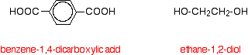

Now imagine lining these up alternately and making esters with each acid group and each alcohol group, losing a molecule of water every time an ester linkage is made.
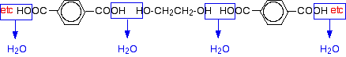
That would produce the chain shown above (although this time written without separating out the carbon-oxygen double bond - write it whichever way you like).
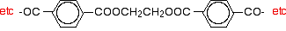
Manufacturing poly(ethylene terephthalate)
The reaction takes place in two main stages: a pre-polymerisation stage and the actual polymerisation.
In the first stage, before polymerisation happens, you get a fairly simple ester formed between the acid and two molecules of ethane-1,2-diol.
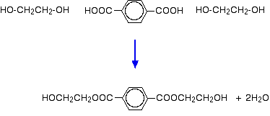
In the polymerisation stage, this is heated to a temperature of about 260°C and at a low pressure. A catalyst is needed - there are several possibilities including antimony compounds like antimony(III) oxide.
The polyester forms and half of the ethane-1,2-diol is regenerated. This is removed and recycled.
