Heterocyclic Compounds

Assoc. prof. Lubomir Makedonski, PhD
Medical University of Varna

Other elements such as nitrogen and oxygen can be included in the rings. When they are, the compounds are called heterocyclic compounds. The hetero- part of the name means that more than one kind of element is included within the ring and -cyclic, of course, indicates that there is at least one ring present in the compound.

Compounds classified as heterocyclic probably constitute the largest and most varied family of organic compounds. After all, every carbocyclic compound, regardless of structure and functionality, may in principle be converted into a collection of heterocyclic analogs by replacing one or more of the ring carbon atoms with a different element. Even if we restrict our consideration to oxygen, nitrogen and sulfur (the most common heterocyclic elements), the permutations and combinations of such a replacement are numerous.

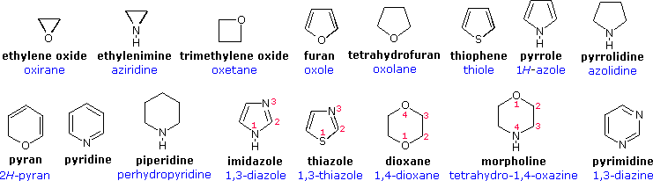
Some important heterocyclic compounds with N-heteroatom

Pyrrol Indole

Pyridine Pyrazole Imidazole

Pyramidine Purine

Nomenclature
Devising a systematic nomenclature system for heterocyclic compounds presented a formidable challenge, which has not been uniformly concluded. Many heterocycles, especially amines, were identified early on, and received trivial names which are still preferred.

An easy to remember, but limited, nomenclature system makes use of an elemental prefix for the heteroatom followed by the appropriate carbocyclic name. A short list of some common prefixes is given in the following table.

Examples of this nomenclature are:
- ethylene oxide = oxacyclopropane
- furan = oxacyclopenta-2,4-diene
- pyridine = azabenzene
- morpholine = 1-oxa-4-azacyclohexane.

Element | oxygen | sulfur | selenium | nitrogen | phosphorous | silicon | boron
Valence | II | II | II | III | III | IV | III
Prefix | Oxa | Thia | Selena | Aza | Phospha | Sila | Bora

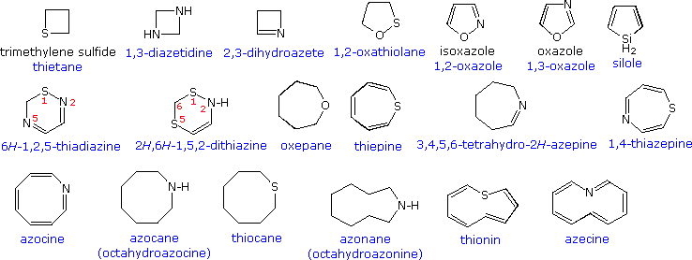

All the previous examples have been monocyclic compounds. Polycyclic compounds incorporating one or more heterocyclic rings are well known. A few of these are shown in the following diagram. Thus, the location of a fused ring may be indicated by a lowercase letter which designates the edge of the heterocyclic ring involved in the fusion, as shown by the pyridine ring in the green shaded box.

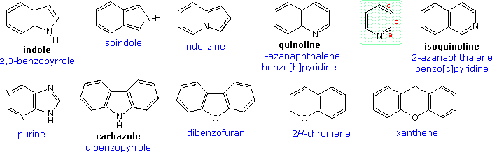
Heterocyclic rings are found in many naturally occuring compounds. Most notably, they compose the core structures of mono and polysaccharides, and the four DNA bases that establish the genetic code

Heterocyclic compounds are:

- Heterocyclic compounds with three - membered rings
- Heterocyclic compounds with four - membered rings
- Heterocyclic compounds with five - membered rings
- Heterocyclic compounds with six - membered rings

Heterocyclic compounds with five-membered rings

Pyrrol
Pyrrole, or pyrrol, is a heterocyclic aromatic organic compound, a five-membered ring with the formula C₄H₄NH. Substituted derivatives are also called pyrroles. For example, C₄H₄NCH₃ is N-methylpyrrole. Porphobilinogen is a trisubstituted pyrrole, which is the biosynthetic precursor to many natural products.

Pyrroles are components of more complex macrocycles, including the porphyrins of heme, the chlorins and bacteriochlorins of chlorophyll, and porphyrinogens.
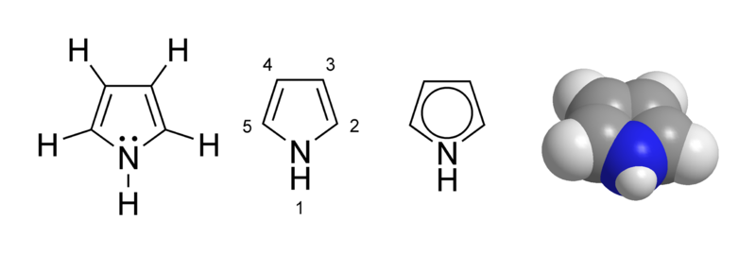

Pyrrol
Properties

Pyrrole has very low basicity compared to amines and other aromatic compounds like pyridine, wherin the ring nitrogen is not bonded to a hydrogen atom. This decreased basicity is attributed to the delocalization of the lone pair of electrons of the nitrogen atom in the aromatic ring. Pyrrole is a very weak base with a pKaH of about −4. Protonation results in loss of aromaticity, and is, therefore, unfavorable.

Reactivity
Both NH and CH protons in pyrroles are moderately acidic and can be deprotonated with strong bases such as butyllithium and the metal hydrides. The resulting "pyrrolides" are nucleophilic. Trapping of the conjugate base with an electrophile (e.g., an alkyl or acyl halide) reveals which sites were deprotonated based on which ring positions actually react as nucleophiles. The product distribution of such a reaction can often be complex and depends on the base used (especially the counterion, such as lithium from butyllithium or sodium from sodium hydride), existing substitution of the pyrrole, and the electrophile.

The resonance contributors of pyrrole provide insight to the reactivity of the compound. Like furan and thiophene, pyrrole is more reactive than benzene towards nucleophilic aromatic substitution because it is able to stabilize the positive charge of the intermediate carbanion. This is because the nitrogen can donate a lone pair into the ring by resonance.
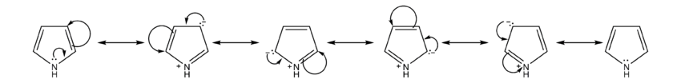

Pyrrole undergoes electrophilic aromatic substitution at the 2 and 5 positions, though the substitution product at positions 3 and 4 is obtained in low yields.

Preparation
Chemical properties
- With iodine

- Hydrogenaration

Porphin, sometimes spelled porphine, is the parent chemical compound for types of biochemically significant compounds called porphyrins.
The chemical formula of porphin is C₂₀H₁₄N₄. Porphin is an organic compound that is aromatic and heterocyclic since its chemical structure, shown at right, essentially consists of four pyrrole rings joined together by four methine (=CH—) groups to form a larger macrocycle ring. The compound itself is a solid.

Structural characteristics of porphin
Around the perimeter of the macrocycle ring, there is a cyclic chain of sp2 hybridized carbon atoms, all of which are part of a conjugated double bond system, giving the molecule its aromatic character.

Porphin

The aromatic character of porphin stems both from its conjugation as well as its flat or planar geometry, meaning that all the atoms lie in a single plane. Bonded to the cyclic chain of carbons are four nitrogen atoms facing the center of the molecule, two of which are bonded to hydrogen atoms and the other two nitrogens forming part of the conjugated double bond system.

Protoporphyrin

Protoporphyrin
Protoporphyrins are tetrapyrroles containing the following side chains:
methyl (4) – 1, 3, 5 and 8 locations
propionic acid (2) – 2 and 4 locations
vinyl (2) – 6 and 7 location

Complex with metal in the center
If the two nitrogens give up their hydrogens, the four central nitrogen atoms can act as ligands to bond to a metal ion in the center of the molecule. This is often the case with biological porphyrin compounds, especially with an iron atom in the center. When there is no metal ion (or atom) bound to the nitrogens in the center, then the compounds are called free porphin or free porphyrins. If they are bonded to a metal in the center, then they are bound. A porphyrin with an iron atom of the type found in myoglobin, hemoglobin, or certain cytochromes is called heme.

Protoporphyrin IX is a biochemically widely used carrier molecule for divalent cations, e.g. together with iron (Fe²⁺) the body of the heme- group of hemoglobin, myoglobin and many other heme-containing enzymes like cytochrome c and catalase are formed, complexed with magnesium-ions (Mg²⁺) the main part of the Chlorophylls are formed. Complexed with zinc-ions (Zn²⁺) it forms Zinc protoporphyrin.

Protoporphyrin IX
The number (e.g. IX) indicates the position of different side cains, but the nomenclature is historically grown and only in parts systematically.
Protoporphyrin IX as a direct precursor of heme is accumulated by patients of erythropoietic protoporphyria, which is one of the genetic disorders of the biosynthesis of the heme -pathway. It causes a severe photosensivity against visible light.
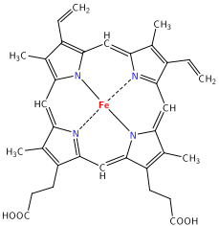

Protoporphyrin IX

The sensitivity of protoporphyrin IX against light is also used as a therapy against different forms of cancer (photodynamic therapy, PDT).

Protoporphyrins are deposited in the shells of the eggs of some birds as a brown or red pigment, either as a ground colour or as spotting. This occurs in most passerine species, some ground-nesting non-passerines, such as waders, gulls, nightjars and sandgrouse, where it provides camouflage, and some parasitic cuckoos, which need to mimic their passerine hosts' eggs.

Protoporphyrins strengthen the egg shell, and are deposited where the shell is too thin as a result of calcium shortage. Spotting therefore tend to be heavier where the local soil is calcium-deficient, and in the eggs laid last in a clutch.

Hemoglobin
Hemoglobin (also spelled haemoglobin and abbreviated Hb or Hgb) is the iron-containing oxygen-transport metalloprotein in the red blood cells of vertebrates, and the tissues of some invertebrates.
In mammals, the protein makes up about 97% of the red blood cell’s dry content, and around 35% of the total content (including water). Hemoglobin transports oxygen from the lungs or gills to the rest of the body where it releases the oxygen for cell use. It also has a variety of other roles of gas transport and effect-modulation which vary from species to species, and are quite diverse in some invertebrates.

Hemoglobin

In most humans, the hemoglobin molecule is an assembly of four globular protein subunits. Each subunit is composed of a protein chain tightly associated with a non-protein heme group. Each protein chain arranges into a set of alpha-helix structural segments connected together in a globin fold arrangement, so called because this arrangement is the same folding motif used in other heme/globin proteins such as myoglobin. This folding pattern contains a pocket which strongly binds the heme group.

A heme group consists of an iron (Fe) ion (charged atom) held in a heterocyclic ring, known as a porphyrin. The iron ion, which is the site of oxygen binding, coordinates with the four nitrogens in the center of the ring, which all lie in one plane. The iron is also bound strongly to the globular protein via the imidazole ring of the F8 histidine residue below the porphyrin ring. A sixth position can reversibly bind oxygen, completing the octahedral group of six ligands. Oxygen binds in an "end-on bent" geometry where one oxygen atom binds Fe and the other protrudes at an angle. When oxygen is not bound, a very weakly bonded water molecule fills the site, forming a distorted octahedron.

The iron ion may either be in the Fe²⁺ or Fe³⁺ state, but ferrihemoglobin (methemoglobin) (Fe³⁺) cannot bind oxygen. In binding, oxygen temporarily oxidizes Fe to (Fe³⁺), so iron must exist in the +2 oxidation state in order to bind oxygen. The enzyme methemoglobin reductase reactivates hemoglobin found in the inactive (Fe3+) state by reducing the iron center.

Iron's oxidation state in oxyhemoglobin

Assigning oxygenated hemoglobin's oxidation state is difficult because oxyhemoglobin (Hb-O₂), by experimental measurement, is diamagnetic (no net unpaired electrons), yet the low-energy electron configurations in both oxygen and iron are paramagnetic (suggesting at least one unpaired electron in the complex).
It should be noted that the assignment of a whole-number oxidation state is a formalism, as the covalent bonds are not required to have perfect bond orders involving whole electron-transfer. Thus, all three models for paramagnetic Hb-O₂ may contribute to some small degree (by resonance) to the actual electronic configuration of Hb-O₂. However, the model of iron in Hb-O₂ being Fe(III) is more correct than the classical idea that it remains Fe(II).

Indole
Indole is an aromatic heterocyclic organic compound. It has a bicyclic structure, consisting of a six-membered benzene ring fused to a five-membered nitrogen-containing pyrrole ring. The participation of the nitrogen lone electron pair in the aromatic ring means that indole is not a base, and it does not behave like a simple amine.

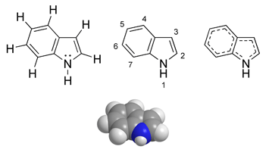

Indole
Indole is a solid at room temperature. Indole can be produced by bacteria as a degradation product of the amino acid - tryptophan. It occurs naturally in human feces and has an intense fecal odor. At very low concentrations, however, it has a flowery smell, and is a constituent of many flower scents (such as orange blossoms) and perfumes. It also occurs in coal tar.
The indole structure can be found in many organic compounds like the amino acid tryptophan and in tryptophan-containing protein, in alkaloids, and in pigments.
Indole undergoes electrophilic substitution, mainly at position 3. Substituted indoles are structural elements of (and for some compounds the synthetic precursors for) the tryptophan-derived tryptamine alkaloids like the neurotransmitter serotonin, and melatonin. Other indolic compounds include the plant hormone Auxin (indolyl-3-acetic acid, IAA), the anti-inflammatory drug indomethacin, and the betablocker pindolol.
The name indole is a portmanteau of the words indigo and oleum, since indole was first isolated by treatment of the indigo dye with oleum.

Chemical reactions of indole

Nitrogen basicity

Although the indole N-1 nitrogen atom has a lone pair of electrons, indole is not basic like amines and anilines because the lone pair is delocalised and contributes to the aromatic system. The protonated form has an pKa of -3.6, so that very strong acids like hydrochloric acid are needed to protonate a substantial amount of indole. The sensitivity of many indolic compounds (e.g., tryptamines) under acidic conditions is caused by this protonation.

Electrophilic substitution
The most reactive position on indole for electrophilic aromatic substitution is C-3, which is 1013 times more reactive than benzene. For example, Vilsmeier-Haack formylation of indole[10] will take place at room temperature exclusively at C-3. Since the pyrrollic ring is the most reactive portion of indole, nucleophilic substitution of the carbocyclic (benzene) ring can take place only after N-1, C-2, and C-3 are substituted.
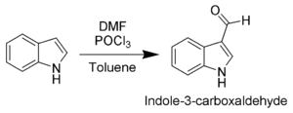
Gramine, a useful synthetic intermediate, is produced via a Mannich reaction of indole with dimethylamine and formaldehyde.
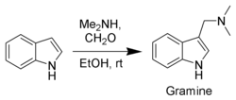

Oxidation of indole
Due to the electron-rich nature of indole, it is easily oxidized. Simple oxidants such as N-bromosuccinimide will selectively oxidize indole 1 to oxindole (4 and 5).
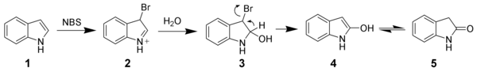

Cycloadditions of indole
Only the C-2 to C-3 pi-bond of indole is capable of cycloaddition reactions. Intermolecular cycloadditions are not favorable, whereas intramolecular variants are often high-yielding. For example, Padwa et al.[13] have developed this Diels-Alder reaction to form advanced strychnine intermediates. In this case, the 2-aminofuran is the diene, whereas the indole is the dienophile.
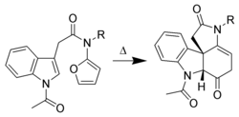
Indoles also undergo intramolecular [2+3] and [2+2] cycloadditions.
Derivaties of indole
Tryptophan (abbreviated as Trp or W) is one of the 20 standard amino acids, as well as an essential amino acid in the human diet. It is encoded in the standard genetic code as the codon UGG. Only the L-stereoisomer of tryptophan is used in structural or enzyme proteins, but the D-stereoisomer is occasionally found in naturally produced peptides (for example, the marine venom peptide contryphan). The distinguishing structural characteristic of tryptophan is that it contains an indole functional group.
Tryptamine is a monoamine alkaloid found in plants, fungi, and animals. It is based around the indole ring structure, and is chemically related to the amino acid tryptophan, from which its name is derived. Tryptamine is found in trace amounts in the brains of mammals and is believed to play a role as a neuromodulator or neurotransmitter.
Tryptamine is also the backbone for a group of compounds known collectively as tryptamines. This group includes many biologically active compounds, including neurotransmitters and hallucinogens. Its name was used to coin the term tripping.
The concentration of tryptamine in rat brains is about 3.5 pmol/g.
Tryptophan Tryptamine
Serotonin (5-hydroxytryptamine, or 5-HT) is a monoamine neurotransmitter synthesized in serotonergic neurons in the central nervous system (CNS) and enterochromaffin cells in the gastrointestinal tract of animals including humans. Serotonin is also found in many mushrooms and plants, including fruits and vegetables.

Serotonin
Skatole or 3-methylindole is a mildly toxic white crystalline organic compound belonging to the indole family. It occurs naturally in feces (it is produced from tryptophan in the mammalian digestive tract), beets, and coal tar, and has a strong fecal odor. In low concentrations it has a flowery smell and is found in several flowers and essential oils, including those of orange blossoms, jasmine, and Ziziphus mauritiana. It is used as a fragrance and fixative in many perfumes and as an aroma compound. Its name is derived from the Greek root skato- meaning "dung". Additionally it is used in very small quantities as an artificial flavor and scent for strawberry flavored food products including ice cream.

Skatole

Applications
Natural jasmine oil, used in the perfume industry, contains around 2.5% of indole. Since 1 kilogram of the natural oil requires processing several million jasmine blossoms and costs around $10,000, indole (among other things) is used in the manufacture of synthetic jasmine oil (which costs around $10/kg).

Pyrazole
Pyrazole refers both to the class of simple aromatic ring organic compounds of the heterocyclic series characterized by a 5-membered ring structure composed of three carbon atoms and two nitrogen atoms in adjacent positions and to the unsubstituted parent compound. Being so composed and having pharmacological effects on humans, they are classified as alkaloids, although they are rare in nature.

Diazole
Diazole refers to either one of a pair of isomeric chemical compounds with molecular formula C₃H₄N₂, having a five-membered ring consisting of three carbon atoms and two nitrogen atoms.
The two isomers are:

- Imidazole (1,3-diazole) 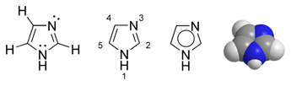
- Pyrazole (1,2-diazole) 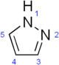

Pyrazole
Pyrazole refers both to the class of simple aromatic ring organic compounds of the heterocyclic series characterized by a 5-membered ring structure composed of three carbon atoms and two nitrogen atoms in adjacent positions and to the unsubstituted parent compound. Being so composed and having pharmacological effects on humans, they are classified as alkaloids, although they are rare in nature.

Pyrazoles
Pyrazoles are produced synthetically through the reaction of α,β-unsaturated aldehydes with hydrazine and subsequent dehydrogenation.
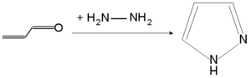
In medicine, pyrazoles are used for their analgesic, anti-inflammatory, antipyretic, antiarrhythmic, tranquilizing, muscle relaxing, psychoanaleptic, anticonvulsant, monoamineoxidase inhibiting, antidiabetic and antibacterial activities.
Pyrazoles react with potassium borohydride to form a class of ligands known as Scorpionates.
Structurally related compounds are pyrazoline and pyrazolidine.
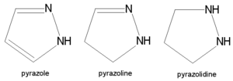

Pyrazolone-5
Derivaties of Pyrazolone-5

Antipyrine (Phenazone, or phenazon), is an analgesic. It was first synthesized by Ludwig Knorr in 1883. It is formed by reducing diortho- dinitrodiphenyl with sodium amalgam and methyl alcohol, or by heating diphenylene- ortho- dihydrazine with hydrochloric acid to 150 C. It crystallizes in needles which melt at 156 C. Potassium permanganate oxidizes it to pyridazine tetracarboxylic acid.

Antipyrine (Phenazone, or phenazon)
Primidone
Primidone

Analgin
Metamizole sodium is a non-steroidal anti-inflammatory drug (NSAID), commonly used in many countries as a powerful painkiller and fever reducer. It is better known under the names Dipyrone, Analgin, Novalgin, and Melubrin.
Metamizole was first synthesized by the German company Hoechst AG (now part of Sanofi-Aventis) in 1920, and its mass production started in 1922. It remained freely available worldwide until the 1970s, when it was discovered that the drug carries a small risk of causing agranulocytosis - a very dangerous and potentially fatal condition. Controversy remains regarding the level of risk. Several national medical authorities have banned metamizole either totally or have restricted it to be available only on prescription, while others have maintained its availability over the counter.

CH
3
CH
3
C
6
H
5
H
3
N
N
CH
3
H
H
3
C
C
6
H
5
N
O
O
C
N
N
N
NaO
3
H
2
C
S
NaO
3
H
2
C
S
Metamizole (Dipyrone, Analgin, Novalgin) Melubrin

Heterocyclic compounds with six - membered rings

The chemical reactivity of the saturated members of this class of heterocycles: tetrahydropyran, thiane and piperidine, resemble that of acyclic ethers, sulfides, and 2º-amines, and will not be described here. 1,3-Dioxanes and dithianes are cyclic acetals and thioacetals. These units are commonly used as protective groups for aldehydes and ketones, as well as synthetic intermediates, and may be hydrolyzed by the action of aqueous acid. The reactivity of partially unsaturated compounds depends on the relationship of the double bond and the heteroatom (e.g. 3,4-dihydro-2H-pyran is an enol ether).
Fully unsaturated six-membered nitrogen heterocycles, such as pyridine, pyrazine, pyrimidine and pyridazine, have stable aromatic rings. Oxygen and sulfur analogs are necessarily positively charged, as in the case of 2,4,6-triphenylpyrylium tetrafluoroborate.

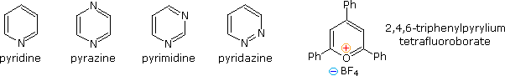

Pyridine
Pyridine is a simple aromatic heterocyclic organic compound with the chemical formula C₅H₅N used as a precursor to agrochemicals and pharmaceuticals, and is also an important solvent and reagent. It is structurally related to benzene, wherein one CH group in the aromatic six-membered ring is replaced by a nitrogen atom. It exists as a colorless liquid with a distinctive, unpleasant fish-like odor. The pyridine ring occurs in many important compounds, including nicotinamides.

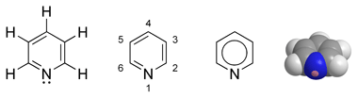

Reactions

As a base
In organic reactions pyridine behaves both as a tertiary amine, undergoing protonation, alkylation, acylation, and N-oxidation at nitrogen, and as an aromatic compound, undergoing Nucleophilic substitutions.
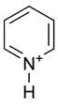
Pyridinium cation
The nitrogen atom on pyridine features a basic lone pair of electrons. Because this lone pair is not delocalized into the aromatic pi-system, pyridine is basic with chemical properties similar to tertiary amines. The pKa of the conjugate acid is 5.21. Pyridine is protonated by reaction with acids and forms a positively charged aromatic polyatomic ion called pyridinium. The bond lengths and bond angles in pyridine and the pyridinium ion are almost identical. In addition, the pyridinium cation is isoelectronic with benzene.
Pyidine is widely used as a ligand in coordination chemistry. Also important are its chelating derivatives 2,2'-bipyridine, consisting of two pyridine molecules joined by a single bond, and terpyridine, a molecule of three pyridine rings linked together.

Nucleophilic reactions at the ring
Nucleophilic aromatic substitution occurs at C-2 and at C-4. For example in the Chichibabin reaction, pyridine reacts with sodium amide to give 2-aminopyridine. In the Emmert reaction, named for Bruno Emmert), pyridine reacts with a ketone in presence of aluminium or magnesium and mercuric chloride to give the carbinol also at C₂.
Pyridine is also used as a denaturant for antifreeze mixtures, for ethyl alcohol, for fungicides, and as a dyeing aid for textiles.

Safety and environmental aspects
The LD50 in rats (oral) is 891 mg kg–1. It is volatile and can be absorbed through skin. Available data indicate that "exposure to pyridine in drinking-water led to reduction of sperm motility at all dose levels in mice and increased estrous cycle length at the highest dose level in rats". Currently its evaluations as a possible carcinogenic agent showed there is inadequate evidence in humans for the carcinogenicity of pyridine, albeit there is limited evidence of carcinogenic effects on animals. Effects of an acute pyridine intoxication include dizziness, headache, nausea and anorexia. Further symptoms include abdominal pain and pulmonary congestion. Although resistant to oxidation, pyridine is readily degraded by bacteria to ammonia and carbon dioxide.

Electrophilic Substitution of Pyridine
Pyridine is a modest base (pKa=5.2). Since the basic unshared electron pair is not part of the aromatic sextet, as in pyrrole, pyridinium species produced by N-substitution retain the aromaticity of pyridine. As shown below, N-alkylation and N-acylation products may be prepared as stable crystalline solids in the absence of water or other reactive nucleophiles. The N-acyl salts may serve as acyl transfer agents for the preparation of esters and amides. Because of the stability of the pyridinium cation, it has been used as a moderating component in complexes with a number of reactive inorganic compounds. Several examples of these stable and easily handled reagents are shown at the bottom of the diagram. The poly(hydrogen fluoride) salt is a convenient source of HF for addition to alkenes and conversion of alcohols to alkyl fluorides, pyridinium chlorochromate (PCC) and its related dichromate analog are versatile oxidation agents and the tribromide salt is a convenient source of bromine. Similarly, the reactive compounds sulfur trioxide and diborane are conveniently and safely handled as pyridine complexes.
Amine oxide derivatives of 3º-amines and pyridine are readily prepared by oxidation with peracids or peroxides, as shown by the upper right equation. Reduction back to the amine can usually be achieved by treatment with zinc (or other reactive metals) in dilute acid.

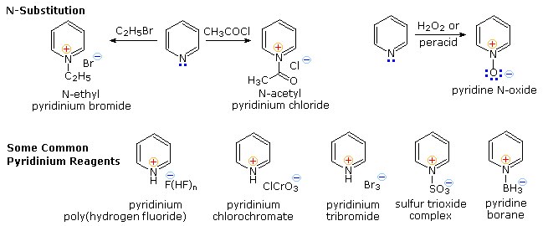

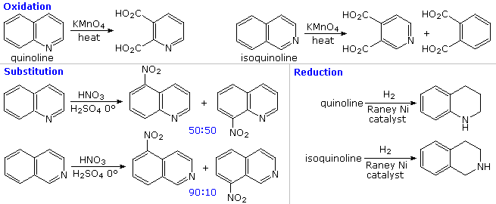

N-subtitution

Vitamin B₆
Pyrimidine is a heterocyclic aromatic organic compound similar to benzene and pyridine, containing two nitrogen atoms at positions 1 and 3 of the six-member ring.[1] It is isomeric with two other forms of diazine.

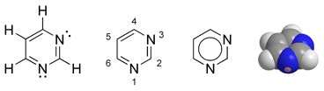

Nucleotides
Three nucleobases found in nucleic acids (cytosine, thymine, and uracil) are pyrimidine derivatives:
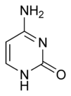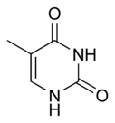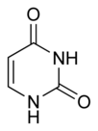
In DNA and RNA, these bases form hydrogen bonds with their complementary purines. Thus the purines adenine (A) and guanine (G) pair up with the pyrimidines thymine (T) and cytosine (C), respectively.
In RNA, the complement of A is U instead of T and the pairs that form are adenine:uracil and guanine:cytosine.
These hydrogen bonding modes are for classical Watson-Crick base pairing. Other hydrogen bonding modes ("wobble pairings") are available in both DNA and RNA, although the additional 2'-hydroxyl group of RNA expands the configurations through which RNA can form hydrogen bonds.[citation needed]

Cytosine
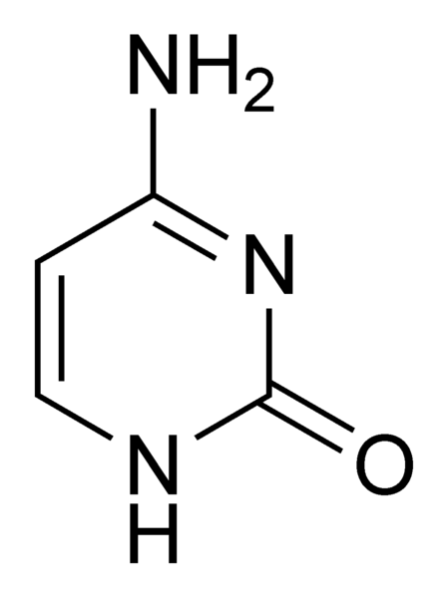

Cytosine is one of the five main bases found in DNA and RNA. It is a pyrimidine derivative, with a heterocyclic aromatic ring and two substituents attached (an amine group at position 4 and a keto group at position 2). The nucleoside of cytosine is cytidine. In Watson-Crick base pairing, it forms three hydrogen bonds with guanine.

History
Cytosine was discovered by Albrecht Kossel in 1894 when it was hydrolysed from calf thymus tissues.[1] A structure was proposed in 1903, and was synthesized (and thus confirmed) in the laboratory in the same year.
Cytosine recently found use in quantum computation. The first time any quantum mechanical properties were harnessed to process information took place on August 1st in 1998 when researchers at Oxford implemented David Deutsch's algorithm on a two qubit NMRQC (Nuclear Magnetic Resonance Quantum Computer) based on the cytosine molecule.[2]

Chemical reactions
Cytosine can be found as part of DNA, RNA, or as a part of a nucleotide. As cytidine triphosphate (CTP), it can act as a co-factor to enzymes, and can transfer a phosphate to convert adenosine diphosphate (ADP) to adenosine triphosphate (ATP).
In DNA and RNA, cytosine is paired with guanine. However, it is inherently unstable, and can change into uracil (spontaneous deamination). This can lead to a point mutation if not repaired by the DNA repair enzymes such as uracil glycosylase, which cleaves a uracil in DNA.
Cytosine can also be methylated into 5-methylcytosine by an enzyme called DNA methyltransferase.
Uracil
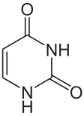

Uracil is a common and naturally occurring pyrimidine derivative. Originally discovered in 1900, it was isolated by hydrolysis of yeast nuclein that was found in bovine thymus and spleen, herring, sperm, and wheat germ. It is a planar, unsaturated compound that has the ability to absorb light.
Found in RNA, it base pairs with adenine and is replaced by thymine in DNA. Methylation of uracil produces thymine. It turns into thymine to protect the DNA and to improve the efficiency of DNA replication. Uracil can base pair with any of the bases depending on how the molecule arranges itself on the helix, but readily pairs with adenine because the methyl group is repelled into a fixed position. Uracil pairs with adenine through hydrogen bonding. Uracil is the hydrogen bond acceptor and can form two hydrogen bonds. Uracil can also bind with a ribose sugar to form a ribonucleoside, uridine. When a phosphate attaches to uridine, uridine 5'-monophosphate is produced.
Uracil undergoes amide-imidic acid tautomeric shifts because any nuclear instability the molecule may have from the lack of formal aromaticity is compensated by the cyclic-amidic stability. The keto tautomer is referred to the lactam structure, while the imidic acid tautomer is referred to as the lactim structure. These tautomeric forms are predominant at pH=7. The lactam structure is the most common form of uracil.

Thymine
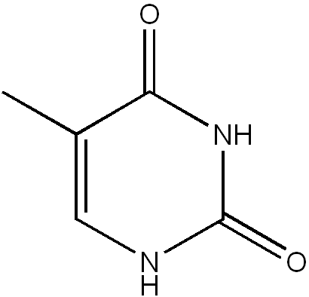

Thymine is one of the four bases in the nucleic acid of DNA that make up the letters GCAT. The others are adenine, guanine, and cytosine. Thymine (T) always pairs with adenine. Thymine is also known as 5-methyluracil, a pyrimidine nucleobase. As the name suggests, thymine may be derived by methylation of uracil at the 5th carbon. In RNA, thymine is replaced with uracil in most cases. In DNA, thymine(T) binds to adenine (A) via two hydrogen bonds to assist in stabilizing the nucleic acid structures.
Thymine combined with deoxyribose creates the nucleoside deoxythymidine, which is synonymous with the term thymidine. Thymidine can be phosphorylated with one, two, or three phosphoric acid groups, creating, respectively, TMP, TDP, or TTP (thymidine mono-, di-, or triphosphate).
One of the common mutations of DNA involves two adjacent thymines or cytosine, which, in presence of ultraviolet light, may form thymine dimers, causing "kinks" in the DNA molecule that inhibit normal function.
Thymine could also be a target for actions of 5-fluorouracil (5-FU) in cancer treatment. 5-FU can be a metabolic analog of thymine (in DNA synthesis) or uracil (in RNA synthesis). Substitution of this analog inhibits DNA synthesis in actively-dividing cells.
Thymine bases are frequently oxidized to hydantoins over time after the death of an organism.

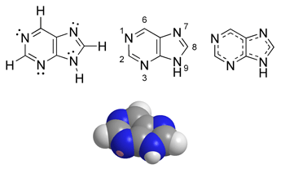
Purine (1) is a heterocyclic aromatic organic compound, consisting of a pyrimidine ring fused to an imidazole ring. Purines, including substituted purines and their tautomers, are the most widely distributed kind of nitrogen-containing heterocycle in nature.
Purines and pyrimidines make up the two groups of nitrogenous bases, including the two groups of nucleotide bases. Two of the four deoxyribonucleotides and two of the four ribonucleotides, the respective building blocks of DNA and RNA, are purines.
Purines and pyrimidines make up the two groups of nitrogenous bases, including the two groups of nucleotide bases. Two of the four deoxyribonucleotides and two of the four ribonucleotides, the respective building blocks of DNA and RNA, are purines.
The quantity of naturally occurring purines produced on earth is enormous, as 50 % of the bases in nucleic acids, adenine (2) and guanine (3), are purines. In DNA, these bases form hydrogen bonds with their complementary pyrimidines thymine and cytosine respectively. This is called complementary base pairing. In RNA, the complement of adenine is uracil (U) instead of thymine.
Other notable purines are hypoxanthine (4), xanthine (5), theobromine (6), caffeine (7), uric acid (8) and isoguanine (9).
Uric acid
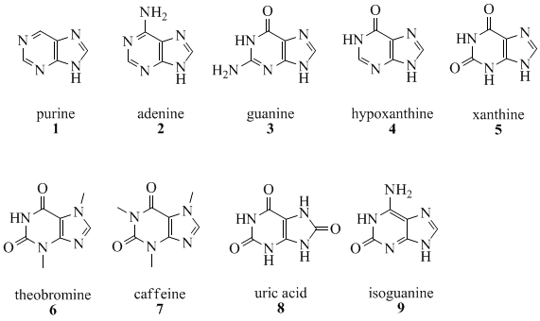

Adenin ( 6 amino purin)

guanine (2-amino-6-hydroxy purin)

Xantine (2, 6 - dihydroxy purin)

Theophilin (1,3 dimethylxantine )

Theobromine (3,7 dimethylxantine )

caffeine (1, 3,7 trimethylxantine )

