Alpha Hydroxy Carboxylic Acids

Assoc. Prof. Lubomir Makedonski
Medical University - Varna

I. Alpha Hydroxy Carboxylic Acids – structure and medical uses

Lactic acid

Lactic acid (2-hydroxypropanoic acid), also known as milk acid, is a chemical compound that plays a role in several biochemical processes. It has a hydroxyl group adjacent to the carboxyl group, making it an alpha hydroxy acid . In solution, it can lose a proton from the acidic group, producing the lactate ion CH₃CH(OH)COO−. It is miscible with water or ethanol.

Lactic acid

Lactic acid is chiral and has two optical isomers. One is known as L-(+)-lactic acid or (S)-lactic acid and the other, its mirror image, is D-(-)-lactic acid or (R)-lactic acid. L-(+)-Lactic acid is the biologically important isomer.

In medicine, lactate is one of the main components of Ringer's lactate or lactated Ringer's solution (Compound Sodium Lactate or Hartmann's Solution in the UK). This intravenous fluid consists of sodium and potassium cations, with lactate and chloride anions, in solution with distilled water in concentration so as to be isotonic compared to human blood. It is most commonly used for fluid resuscitation after blood loss due to trauma, surgery, or a burn injury.

Lactic acid in foods

Lactic acid is primarily found in sour milk products, such as: koumiss, leban, yogurt, kefir, and some cottage cheeses. The casein in fermented milk is coagulated (curdled) by lactic acid.

Although it can be fermented from lactose (milk sugar), most commercially used lactic acid is derived by using bacteria such as Streptococcus thermophilus, Lactobacillus acidophilus, or Lactobacillus delbrueckii subsp. bulgaricus (formerly known as Lactobacillus bulgaricus) to ferment carbohydrates from nondairy sources such as cornstarch, potatoes, and molasses. Thus, although it is commonly known as "milk acid", vegan products can contain lactic acid as an ingredient.

Lactic acid may also be found in various processed foods, usually either as a pH-adjusting ingredient, or as a preservative (either as antioxidant or for control of pathogenic micro-organisms). It may also be used as a fermentation booster in rye and sourdough breads.

Potassium lactate, sodium lactate, and calcium lactate are the neutralized salts of lactic acid. Potassium lactate is used in many fresh and cooked meat products for shelf life control, color preservation, and reduction of sodium content. Sodium lactate has a mild saline taste and is therefore suitable for flavor enhancement in meat products as well. Sodium lactate is being produced in solution as well as dry. Calcium lactate is popular for fortification and improved texture in emulsified meat products like frankfurters. Ready-to-eat meat and poultry products commonly contain sodium or potassium lactate to control Listeria monocytogenes.

Lactic acid is also present in wheat beers, especially lambic, due to the activity of Pediococcus damnosus.

Lactic acid is widely used for reducing the number of pathogenic bacteria like E.coli, Salmonella, Campylobacter, and Listeria on animal carcasses like beef, pork, and poultry during the slaughtering process.

Salicylic acids

Salicylic acid (from the Latin word for the willow tree, Salix, from whose bark it can be obtained) is a beta hydroxy acid (BHA) with the formula C₆H₄(OH)COOH, where the OH group is adjacent to the carboxyl group. This colorless crystalline organic acid is widely used in organic synthesis and functions as a plant hormone. It is derived from the metabolism of salicin. In addition to being a compound that is chemically similar to but not identical to the active component of aspirin (acetylsalicylic acid), it is probably best known for its use in anti-acne treatments. It is poorly soluble in water (0.2 g/100 ml H₂O at 20°C).

Production
Salicylic acid is an organic acid biosynthesized from the amino acid phenylalanine.
Sodium salicylate is commercially prepared by treating sodium phenolate (the sodium salt of phenol) with carbon dioxide at high pressure (100 atm) and high temperature (390K) - a method known as the Kolbe-Schmitt reaction. Acidification of the product with sulfuric acid gives salicylic acid:

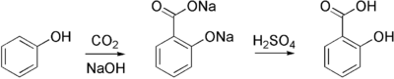

It can be prepared by the hydrolysis of Aspirin (acetylsalicylic acid) or methyl salicylate (Oil of Wintergreen) with a strong acid or base.

Derivatieves of the Salicylic acids

Sodium salicylate methyl salicylate Phenyl salicylate

Acetylsalicylic acid PASA Izoamilov esters

Medicinal and cosmetic uses
It is known for its ability to ease aches and pains and reduce fevers. The medicinal properties of salicylate, mainly for fever relief, have been known since ancient times, and it was used as an anti-inflammatory drug.
Also known as 2-hydroxybenzoic acid, one of several beta hydroxy acids (compare to AHA), salicylic acid is a key ingredient in many skin-care products for the treatment of acne, psoriasis, calluses, corns, keratosis pilaris, and warts. It works by causing the cells of the epidermis to shed more readily, preventing pores from clogging up, and allowing room for new cell growth. Because of its effect on skin cells, salicylic acid is used in several shampoos used to treat dandruff. Salicylic acid is also used as an active ingredient in gels that remove warts.

Aspirin (acetylsalicylic acid or ASA) can be prepared by the esterification of the phenolic hydroxyl group of salicylic acid.

Citric acid
3-hydroxypentanedioic acid-3-carboxylic acid
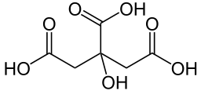

Citric acid

Citric acid is a weak organic acid, and it is a natural preservative and is also used to add an acidic, or sour, taste to foods and soft drinks. In biochemistry, it is important as an intermediate in the citric acid cycle and therefore occurs in the metabolism of almost all living things. It also serves as an environmentally benign cleaning agent and acts as an antioxidant and a lubricant.

Citric acid exists in a variety of fruits and vegetables, most notably citrus fruits. Lemons and limes have particularly high concentrations of the acid; it can constitute as much as 8% of the dry weight of these fruits (1.44 and 1.38 grams per ounce of the juices, respectively). The concentrations of citric acid in citrus fruits range from .005 mol/L for oranges and grapefruits to .030 mol/L in lemons and limes. These values will vary depending on the circumstances in which the fruit was grown.

Properties
At room temperature, citric acid is a white crystalline powder. It can exist either in an anhydrous (water-free) form or as a monohydrate. The anhydrous form crystallizes from hot water, whereas the monohydrate forms when citric acid is crystallized from cold water. The monohydrate can be converted to the anhydrous form by heating it above 78 °C. Citric acid also dissolves in absolute (anhydrous) ethanol (76 parts of citric acid per 100 parts of ethanol) at 15 degrees Celsius.

Krebs cycle
Citric acid is one of a series of compounds involved in the physiological oxidation of fats, proteins, and carbohydrates to carbon dioxide and water.
This series of chemical reactions is central to nearly all metabolic reactions, and is the source of two-thirds of the food-derived energy in higher organisms. It was discovered by Sir Hans Adolf Krebs. Krebs received the 1953 Nobel Prize in Physiology or Medicine for the discovery. The series of reactions is known by various names, including the citric acid cycle, the Krebs cycle, and the tricarboxylic acid cycle (or TCA cycle).

Food additive
As a food additive, citric acid is used as a flavoring and preservative in food and beverages, especially soft drinks. It is denoted by E number E330. Citrate salts of various metals are used to deliver those minerals in a biologically available form in many dietary supplements. The buffering properties of citrates are used to control pH in household cleaners and pharmaceuticals. In the United States the purity requirements for citric acid as a food additive is defined by the Food Chemical Codex (FCC), which is published by the United States Pharmacopoeia (USP).

Others
Citric acid is used in biotechnology and the pharmaceutical industry to passivate high-purity process piping (in lieu of using nitric acid). Nitric acid is considered hazardous to dispose once used for this purpose, while citric acid is not.

Citric acid is the active ingredient in some bathroom and kitchen cleaning solutions. A solution with a 6% concentration of citric acid will remove hard water stains from glass without scrubbing. In industry it is used to dissolve rust from steel.

Fumaric acid

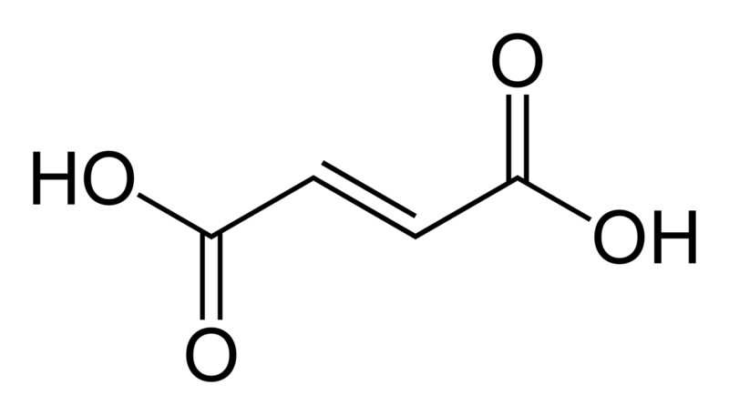
Fumaric acid is the chemical compound with the formula HO₂CCH=CHCO₂H. This white crystalline compound is one of two isomeric unsaturated dicarboxylic acids, the other being maleic acid wherein the carboxylic acid groups are cis. It has a fruit-like taste. The salts and esters of fumaric acid are known as fumarates.
Fumaric acid, when added to food products, is denoted by E number E297.

Biology
Fumaric acid is found in fumitory (Fumaria officinalis), bolete mushrooms (specifically Boletus fomentarius var. pseudo-igniarius), lichen, and Iceland moss.
Fumarate is an intermediate in the citric acid cycle used by cells to produce energy in the form of adenosine triphosphate (ATP) from food. It is formed by the oxidation of succinate by the enzyme succinate dehydrogenase. Fumarate is then converted by the enzyme fumarase to malate. Human skin naturally produces fumaric acid when exposed to sunlight.
Fumarate is also a byproduct of the urea cycle.

Medicine
Fumaric acid esters are sometimes used to treat psoriasis, as it has been suggested that the condition is caused by an impairment of fumaric acid production in the skin Dermatol 05; 152(4):597-615), BR J Dermatol 98;138(3): 456-460). A starting dose is 60-105 mg daily, which may be gradually increased to as much as 1,290 mg per day. Side-effects include kidney or gastrointestinal disorders, as well as skin flushing; these are mainly caused by excess intake. Decreased white blood cell (WBC) counts have been reported with prolonged use.

Food
Fumaric acid is a food acidulent used since 1946. It is non-toxic. It is generally used in beverages and baking powders for which requirements are placed on purity. It is generally used as a substitute for tartaric acid and occasionally in place of citric acid, at a rate of 1.36 g of citric acid to every 0.91 grams of fumaric acid for the same taste. It is also used in candy to add sourness, similar to the way malic acid is used.

Chemistry
Fumaric acid was first prepared from Succinic acid. A traditional synthesis involves oxidation of furfural (from the processing of maize) using sodium chlorate in the presence of a vanadium-based catalyst. Nowadays industrial synthesis of fumaric acid is mostly based on catalytic isomerisation of maleic acid (which in turn is accessible in large volumes as a hydrolysis product of maleic anhydride, produced by catalytic oxidation of benzene or butane) in aqueous solutions.

Safety
Fumaric acid converts to the irritant maleic anhydride, upon partial combustion.

Maleic acid

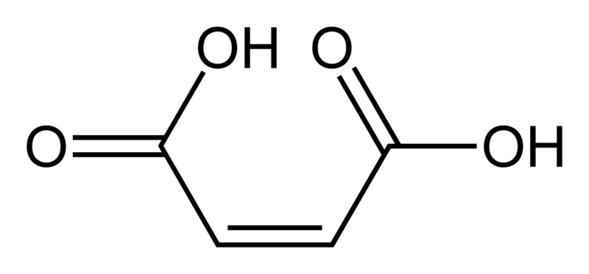

Maleic acid or (Z)-butenedioic acid or cis-butenedioic acid or malenic acid or maleinic acid or toxilic acid is an organic compound that is a dicarboxylic acid (molecule with two carboxyl groups). The molecule consists of an ethylene group flanked by two carboxylic acid groups. Maleic acid is the cis isomer of butenedioic acid, whereas fumaric acid is the trans isomer. Maleic acid is the less stable molecule: e.g., the difference in heat of combustion is 22.7 kJ/mol.

The physical properties of maleic acid are very different from those of fumaric acid. Maleic acid is soluble in water, whereas fumaric acid is not; and the melting point of maleic acid (130 - 139 °C) is also much lower than that of fumaric acid (287 °C). Both properties of maleic acid can be explained on account of the intramolecular hydrogen bonding that takes place at the expense of intermolecular interactions.
Maleic acid should not be confused with malic acid or malonic acid, both of which are different types of dicarboxylic acids.

Synthesis
In industry, maleic acid is derived from maleic anhydride by hydrolysis. Maleic anhydride is produced from benzene or butane in an oxidation process.

Reactions
Isomerization
Maleic acid and fumaric acid can normally not be interconverted because rotation around a carbon carbon double bond is not energetically favourable. In the laboratory, conversion of the cis isomer into the trans isomer is possible by application of light and a small amount of bromine. Light converts elemental bromine into a bromine radical, which attacks the alkene in a radical addition reaction to a bromo-alkane radical; and now single bond rotation is possible. The bromine radicals recombine and fumaric acid is formed. In another method (used as a classroom demonstration), maleic acid is transformed into fumaric acid through the process of heating the maleic acid in 12 molar hydrochloric acid solution. Reversible addition (of H⁺) leads to free rotation about the central C-C bond and formation of the more stable and less soluble fumaric acid. In industry, fumaric acid is also produced from maleic acid by catalytic isomerization with mineral acids, bromates, or thiourea. Again the large difference in water solubility makes fumaric acid purification easy.

Maleic acid is converted into maleic anhydride by dehydration, to malic acid by hydration, and to succinic acid by hydrogenation (ethanol / Palladium on carbon). It reacts with thionyl chloride or phosphorus pentachloride to give the maleic acid chloride (it is not possible to isolate the mono acid chloride).
Maleic acid is a reactant in many Diels-Alder reactions.

cis –isomer trans–isomer
maleic acid Fumaric acid

Tartaric acid
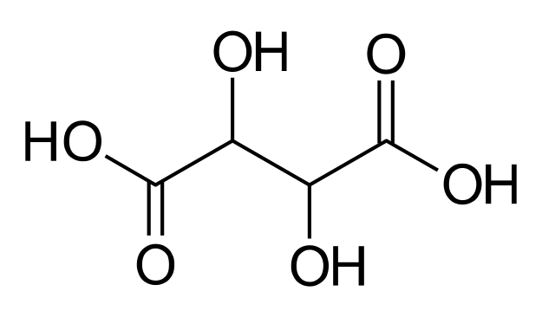
Tartaric acid
Tartaric acid is a white crystalline organic acid. It occurs naturally in many plants, particularly grapes, bananas, and tamarinds, and is one of the main acids found in wine. It is added to other foods to give a sour taste, and is used as an antioxidant. Salts of tartaric acid are known as tartrates. It is a dihydroxy derivative of succinic acid.
Tartaric acid was first isolated from potassium tartrate, known to the ancients as tartar, c. 800 by the Persian alchemist Jabir ibn Hayyan, who was also responsible for numerous other basic chemical processes still in use today. The modern process was developed in 1769 by the Swedish chemist Carl Wilhelm Scheele. The chirality of tartaric acid was discovered in 1832 by Jean Baptiste Biot, who observed its ability to rotate polarized light. Louis Pasteur continued this research in 1847 by investigating the shapes of tartaric acid crystals, which he found to be asymmetric. Pasteur was the first to produce a pure sample of levotartaric acid.

Stereochemistry
Naturally occurring tartaric acid is chiral, meaning that it has molecules that are non-superimposable on their mirror-images. It is a useful raw material in organic chemistry for the synthesis of other chiral molecules. The naturally occurring form of the acid is L-(+)-tartaric acid or dextrotartaric acid. The mirror-image (enantiomeric) form, levotartaric acid or D-(−)-tartaric acid, and the achiral form, mesotartaric acid, can be made artificially. Note, that the dextro and levo prefixes are not related to the D/L configuration (which is derived from the reference D- or L-glyceraldehyde), but to the orientation of the optical rotation, (+) = dextrorotatory, (−) = levorotatory. Sometimes, instead of capital letters, small italic d and l are used. They are abbreviations of dextro- and levo- and, nowadays, should not be used. Levotartaric and dextrotartaric acid are enantiomers, mesotartaric acid is a diastereomer of both of them.
A rarely occurring optically inactive form of tartaric acid, DL-tartaric acid is a 1:1 mixture of the levo and dextro forms. It is distinct from mesotartaric acid and was called racemic acid (from Latin racemus - "a bunch of grapes"). The word racemic later changed its meaning, becoming a general term for 1:1 enantiomeric mixtures - racemates. Tartaric acid is used to prevent Copper(II) ions from reacting with the hydroxide ions present in the preparation of copper(I) oxide. Copper(I) oxide is a reddish brown solid, and is produced by the reduction of a Cu(II) salt with an aldehyde, in an alkaline solution.

levotartaric acid  (D-(−)-tartaric acid) | dextrotartaric acid  (L-(+)-tartaric acid) | mesotartaric acid
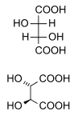 | 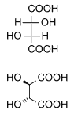 | 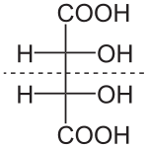

II. Chemical properties of Aplha Hydroxy Acids

Derivatives

- COOO group
- OH and –COOH groups

Oxidation (α – hydroxy acid)

lactic acid pyruvate acid

Properties of hydroxy carboxylic acids when heated

- α-acids - lactide

- β-acids α- and β – unsaturated acids

- γ – acids

γ – lactone

Phenol acids – depside

