INTRODUCING AMIDES

This page explains what amides are and looks at their simple physical properties such as solubility and melting points.

What are amides?
Amides are derived from carboxylic acids. A carboxylic acid contains the -COOH group, and in an amide the -OH part of that group is replaced by an -NH₂ group.
So . . . amides contain the -CONH₂ group.
Some simple amides
The most commonly discussed amide is ethanamide, CH₃CONH₂ (old name: acetamide).
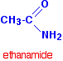
The three simplest amides are:
HCONH₂ | methanamide
CH₃CONH₂ | ethanamide
CH₃CH₂CONH₂ | propanamide
Notice that in each case, the name is derived from the acid by replacing the "oic acid" ending by "amide".
If the chain was branched, the carbon in the -CONH₂ group counts as the number 1 carbon atom. For example:
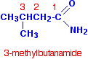

Physical properties
Melting points
Methanamide is a liquid at room temperature (melting point: 3°C), but the other amides are solid.
For example, ethanamide forms colourless deliquescent crystals with a melting point of 82°C. A deliquescent substance is one which picks up water from the atmosphere and dissolves in it. Ethanamide crystals nearly always look wet.
Note: Ethanamide is said to smell of mice. In fact, the smell is due to an impurity in the ethanamide called N-methylethanamide, CH₃CONHCH₃, where one of the hydrogens in the -NH₂ group has been replaced by a methyl group.
The melting points of the amides are high for the size of the molecules because they can form hydrogen bonds. The hydrogen atoms in the -NH₂ group are sufficiently positive to form a hydrogen bond with a lone pair on the oxygen atom of another molecule.
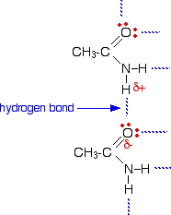
As you can see, there is the potential for lots of hydrogen bonds to be formed. Each molecule has two slightly positive hydrogen atoms and two lone pairs on the oxygen atom.
These hydrogen bonds need a reasonable amount of energy to break, and so the melting points of the amides are quite high.
Solubility in water
The small amides are soluble in water because they have the ability to hydrogen bond with the water molecules.
It needs energy to break the hydrogen bonds between amide molecules and between water molecules before they can mix - but enough energy is released again when the new hydrogen bonds are set up to allow this to happen.

MAKING AMIDES

This page describes the preparation of amides from carboxylic acids, acyl chlorides (acid chlorides) and acid anhydrides.

Making amides from carboxylic acids
Summary of the process
The carboxylic acid is first converted into an ammonium salt which then produces an amide on heating.
The ammonium salt is formed by adding solid ammonium carbonate to an excess of the acid.
For example, ammonium ethanoate is made by adding ammonium carbonate to an excess of ethanoic acid.
When the reaction is complete, the mixture is heated and the ammonium salt dehydrates producing ethanamide.
The excess of ethanoic acid is there to prevent dissociation of the ammonium salt before it dehydrates.
Ammonium salts tend to split into ammonia and the parent acid on heating, recombining on cooling. If dissociation happened in this case, the ammonia would escape from the reaction mixture and be lost. You couldn't get any recombination.
The dissociation is reversible:
The presence of the excess ethanoic acid helps to prevent this from happening by moving the position of equilibrium to the left.
Some brief practical details
The ammonium carbonate is added slowly to concentrated ethanoic acid and the reaction is left until all production of carbon dioxide stops.
It is then heated under reflux for half an hour for the dehydration to take place.
The mixture is distilled at about 170°C to remove excess ethanoic acid and water - leaving almost pure ethanamide in the flask.
Further purification stages are beyond the scope of this site.

Making amides from acyl chlorides
Acyl chlorides (also known as acid chlorides) have the general formula RCOCl. The chlorine atom is very easily replaced by other things. For example, it is easily replaced by an -NH₂ group to make an amide.
To make ethanamide from ethanoyl chloride, you normally add the ethanoyl chloride to a concentrated solution of ammonia in water. There is a very violent reaction producing lots of white smoke - a mixture of solid ammonium chloride and ethanamide. Some of the mixture remains dissolved in water as a colourless solution.
You can think of the reaction as happening in two stages.
In the first stage, the ammonia reacts with the ethanoyl chloride to give ethanamide and hydrogen chloride gas.
Then the hydrogen chloride produced reacts with excess ammonia to give ammonium chloride.
. . . and you can combine all this together to give one overall equation:
Making amides from acid anhydrides
An acid anhydride is what you get if you remove a molecule of water from two carboxylic acid -COOH groups.
For example, if you took two ethanoic acid molecules and removed a molecule of water between them you would get the acid anhydride, ethanoic anhydride (old name: acetic anhydride).
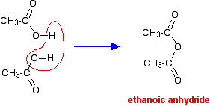
For equation purposes, ethanoic anhydride is often written as (CH₃CO)₂O.
The reactions of acid anhydrides are rather like those of acyl chlorides except that during their reactions, a molecule of carboxylic acid is produced rather than the HCl formed when an acyl chloride reacts.
If ethanoic anhydride is added to concentrated ammonia solution, ethanamide is formed together with ammonium ethanoate. Again, the reaction happens in two stages.
In the first stage, ethanamide is formed together with ethanoic acid.
Then the ethanoic acid produced reacts with excess ammonia to give ammonium ethanoate.
. . . and you can combine all this together to give one overall equation:
You need to follow this through really carefully, because the two products of the reaction overall can look confusingly similar.
HYDROLYSING AMIDES

This page describes the hydrolysis of amides under both acidic and alkaline conditions. It also describes the use of alkaline hydrolysis in testing for amides.

The hydrolysis of amides
What is hydrolysis?
Technically, hydrolysis is a reaction with water. That is exactly what happens when amides are hydrolysed in the presence of dilute acids such as dilute hydrochloric acid. The acid acts as a catalyst for the reaction between the amide and water.
The alkaline hydrolysis of amides actually involves reaction with hydroxide ions, but the result is similar enough that it is still classed as hydrolysis.

Hydrolysis under acidic conditions
Taking ethanamide as a typical amide:
If ethanamide is heated with a dilute acid (such as dilute hydrochloric acid), ethanoic acid is formed together with ammonium ions. So, if you were using hydrochloric acid, the final solution would contain ammonium chloride and ethanoic acid.
Hydrolysis under alkaline conditions
Again, taking ethanamide as a typical amide:
If ethanamide is heated with sodium hydroxide solution, ammonia gas is given off and you are left with a solution containing sodium ethanoate.
Using alkaline hydrolysis to test for an amide
If you add sodium hydroxide solution to an unknown organic compound, and it gives off ammonia on heating (but not immediately in the cold), then it is an amide.
You can recognise the ammonia by smell and because it turns red litmus paper blue.
The possible confusion using this test is with ammonium salts. Ammonium salts also produce ammonia with sodium hydroxide solution, but in this case there is always enough ammonia produced in the cold for the smell to be immediately obvious.
OTHER REACTIONS OF AMIDES

This page explains the reason for the lack of basic character in amides, and describes their dehydration to give nitriles, and their reaction with bromine and sodium hydroxide solution to form primary amines with one less carbon atom (the Hofmann degradation).
The lack of base character in amides
Unusually for compounds containing the -NH₂ group, amides are neutral. This section explains why -NH₂ groups are usually basic and why amides are different.
The usual basic character of the -NH₂ group
Simple compounds containing an -NH₂ group such as ammonia, NH₃, or a primary amine like methylamine, CH₃NH₂, are weak bases. A primary amine is a compound where the -NH₂ group is attached to a hydrocarbon group.
The active lone pair of electrons on the nitrogen atom in ammonia can combine with a hydrogen ion (a proton) from some other source - in other words it acts as a base.
With a compound like methylamine, all that has happened is that one of the hydrogen atoms attached to the nitrogen has been replaced by a methyl group. It doesn't make a huge amount of difference to the lone pair and so ammonia and methylamine behave similarly.
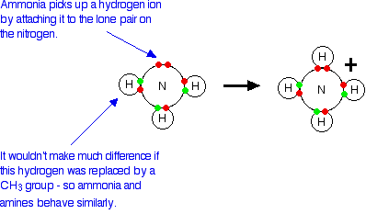
For example, if you dissolve these compounds in water, the nitrogen lone pair takes a hydrogen ion from a water molecule - and equilibria like these are set up:
Notice that the reactions are reversible. In both cases the positions of equilibrium lie well to the left. These compounds are weak bases because they don't hang on to the incoming hydrogen ion very well.
Both ammonia and the amines are alkaline in solution because of the presence of the hydroxide ions, and both of them turn red litmus blue.

Why doesn't something similar happen with amides?
Amides are neutral to litmus and have virtually no basic character at all - despite having the -NH₂ group. Their tendency to attract hydrogen ions is so slight that it can be ignored for most purposes.
We need to look at the bonding in the -CONH₂ group.
Like any other double bond, a carbon-oxygen double bond is made up of two different parts. One electron pair is found on the line between the two nuclei - this is known as a sigma bond. The other electron pair is found above and below the plane of the molecule in a pi bond.
A pi bond is made by sideways overlap between p orbitals on the carbon and the oxygen.
In an amide, the lone pair on the nitrogen atom ends up almost parallel to these p orbitals, and overlaps with them as they form the pi bond.
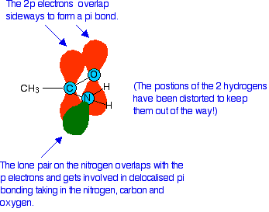
The result of this is that the nitrogen lone pair becomes delocalised - in other words it is no longer found located on the nitrogen atom, but the electrons from it are spread out over the whole of that part of the molecule.
This has two effects which prevent the lone pair accepting hydrogen ions and acting as a base:
- Because the lone pair is no longer located on a single atom as an intensely negative region of space, it isn't anything like as attractive for a nearby hydrogen ion.
- Delocalisation makes molecules more stable. For the nitrogen to reclaim its lone pair and join to a hydrogen ion, the delocalisation would have to be broken, and that will cost energy.
The dehydration of amides
Amides are dehydrated by heating a solid mixture of the amide and phosphorus(V) oxide, P₄O₁₀.
Water is removed from the amide group to leave a nitrile group, -CN. The liquid nitrile is collected by simple distillation.
For example, with ethanamide, you will get ethanenitrile.
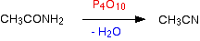
The Hofmann Degradation
The Hofmann degradation is a reaction between an amide and a mixture of bromine and sodium hydroxide solution. Heat is needed.
The net effect of the reaction is a loss of the -CO- part of the amide group. You get a primary amine with one less carbon atom than the original amide had.
The general case would be (as a flow scheme):

If you started with ethanamide, you would get methylamine. The full equation for the reaction is:
The Hofmann degradation is used as a way of cutting a single carbon atom out of a chain.

POLYAMIDES

This page looks at the structures, formation, hydrolysis and uses of the polyamides, nylon and Kevlar.

What are polyamides?
Polyamides are polymers where the repeating units are held together by amide links.
An amide group has the formula - CONH₂. An amide link has this structure:
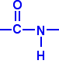
In an amide itself, of course, the bond on the right is attached to a hydrogen atom.
Nylon
In nylon, the repeating units contain chains of carbon atoms. (That is different from Kevlar, where the repeating units contain benzene rings - see below.) There are various different types of nylon depending on the nature of those chains.
Nylon-6,6
Nylon-6,6 is made from two monomers each of which contain 6 carbon atoms - hence its name.
One of the monomers is a 6 carbon acid with a -COOH group at each end - hexanedioic acid.
The other monomer is a 6 carbon chain with an amino group, -NH₂, at each end. This is 1,6-diaminohexane (also known as hexane-1,6-diamine).
When these two compounds polymerise, the amine and acid groups combine, each time with the loss of a molecule of water. This is known as condensation polymerisation.
Condensation polymerisation is the formation of a polymer involving the loss of a small molecule. In this case, the molecule is water, but in other cases different small molecules might be lost.
The diagram shows the loss of water between two of the monomers:
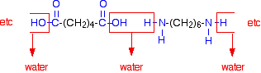
This keeps on happening, and so you get a chain which looks like this:
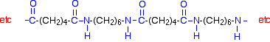
Nylon-6
If you are doing UK A level, you are unlikely to need the structure of nylon-6. I am including it to show that it is possible to get a polyamide from a single monomer.
Nylon-6 is made from a monomer called caprolactam.
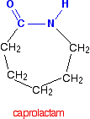
Notice that this already contains an amide link. When this molecule polymerises, the ring opens, and the molecules join up in a continuous chain.
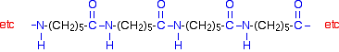

Kevlar
Kevlar is similar in structure to nylon-6,6 except that instead of the amide links joining chains of carbon atoms together, they join benzene rings.
The two monomers are benzene-1,4-dicarboxylic acid and 1,4-diaminobenzene.
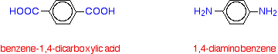
If you line these up and remove water between the -COOH and -NH₂ groups in the same way as we did with nylon-6,6, you get the structure of Kevlar:
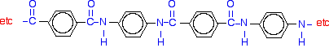

Making nylon-6,6
Making nylon-6,6 industrially
Nylon-6,6 is made by polymerising hexanedioic acid and 1,6-diaminohexane exactly as shown further up the page.
Because the acid is acidic and the amine is basic, they first react together to form a salt. That is then converted into nylon-6,6 by heating it under pressure at 350°C.
The two monomers can both be made from cyclohexane.
- Oxidation of the cyclohexane opens the ring of carbon atoms and produces a -COOH group at each end. That gives you the hexanedioic acid.
Some of that can then be converted into the 1,6-diaminohexane.
- The acid is treated with ammonia to produce the ammonium salt.
- The ammonium salt is heated to 350°C in the presence of hydrogen and a nickel catalyst. This both dehydrates the salt and reduces it to the 1,6-diaminohexane.

Making nylon-6,6 in the lab
In the lab, it is easy to make nylon-6,6 at room temperature using an acyl chloride (acid chloride) rather than an acid.
The 1,6-diaminohexane is used just as before, but hexanedioyl dichloride is used instead of hexanedioic acid.
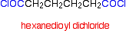
If you compare the next diagram with the diagram further up the page for the formation of nylon-6,6, you will see that the only difference is that molecules of HCl are lost rather than molecules of water.
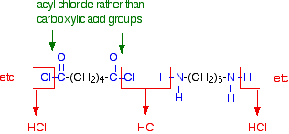
In the lab, this reaction is the basis for the nylon rope trick.
You make a solution of the hexanedioyl dichloride in an organic solvent, and a solution of 1,6-diaminohexane in water. You carefully float one solution on top of the other in a small beaker, taking care to get as little mixing as possible.
Nylon-6,6 forms at the boundary between the two solutions. If you pick up the boundary layer with a pair of tweezers, you can pull out an amazingly long tube of nylon from the beaker
Hydrolysis of polyamides
Simple amides are easily hydrolysed by reaction with dilute acids or alkalis.
Polyamides are fairly readily attacked by strong acids, but are much more resistant to alkaline hydrolysis. Hydrolysis is faster at higher temperatures. Hydrolysis by water alone is so slow as to be completely unimportant. Kevlar is rather more resistant to hydrolysis than nylon is.
If you spill something like dilute sulphuric acid on a fabric made from nylon, the amide linkages are broken. The long chains break and you can eventually end up with the original monomers - hexanedioic acid and 1,6-diaminohexane.
Because you produce small molecules rather than the original polymer, the fibres are destroyed, and you end up with a hole!
Uses of polyamides
Nylon
Apart from obvious uses in textiles for clothing and carpets, a lot of nylon is used to make tyre cords - the inner structure of a vehicle tyre underneath the rubber.
The fibres are also used in ropes, and nylon can be cast into solid shapes for cogs and bearings in machines, for example.
Kevlar
Kevlar is a very strong material - about five times as strong as steel, weight for weight. It is used in bulletproof vests, in composites for boat construction, in lightweight mountaineering ropes, and for lightweight skis and racquets - amongst many other things.

