INTRODUCING NITRILES

This page explains what nitriles are and looks at their simple physical properties such as solubility and boiling points.

What are nitriles?
Nitriles contain the -CN group, and used to be known as cyanides.
Some simple nitriles
The smallest organic nitrile is ethanenitrile, CH₃CN, (old name: methyl cyanide or acetonitrile - and sometimes now called ethanonitrile). Hydrogen cyanide, HCN, doesn't usually count as organic, even though it contains a carbon atom.
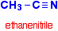
Notice the triple bond between the carbon and nitrogen in the -CN group.
The three simplest nitriles are:
CH₃CN | ethanenitrile
CH₃CH₂CN | propanenitrile
CH₃CH₂CH₂CN | butanenitrile
When you are counting the length of the carbon chain, don't forget the carbon in the -CN group. If the chain is branched, this carbon usually counts as the number 1 carbon.
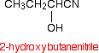
Physical properties
Boiling points
The small nitriles are liquids at room temperature.
nitrile | boiling point (°C)
CH₃CN | 82
CH₃CH₂CN | 97
CH₃CH₂CH₂CN | 116 - 118
These boiling points are very high for the size of the molecules - similar to what you would expect if they were capable of forming hydrogen bonds.
However, they don't form hydrogen bonds - they don't have a hydrogen atom directly attached to an electronegative element.
They are just very polar molecules. The nitrogen is very electronegative and the electrons in the triple bond are very easily pulled towards the nitrogen end of the bond.
Nitriles therefore have strong permanent dipole-dipole attractions as well as van der Waals dispersion forces between their molecules.
Solubility in water
Ethanenitrile is completely soluble in water, and the solubility then falls as chain length increases.
nitrile | solubility at 20°C
CH₃CN | miscible
CH₃CH₂CN | 10 g per 100 cm³ of water
CH₃CH₂CH₂CN | 3 g per 100 cm³ of water
The reason for the solubility is that although nitriles can't hydrogen bond with themselves, they can hydrogen bond with water molecules.
One of the slightly positive hydrogen atoms in a water molecule is attracted to the lone pair on the nitrogen atom in a nitrile and a hydrogen bond is formed.
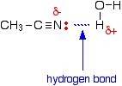
There will also, of course, be dispersion forces and dipole-dipole attractions between the nitrile and water molecules.
Forming these attractions releases energy. This helps to supply the energy needed to separate water molecule from water molecule and nitrile molecule from nitrile molecule before they can mix together.
As chain lengths increase, the hydrocarbon parts of the nitrile molecules start to get in the way.
By forcing themselves between water molecules, they break the relatively strong hydrogen bonds between water molecules without replacing them by anything as good. This makes the process energetically less profitable, and so solubility decreases.

MAKING NITRILES

This page looks at various ways of making nitriles - from halogenoalkanes (haloalkanes or alkyl halides), from amides, and from aldehydes and ketones. It pulls together information from pages dealing with each of these kinds of compounds

Making nitriles from halogenoalkanes
The halogenoalkane is heated under reflux with a solution of sodium or potassium cyanide in ethanol. The halogen is replaced by a -CN group and a nitrile is produced. Heating under reflux means heating with a condenser placed vertically in the flask to prevent loss of volatile substances from the mixture.
The solvent is important. If water is present you tend to get substitution by -OH instead of -CN.
For example, using 1-bromopropane as a typical halogenoalkane:
You could write the full equation rather than the ionic one, but it slightly obscures what's going on:
The bromine (or other halogen) in the halogenoalkane is simply replaced by a -CN group - hence a substitution reaction. In this example, butanenitrile is formed.
THE NUCLEOPHILIC SUBSTITUTION REACTIONS BETWEEN HALOGENOALKANES AND CYANIDE IONS

This page gives you the facts and simple, uncluttered mechanisms for the nucleophilic substitution reactions between halogenoalkanes and cyanide ions (from, for example, potassium cyanide). If you want the mechanisms explained to you in detail, there is a link at the bottom of the page.

The reaction of primary halogenoalkanes with cyanide ions
The facts
If a halogenoalkane is heated under reflux with a solution of sodium or potassium cyanide in ethanol, the halogen is replaced by a -CN group and a nitrile is produced. Heating under reflux means heating with a condenser placed vertically in the flask to prevent loss of volatile substances from the mixture.
The solvent is important. If water is present you tend to get substitution by -OH instead of -CN.
For example, using 1-bromopropane as a typical primary halogenoalkane:
You could write the full equation rather than the ionic one, but it slightly obscures what's going on:
The bromine (or other halogen) in the halogenoalkane is simply replaced by a -CN group - hence a substitution reaction. In this example, butanenitrile is formed.
The mechanism
Here is the mechanism for the reaction involving bromoethane:
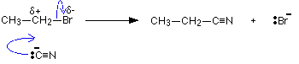
This is an example ofnucleophilic substitution.
Because the mechanism involves collision between two species in the slow step (in this case, the only step) of the reaction, it is known as an S_{N}2 reaction.
Unless your syllabus specifically mentions S_{N}2 by name, you can just call it nucleophilic substitution.

If your examiners want you to show the transition state, draw the mechanism like this:
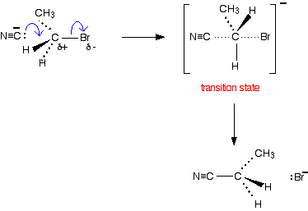

The reaction of tertiary halogenoalkanes with cyanide ions
The facts
The facts of the reaction are exactly the same as with primary halogenoalkanes. If the halogenoalkane is heated under reflux with a solution of sodium or potassium cyanide in ethanol, the halogen is replaced by -CN, and a nitrile is produced.
For example:
Or if you want the full equation rather than the ionic one:
The mechanism
This mechanism involves an initial ionisation of the halogenoalkane:
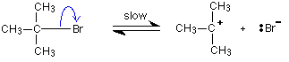
followed by a very rapid attack by the cyanide ion on the carbocation (carbonium ion) formed:
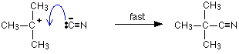
This is again an example ofnucleophilic substitution.
This time the slow step of the reaction only involves one species - the halogenoalkane. It is known as an S_{N}1 reaction.

The reaction of secondary halogenoalkanes with cyanide ions
The facts
The facts of the reaction are exactly the same as with primary or tertiary halogenoalkanes. The halogenoalkane is heated under reflux with a solution of sodium or potassium cyanide in ethanol.
For example:
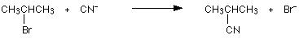
The mechanism
Secondary halogenoalkanes use both S_{N}2 and S_{N}1 mechanisms. For example, the S_{N}2 mechanism is:
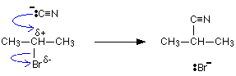
Should you need it, the two stages of the S_{N}1 mechanism are:
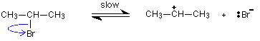
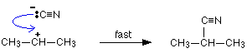
do tuk e otklonemnieto
Making a nitrile by this method is a useful way of increasing the length of a carbon chain. Having made the nitrile, the -CN group can easily be modified to make other things - as you will find if you explore the nitriles menu (link a the bottom of the page).

Making nitriles from amides
Nitriles can be made by dehydrating amides.
Amides are dehydrated by heating a solid mixture of the amide and phosphorus(V) oxide, P₄O₁₀.
Water is removed from the amide group to leave a nitrile group, -CN. The liquid nitrile is collected by simple distillation.
For example, you will get ethanenitrile by dehydrating ethanamide.
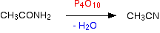
Making nitriles from aldehydes and ketones
Aldehydes and ketones undergo an addition reaction with hydrogen cyanide. The hydrogen cyanide adds across the carbon-oxygen double bond in the aldehyde or ketone to produce a hydroxynitrile. Hydroxynitriles used to be known as cyanohydrins.
For example, with ethanal (an aldehyde) you get 2-hydroxypropanenitrile:
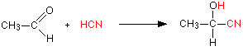
With propanone (a ketone) you get 2-hydroxy-2-methylpropanenitrile:
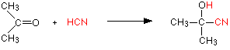
In every example of this kind, the -OH group will be on the number 2 carbon atom - the one next to the -CN group.
The reaction isn't normally done using hydrogen cyanide itself, because this is an extremely poisonous gas. Instead, the aldehyde or ketone is mixed with a solution of sodium or potassium cyanide in water to which a little sulphuric acid has been added. The pH of the solution is adjusted to about 4 - 5, because this gives the fastest reaction. The reaction happens at room temperature.
The solution will contain hydrogen cyanide (from the reaction between the sodium or potassium cyanide and the sulphuric acid), but still contains some free cyanide ions. This is important for the mechanism.
THE NUCLEOPHILIC ADDITION OF HYDROGEN CYANIDE TO ALDEHYDES AND KETONES

This page gives you the facts and simple, uncluttered mechanisms for the nucleophilic addition reactions between carbonyl compounds (specifically aldehydes and ketones) and hydrogen cyanide, HCN. If you want the mechanisms explained to you in detail, there is a link at the bottom of the page.
Aldehydes and ketones behave identically in their reaction with hydrogen cyanide, and so will be considered together - although equations and mechanisms will be given for both types of compounds for the sake of completeness.

The reaction of aldehydes and ketones with hydrogen cyanide
The facts
Hydrogen cyanide adds across the carbon-oxygen double bond in aldehydes and ketones to produce compounds known as hydroxynitriles.
For example, with ethanal (an aldehyde) you get 2-hydroxypropanenitrile:
With propanone (a ketone) you get 2-hydroxy-2-methylpropanenitrile:

The reaction isn't normally done using hydrogen cyanide itself, because this is an extremely poisonous gas. Instead, the aldehyde or ketone is mixed with a solution of sodium or potassium cyanide in water to which a little sulphuric acid has been added. The pH of the solution is adjusted to about 4 - 5, because this gives the fastest reaction.
The solution will contain hydrogen cyanide (from the reaction between the sodium or potassium cyanide and the sulphuric acid), but still contains some free cyanide ions. This is important for the mechanism.
The mechanisms
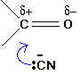
These are examples of nucleophilic addition.
The carbon-oxygen double bond is highly polar, and the slightly positive carbon atom is attacked by the cyanide ion acting as a nucleophile.
The mechanism for the addition of HCN to propanone
In the first stage, there is a nucleophilic attack by the cyanide ion on the slightly positive carbon atom.
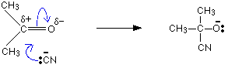
The negative ion formed then picks up a hydrogen ion from somewhere - for example, from a hydrogen cyanide molecule.
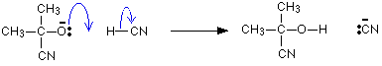
The hydrogen ion could also come from the water or the H₃O⁺ ions present in the slightly acidic solution. You don't need to remember all of these. One equation is perfectly adequate.
The mechanism for the addition of HCN to ethanal
As before, the reaction starts with a nucleophilic attack by the cyanide ion on the slightly positive carbon atom.
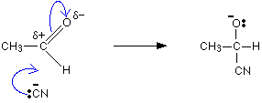
It is completed by the addition of a hydrogen ion from, for example, a hydrogen cyanide molecule.
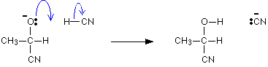
Optical isomerism in 2-hydroxypropanenitrile
When 2-hydroxypropanenitrile is made in this last mechanism, it occurs as a racemic mixture - a 50/50 mixture of two optical isomers. It is possible that you might be exected to explain how this arises.
Optical isomerism occurs in compounds which have four different groups attached to a single carbon atom. In this case, the product molecule contains a CH₃, a CN, an H and an OH all attached to the central carbon atom.
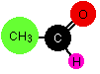
The reason for the formation of equal amounts of two isomers lies in the way the ethanal gets attacked.
Ethanal is a planar molecule, and attack by a cyanide ion will either be from above the plane of the molecule, or from below. There is an equal chance of either happening.
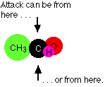
Attack from one side will lead to one of the two isomers, and attack from the other side will lead to the other.
All aldehydes will form a racemic mixture in this way. Unsymmetrical ketones will as well. (A ketone can be unsymmetrical in the sense that there is a different alkyl group either side of the carbonyl group.) What matters is that the product molecule must have four different groups attached to the carbon which was originally part of the carbon-oxygen double bond.

These are useful reactions because they not only increase the number of carbon atoms in a chain, but also introduce another reactive group as well as the -CN group. The -OH group behaves just like the -OH group in any alcohol with a similar structure.
For example, starting from a hydroxynitrile made from an aldehyde, you can quite easily produce relatively complicated molecules like 2-amino acids - the amino acids which are used to construct proteins.
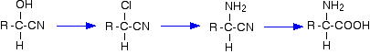
Note: The first step is the replacement of -OH in an alcohol by chlorine.
The second step is the reaction between a halogenoalkane and ammonia.
The final step is hydrolysis of a nitrile.
HYDROLYSING NITRILES

This page looks at the hydrolysis of nitriles under either acidic or alkaline conditions to make carboxylic acids or their salts.

The hydrolysis of nitriles
Introduction
When nitriles are hydrolysed you can think of them reacting with water in two stages - first to produce an amide, and then the ammonium salt of a carboxylic acid.
For example, ethanenitrile would end up as ammonium ethanoate going via ethanamide.
In practice, the reaction between nitriles and water would be so slow as to be completely negligible. The nitrile is instead heated with either a dilute acid such as dilute hydrochloric acid, or with an alkali such as sodium hydroxide solution.
The end result is similar in all the cases, but the exact nature of the final product varies depending on the conditions you use for the reaction.

Acidic hydrolysis of nitriles
The nitrile is heated under reflux with dilute hydrochloric acid. Instead of getting an ammonium salt as you would do if the reaction only involved water, you produce the free carboxylic acid.
For example, with ethanenitrile and hydrochloric acid you would get ethanoic acid and ammonium chloride.
Why is the free acid formed rather than the ammonium salt? The ethanoate ions in the ammonium ethanoate react with hydrogen ions from the hydrochloric acid to produce ethanoic acid. Ethanoic acid is only a weak acid and so once it has got the hydrogen ion, it tends to hang on to it.

Alkaline hydrolysis of nitriles
The nitrile is heated under reflux with sodium hydroxide solution. This time, instead of getting an ammonium salt as you would do if the reaction only involved water, you get the sodium salt. Ammonia gas is given off as well.
For example, with ethanenitrile and sodium hydroxide solution you would get sodium ethanoate and ammonia.
The ammonia is formed from reaction between ammonium ions and hydroxide ions.
If you wanted the free carboxylic acid in this case, you would have to acidify the final solution with a strong acid such as dilute hydrochloric acid or dilute sulphuric acid. The ethanoate ion in the sodium ethanoate will react with hydrogen ions as mentioned above.

REDUCING NITRILES TO PRIMARY AMINES

This page looks at the reduction of nitriles to primary amines using either lithium tetrahydridoaluminate(III) (lithium aluminium hydride) or hydrogen and a metal catalyst.

The reduction of nitriles using LiAlH₄
The reducing agent
Despite its name, the structure of the reducing agent is very simple. There are four hydrogens ("tetrahydido") around the aluminium in a negative ion (shown by the "ate" ending).
The "(III)" shows the oxidation state of the aluminium, and is often left out because aluminium only ever shows the +3 oxidation state in its compounds. To make the name shorter, that's what I shall do for the rest of this page.
The structure of LiAlH₄ is:
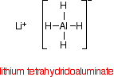
In the negative ion, one of the bonds is a co-ordinate covalent (dative covalent) bond using the lone pair on a hydride ion (H⁻) to form a bond with an empty orbital on the aluminium.
The overall reaction
The nitrile reacts with the lithium tetrahydridoaluminate in solution in ethoxyethane (diethyl ether, or just "ether") followed by treatment of the product of that reaction with a dilute acid.
Overall, the carbon-nitrogen triple bond is reduced to give a primary amine. Primary amines contain the -NH₂ group.
For example, with ethanenitrile you get ethylamine:
Notice that this is a simplified equation - perfectly acceptable to UK A level examiners. [H] means "hydrogen from a reducing agent".
The reduction of nitriles using hydrogen and a metal catalyst
The carbon-nitrogen triple bond in a nitrile can also be reduced by reaction with hydrogen gas in the presence of a variety of metal catalysts.
Commonly quoted catalysts are palladium, platinum or nickel.
The reaction will take place at a raised temperature and pressure. It is impossible to give exact details because it will vary from catalyst to catalyst.
For example, ethanenitrile can be reduced to ethylamine by reaction with hydrogen in the presence of a palladium catalyst.

