PHENOL
Assoc. Prof. Lubomir Makedonski
Medical University of Varna
The structure of phenol
The simplest way to draw the structure of phenol is:
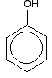
. . . but to understand phenol properly, you need to dig a bit deeper than this.
There is an interaction between the delocalised electrons in the benzene ring and one of the lone pairs on the oxygen atom. This has an important effect on both the properties of the ring and of the -OH group.
Physical properties
Pure phenol is a white crystalline solid, smelling of disinfectant. It has to be handled with great care because it causes immediate white blistering to the skin. The crystals are often rather wet and discolored.
Melting and boiling points
It is useful to compare phenol's melting and boiling points with those of methylbenzene (toluene). Both molecules contain the same number of electrons and are a very similar shape. That means that the intermolecular attractions due to van der Waals dispersion forces are going to be very similar.
The reason for the higher values for phenol is in part due to permanent dipole-dipole attractions due to the electronegativity of the oxygen - but is mainly due to hydrogen bonding.
Hydrogen bonds can form between a lone pair on an oxygen on one molecule and the hydrogen on the -OH group of one of its neighbors
Solubility in water
Phenol is moderately soluble in water - about 8 g of phenol will dissolve in 100 g of water.
If you try to dissolve more than this, you get two layers of liquid. The top layer is a solution of phenol in water, and the bottom one a solution of water in phenol. Phenol is somewhat soluble in water because of its ability to form hydrogen bonds with the water.
THE ACIDITY OF PHENOL
This page explains why phenol is a weak acid and looks at its reactions (or in some cases, lack of reaction) with bases and with sodium metal.
Why is phenol acidic?
Unlike alcohols (which also contain an -OH group) phenol is a weak acid. A hydrogen ion can break away from the -OH group and transfer to a base.
For example, in solution in water:
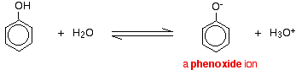
Phenol is a very weak acid and the position of equilibrium lies well to the left.
Phenol can lose a hydrogen ion because the phenoxide ion formed is stabilized to some extent. The negative charge on the oxygen atom is delocalised around the ring. The more stable the ion is, the more likely it is to form.
Properties of phenol as an acid
With indicators
The pH of a typical dilute solution of phenol in water is likely to be around 5 - 6 (depending on its concentration). That means that a very dilute solution isn't really acidic enough to turn litmus paper fully red. Litmus paper is blue at pH 8 and red at pH 5. Anything in between is going to show as some shade of "neutral".
With sodium hydroxide solution
Phenol reacts with sodium hydroxide solution to give a colourless solution containing sodium phenoxide.
With sodium carbonate or sodium hydrogencarbonate
Phenol isn't acidic enough to react with either of these. Or, looked at another way, the carbonate and hydrogencarbonate ions aren't strong enough bases to take a hydrogen ion from the phenol.
Unlike the majority of acids, phenol doesn't give carbon dioxide when you mix it with one of these.
With metallic sodium
Acids react with the more reactive metals to give hydrogen gas. Phenol is no exception - the only difference is the slow reaction because phenol is such a weak acid.
Phenol is warmed in a dry tube until it is molten, and a small piece of sodium added. There is some fizzing as hydrogen gas is given off. The mixture left in the tube will contain sodium phenoxide.
RING REACTIONS OF PHENOL
How does the -OH group modify the ring reactions?
Activation of the ring
The -OH group attached to the benzene ring in phenol has the effect of making the ring much more reactive than it would otherwise be.
For example, as you will find below, phenol will react with a solution of bromine in water (bromine water) in the cold and in the absence of any catalyst. It also reacts with dilute nitric acid, whereas benzene itself needs a nitrating mixture of concentrated nitric acid and concentrated sulfuric acid.
The directing effect of the -OH group
The -OH group has more activating effect on some positions around the ring than others (for reasons which go beyond UK A level). That means that incoming groups will go into some positions much faster than they will into others.
The net effect of this is that the -OH group has a 2,4-directing effect. That means that incoming groups will tend to go into the 2- position (next door to the -OH group) or the 4- position (opposite the -OH group). You will get hardly any of the 3- isomer formed - it is produced too slowly.
Specific examples
Reaction with bromine water
If bromine water is added to a solution of phenol in water, the bromine water is decolourised and a white precipitate is formed which smells of antiseptic.
The precipitate is 2,4,6-tribromophenol.
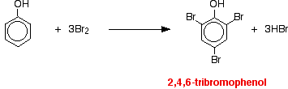
Notice the multiple substitution around the ring - into all the activated positions. (The 6- position is, of course, just the same as the 2- position. Both are next door to the -OH group.)
Reactions with nitric acid
The reactions with nitric acid are complicated because nitric acid is an oxidising agent, and phenol is very easily oxidised to give complex tarry products. What follows misses all that complication out, and just concentrates on the ring substitution which happens as well.
With dilute nitric acid
Phenol reacts with dilute nitric acid at room temperature to give a mixture of 2-nitrophenol and 4-nitrophenol.
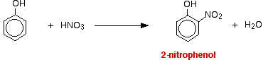
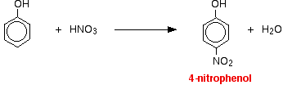
With concentrated nitric acid
With concentrated nitric acid, more nitro groups substitute around the ring to give 2,4,6-trinitrophenol (old name: picric acid).
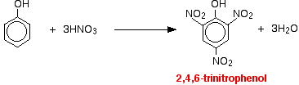

REACTIONS OF DIAZONIUM SALTS
Substitution reactions of diazonium ions
Diazonium ions are present in solutions such as benzenediazonium chloride solution. They contain an -N₂⁺ group. In the case of benzenediazonium chloride, this is attached to a benzene ring.
Benzenediazonium chloride looks like this:
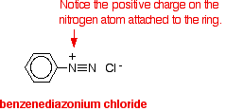

In this set of reactions of the diazonium ion, the -N₂⁺ group is replaced by something else. The nitrogen is released as nitrogen gas.
Substitution by an -OH group
To get this reaction, all you need to do is warm the benzenediazonium chloride solution. The diazonium ion reacts with the water in the solution and phenol is formed - either in solution or as a black oily liquid (depending on how much is formed). Nitrogen gas is evolved.
This is the same reaction that you get if you react phenylamine with nitrous acid in the warm. The diazonium ion is formed first and then immediately reacts with the water in the solution to give phenol.
Substitution by an iodine atom
This is a good example of the use of diazonium salts to substitute things into a benzene ring which are otherwise quite difficult to attach. (That's equally true of the previous reaction, by the way.)
If you add potassium iodide solution to the benzenediazonium chloride solution in the cold, nitrogen gas is given off, and you get oily droplets of iodobenzene formed.
There is a simple reaction between the diazonium ions and the iodide ions from the potassium iodide solution.
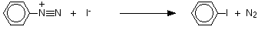
Coupling reactions of diazonium ions
In the substitution reactions above, the nitrogen in the diazonium ion is lost. In the rest of the reactions on this page, the nitrogen is retained and used to make a bridge between two benzene rings.
The reaction with phenol
Phenol is dissolved in sodium hydroxide solution to give a solution of sodium phenoxide.
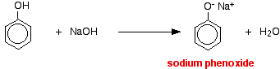
The solution is cooled in ice, and cold benzenediazonium chloride solution is added. There is a reaction between the diazonium ion and the phenoxide ion and a yellow-orange solution or precipitate is formed.
The product is one of the simplest of what are known as azo compounds, in which two benzene rings are linked by a nitrogen bridge.
The reaction with naphthalen-2-ol
Naphthalen-2-ol is also known as 2-naphthol or beta-naphthol. It contains an -OH group attached to a naphthalene molecule rather than to a simple benzene ring. Naphthalene has two benzene rings fused together.
The reaction is done under exactly the same conditions as with phenol. The naphthalen-2-ol is dissolved in sodium hydroxide solution to produce an ion just like the phenol one. This solution is cooled and mixed with the benzenediazonium chloride solution.
An intense orange-red precipitate is formed - another azo compound.
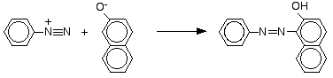

The reaction with phenylamine (aniline)
Some liquid phenylamine is added to a cold solution of benzenediazonium chloride, and the mixture is shaken vigorously. A yellow solid is produced.
These strongly coloured azo compounds are frequently used as dyes known as azo dyes. The one made from phenylamine (aniline) is known as "aniline yellow" . Azo compounds account for more than half of modern dyes.
ASSORTED REACTIONS OF PHENOL
Combustion of phenol
Phenol burns in a plentiful supply of oxygen to give carbon dioxide and water.
However, for compounds containing benzene rings, combustion is hardly ever complete, especially if they are burnt in air. The high proportion of carbon in phenol means that you need a very high proportion of oxygen to phenol to get complete combustion. Look at the equation.
As a general rule, the hydrogen in a molecule tends to get what oxygen is available first, leaving the carbon to form carbon itself, or carbon monoxide, if there isn't enough oxygen to go round.
Phenol tends to burn in air with an extremely smoky flame - full of carbon particles.
Esterification of phenol
You will probably remember that you can make esters from alcohols by reacting them with carboxylic acids. You might expect phenol to be similar.
However, unlike alcohols, phenol reacts so slowly with carboxylic acids that you normally react it with acyl chlorides (acid chlorides) or acid anhydrides instead.
The reaction with iron(III) chloride solution
Iron(III) chloride is sometimes known as ferric chloride.
Iron(III) ions form strongly coloured complexes with several organic compounds including phenol. The colour of the complexes vary from compound to compound. The reaction with iron(III) chloride solution can be used as a test for phenol.
If you add a crystal of phenol to iron(III) chloride solution, you get an intense violet-purple solution formed.

