STEREOISOMERISM - OPTICAL ISOMERISM

Optical isomerism is a form of stereoisomerism. This page explains what stereoisomers are and how you recognise the possibility of optical isomers in a molecule.

What is stereoisomerism?
What are isomers?
Isomers are molecules that have the same molecular formula, but have a different arrangement of the atoms in space. That excludes any different arrangements which are simply due to the molecule rotating as a whole, or rotating about particular bonds.
Where the atoms making up the various isomers are joined up in a different order, this is known as structural isomerism. Structural isomerism is not a form of stereoisomerism, and is dealt with on a separate page.
Simple substances which show optical isomerism exist as two isomers known as enantiomers.
- A solution of one enantiomer rotates the plane of polarisation in a clockwise direction. This enantiomer is known as the (+) form.
For example, one of the optical isomers (enantiomers) of the amino acid alanine is known as (+)alanine.
- A solution of the other enantiomer rotates the plane of polarisation in an anti-clockwise direction. This enantiomer is known as the (-) form. So the other enantiomer of alanine is known as or (-)alanine.
- If the solutions are equally concentrated the amount of rotation caused by the two isomers is exactly the same - but in opposite directions.
- When optically active substances are made in the lab, they often occur as a 50/50 mixture of the two enantiomers. This is known as a racemic mixture or racemate. It has no effect on plane polarised light.
How optical isomers arise
The examples of organic optical isomers required at A' level all contain a carbon atom joined to four different groups. These two models each have the same groups joined to the central carbon atom, but still manage to be different:
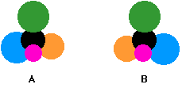
Obviously as they are drawn, the orange and blue groups aren't aligned the same way. Could you get them to align by rotating one of the molecules? The next diagram shows what happens if you rotate molecule B.
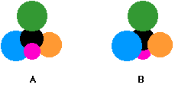
They still aren't the same - and there is no way that you can rotate them so that they look exactly the same. These are isomers of each other.
They are described as being non-superimposable in the sense that (if you imagine molecule B being turned into a ghostly version of itself) you couldn't slide one molecule exactly over the other one. Something would always be pointing in the wrong direction.
What happens if two of the groups attached to the central carbon atom are the same? The next diagram shows this possibility.
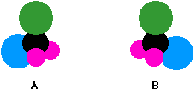
The two models are aligned exactly as before, but the orange group has been replaced by another pink one.
Rotating molecule B this time shows that it is exactly the same as molecule A. You only get optical isomers if all four groups attached to the central carbon are different.
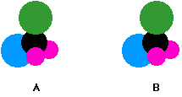
Chiral and achiral molecules
The essential difference between the two examples we've looked at lies in the symmetry of the molecules.
If there are two groups the same attached to the central carbon atom, the molecule has a plane of symmetry. If you imagine slicing through the molecule, the left-hand side is an exact reflection of the right-hand side.
Where there are four groups attached, there is no symmetry anywhere in the molecule.
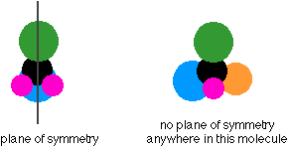
A molecule which has no plane of symmetry is described as chiral. The carbon atom with the four different groups attached which causes this lack of symmetry is described as a chiral centre or as an asymmetric carbon atom.
The molecule on the left above (with a plane of symmetry) is described as achiral.
Only chiral molecules have optical isomers.

The relationship between the enantiomers
One of the enantiomers is simply a non-superimposable mirror image of the other one.
In other words, if one isomer looked in a mirror, what it would see is the other one. The two isomers (the original one and its mirror image) have a different spatial arrangement, and so can't be superimposed on each other.
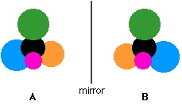
If an achiral molecule (one with a plane of symmetry) looked in a mirror, you would always find that by rotating the image in space, you could make the two look identical. It would be possible to superimpose the original molecule and its mirror image.

Some real examples of optical isomers
Butan-2-ol
The asymmetric carbon atom in a compound (the one with four different groups attached) is often shown by a star.
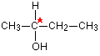
It's extremely important to draw the isomers correctly. Draw one of them using standard bond notation to show the 3-dimensional arrangement around the asymmetric carbon atom. Then draw the mirror to show the examiner that you know what you are doing, and then the mirror image.
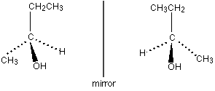
Notice that you don't literally draw the mirror images of all the letters and numbers! It is, however, quite useful to reverse large groups - look, for example, at the ethyl group at the top of the diagram.
It doesn't matter in the least in what order you draw the four groups around the central carbon. As long as your mirror image is drawn accurately, you will automatically have drawn the two isomers.
So which of these two isomers is (+)butan-2-ol and which is (-)butan-2-ol? There is no simple way of telling that. For A'level purposes, you can just ignore that problem - all you need to be able to do is to draw the two isomers correctly.
2-hydroxypropanoic acid (lactic acid)
Once again the chiral centre is shown by a star.
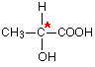
The two enantiomers are:
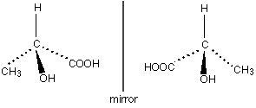
It is important this time to draw the COOH group backwards in the mirror image. If you don't there is a good chance of you joining it on to the central carbon wrongly.
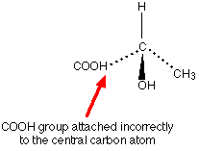
If you draw it like this in an exam, you won't get the mark for that isomer even if you have drawn everything else perfectly.
2-aminopropanoic acid (alanine)
This is typical of naturally-occurring amino acids. Structurally, it is just like the last example, except that the -OH group is replaced by -NH₂
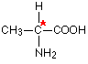
The two enantiomers are:
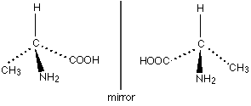
Only one of these isomers occurs naturally: the (+) form. You can't tell just by looking at the structures which this is.
It has, however, been possible to work out which of these structures is which. Naturally occurring alanine is the right-hand structure, and the way the groups are arranged around the central carbon atom is known as an L- configuration. Notice the use of the capital L. The other configuration is known as D-.
So you may well find alanine described as L-(+)alanine.
That means that it has this particular structure and rotates the plane of polarisation clockwise.
Even if you know that a different compound has an arrangement of groups similar to alanine, you still can't say which way it will rotate the plane of polarisation.
The other amino acids, for example, have the same arrangement of groups as alanine does (all that changes is the CH₃ group), but some are (+) forms and others are (-) forms.
It's quite common for natural systems to only work with one of the enantiomers of an optically active substance. It isn't too difficult to see why that might be. Because the molecules have different spatial arrangements of their various groups, only one of them is likely to fit properly into the active sites on the enzymes they work with.
In the lab, it is quite common to produce equal amounts of both forms of a compound when it is synthesised. This happens just by chance, and you tend to get racemic mixtures.

