INTERMOLECULAR BONDING - HYDROGEN BONDS

This page explains the origin of hydrogen bonding - a relatively strong form of intermolecular attraction. If you are also interested in the weaker intermolecular forces (van der Waals dispersion forces and dipole-dipole interactions), there is a link at the bottom of the page.

The evidence for hydrogen bonding
Many elements form compounds with hydrogen - referred to as "hydrides". If you plot the boiling points of the hydrides of the Group 4 elements, you find that the boiling points increase as you go down the group.
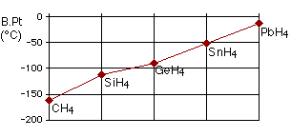
The increase in boiling point happens because the molecules are getting larger with more electrons, and so van der Waals dispersion forces become greater.
If you repeat this exercise with the hydrides of elements in Groups 5, 6 and 7, something odd happens.
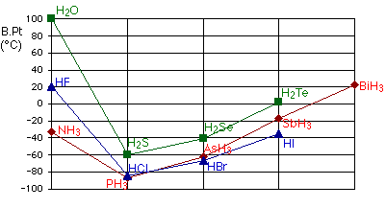
Although for the most part the trend is exactly the same as in group 4 (for exactly the same reasons), the boiling point of the hydride of the first element in each group is abnormally high.
In the cases of NH₃, H₂O and HF there must be some additional intermolecular forces of attraction, requiring significantly more heat energy to break. These relatively powerful intermolecular forces are described as hydrogen bonds.

The origin of hydrogen bonding
The molecules which have this extra bonding are:
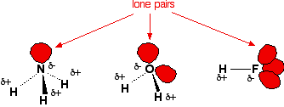
Notice that in each of these molecules:
- The hydrogen is attached directly to one of the most electronegative elements, causing the hydrogen to acquire a significant amount of positive charge.
- Each of the elements to which the hydrogen is attached is not only significantly negative, but also has at least one "active" lone pair.
Lone pairs at the 2-level have the electrons contained in a relatively small volume of space which therefore has a high density of negative charge. Lone pairs at higher levels are more diffuse and not so attractive to positive things.
Consider two water molecules coming close together.
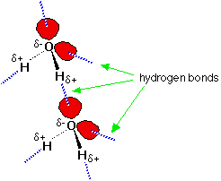
The + hydrogen is so strongly attracted to the lone pair that it is almost as if you were beginning to form a co-ordinate (dative covalent) bond. It doesn't go that far, but the attraction is significantly stronger than an ordinary dipole-dipole interaction.
Hydrogen bonds have about a tenth of the strength of an average covalent bond, and are being constantly broken and reformed in liquid water. If you liken the covalent bond between the oxygen and hydrogen to a stable marriage, the hydrogen bond has "just good friends" status. On the same scale, van der Waals attractions represent mere passing acquaintances!
Water as a "perfect" example of hydrogen bonding
Notice that each water molecule can potentially form four hydrogen bonds with surrounding water molecules. There are exactly the right numbers of + hydrogens and lone pairs so that every one of them can be involved in hydrogen bonding.
This is why the boiling point of water is higher than that of ammonia or hydrogen fluoride. In the case of ammonia, the amount of hydrogen bonding is limited by the fact that each nitrogen only has one lone pair. In a group of ammonia molecules, there aren't enough lone pairs to go around to satisfy all the hydrogens.
In hydrogen fluoride, the problem is a shortage of hydrogens. In water, there are exactly the right number of each. Water could be considered as the "perfect" hydrogen bonded system.
More complex examples of hydrogen bonding
The hydration of negative ions
When an ionic substance dissolves in water, water molecules cluster around the separated ions. This process is called hydration.
Water frequently attaches to positive ions by co-ordinate (dative covalent) bonds. It bonds to negative ions using hydrogen bonds.
The diagram shows the potential hydrogen bonds formed to a chloride ion, Cl⁻. Although the lone pairs in the chloride ion are at the 3-level and wouldn't normally be active enough to form hydrogen bonds, in this case they are made more attractive by the full negative charge on the chlorine.
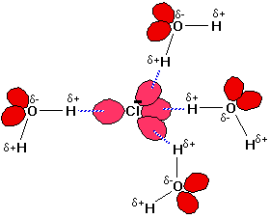
However complicated the negative ion, there will always be lone pairs that the hydrogen atoms from the water molecules can hydrogen bond to.

Hydrogen bonding in alcohols
An alcohol is an organic molecule containing an -O-H group.
Any molecule which has a hydrogen atom attached directly to an oxygen or a nitrogen is capable of hydrogen bonding. Such molecules will always have higher boiling points than similarly sized molecules which don't have an -O-H or an -N-H group. The hydrogen bonding makes the molecules "stickier", and more heat is necessary to separate them.
Ethanol, CH₃CH₂-O-H, and methoxymethane, CH₃-O-CH₃, both have the same molecular formula, C₂H₆O.
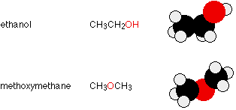
They have the same number of electrons, and a similar length to the molecule. The van der Waals attractions (both dispersion forces and dipole-dipole attractions) in each will be much the same.
However, ethanol has a hydrogen atom attached directly to an oxygen - and that oxygen still has exactly the same two lone pairs as in a water molecule. Hydrogen bonding can occur between ethanol molecules, although not as effectively as in water. The hydrogen bonding is limited by the fact that there is only one hydrogen in each ethanol molecule with sufficient + charge.
In methoxymethane, the lone pairs on the oxygen are still there, but the hydrogens aren't sufficiently + for hydrogen bonds to form. Except in some rather unusual cases, the hydrogen atom has to be attached directly to the very electronegative element for hydrogen bonding to occur.
The boiling points of ethanol and methoxymethane show the dramatic effect that the hydrogen bonding has on the stickiness of the ethanol molecules:
ethanol (with hydrogen bonding) |  | 78.5°C
methoxymethane (without hydrogen bonding) |  | -24.8°C
The hydrogen bonding in the ethanol has lifted its boiling point about 100°C.

It is important to realise that hydrogen bonding exists in addition to van der Waals attractions. For example, all the following molecules contain the same number of electrons, and the first two are much the same length. The higher boiling point of the butan-1-ol is due to the additional hydrogen bonding.
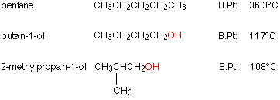
Comparing the two alcohols (containing -OH groups), both boiling points are high because of the additional hydrogen bonding due to the hydrogen attached directly to the oxygen - but they aren't the same.
The boiling point of the 2-methylpropan-1-ol isn't as high as the butan-1-ol because the branching in the molecule makes the van der Waals attractions less effective than in the longer butan-1-ol.

Hydrogen bonding in organic molecules containing nitrogen
Hydrogen bonding also occurs in organic molecules containing N-H groups - in the same sort of way that it occurs in ammonia. Examples range from simple molecules like CH₃NH₂ (methylamine) to large molecules like proteins and DNA.
The two strands of the famous double helix in DNA are held together by hydrogen bonds between hydrogen atoms attached to nitrogen on one strand, and lone pairs on another nitrogen or an oxygen on the other one.

