MEDICAL UNIVERSITY “PROF. DR. PARASKEV STOYANOV” – VARNA
DEPARTMENT OF ANESTHESIOLOGY, EMERGENCY, INTENSIVE AND MARITIME MEDICINE
O R G A N I S E

ANAESTHESIA OPEN 2014
16, 17 и 18. 05. 2014, Varna
NATIONAL TENNIS TOURNAMENT FOR ANAESTHESIOLOGIESTS,
physicians from other specialties students of medicine, dental medicine and pharmacy
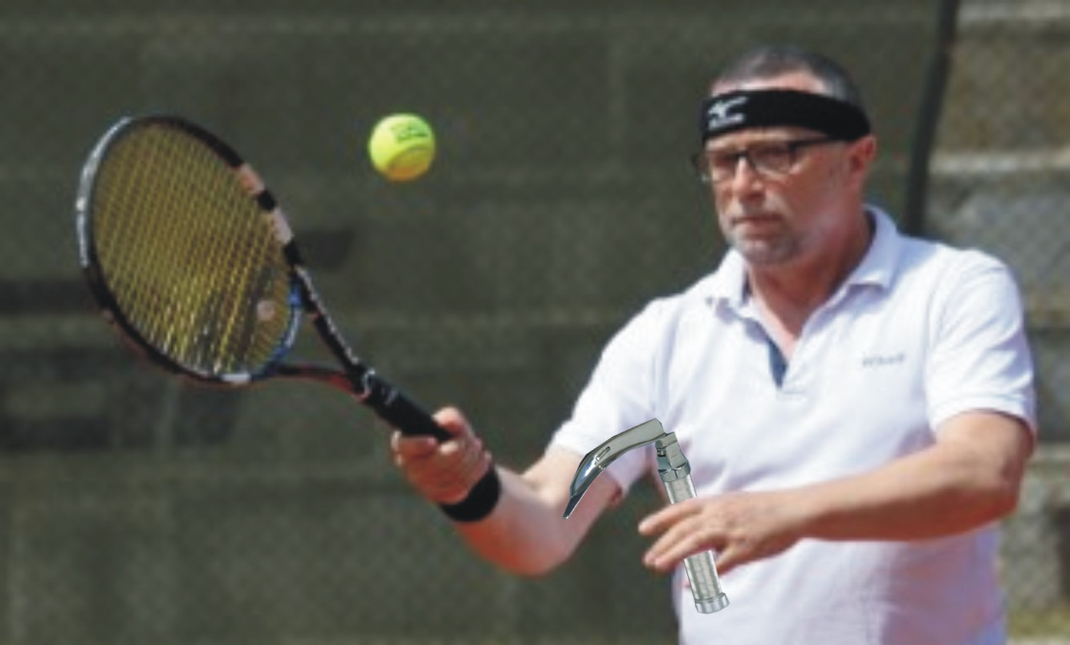
P R O G R A M M E

16.05. 14.00 TECHNICAL CONFERENCE
14.30 – 18.00 COMPETITION
20.00 – (social programme) dinner

17.05 09.00 – 18.00 COMPETITION
20.00 – (social programme) dinner
18.05 09.00 – 13.00 FINALS
13.00 - AWARD CEREMONY
14.00 – CLOSING OF THE TOURNAMENT

Fee for participation - 50 BGN (students participate free of charge)
The fee includes the following:
- Participation in the competition
- T-shirt from the tournament
- Participation in the social programme
Hotel booking:
Complex “Kamelia” is situated 10 minutes away by car from the venue of the event.
It is located on the way to “Golden Sands” resort. The complex offers single, double rooms and suites. There are special prices for the participants in the tournament. Telephone for individual booking – 052 / 30 22 66 or 0888349574.

Deadline for application 12.05.2014
Contact person Prof. V. Platikanov, tel. 052 978616, 0886613461

TOURNAMENT FORMAT

Venue Municipal courts in the “Chaika” complex – 4 clay courts
Type of games Singles / Quarters
System Single – up to 9 games/8;8-tiebreak/
Final - 2 of 3 tiebreak sets with counter tiebreak to 10.
Quarters -to 9 games/8;8-tiebreaks/ with NO-ED report
Points for individual qualification: winner – 5p. looser – 2 p.

Balls BABOLAT – Rolan Garos
Tournament rank SENIORS ITF
Director of the tournament Prof. Dr. Krasimir Ivanov, PhD, DSc, Rector of Varna Medical University
General Secretary Prof. Dr. V. Platikanov (with right to participate)
Chief referee Eng. Dr. Lazar Tsankov, PhD (with right to participate)
Other referees not secured, loyalty is expected
Financial conditions Balls, court, mineral water and snacks are provided.
Other costs are at the participants’ expense
Award fund First prize single – 100 BGN, cup and honorary diploma
First prize quarter – 2 x 100 BGN, cup and honorary diploma

