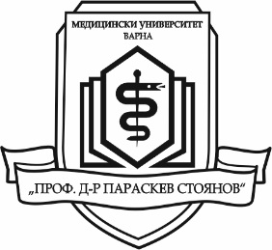
SUMMER PRACTICES FOR THE
STUDENTS OF MU-VARNA

in the First Moscow State Medical University
“I. M. Sechenov” MOSCOW, RUSSIA
Summer practice for 3rd, 4th and 5th year students
from all faculties
of Medical University “Prof. Dr. Paraskev Stoyanov”– Varna
will be carried out in Moscow, Russia
from 18th to 31st of July 2016.

Documents can be submitted in the period
February 16th – March 9th 2016

Dormitory, breakfast and lunch - provided by the host university
Airplane tickets and daily costs - covered by the candidates

Criteria for the selection of students:

Compulsory:
1. To have a minimum average grade from the studies – Very Good 4.50 (including the winter semester of the academic year 2015 - 2016);
2. To have successfully passed all examinations (including the winter semester of the academic year 2015 - 2016);
3. Good command of Russian language is an advantage.
Additional:
To have interests in one of the following areas: sport, music, dancing and others.

A special commission will select the best 15 candidates
until March 3rd 2016.
The approved candidates will be informed by е-mail or telephone.

Documents:
1. Application to the Dean of the Faculty
2. CV (with contact information)
3. Certificate of proficiency of Russian language, if applicable
4. Certificate for academic results
Document submission: in the Dean’s Office of the corresponding Faculty
Additional information: in the Department of International Relations, Main university building, 2nd floor, room 209
Tel.: +359 52 677109, е-mail: international_relations@mu-varna.bg

